# Building IP Futures

# The LEGO Wardley Mapping Manual for Intellectual Property Horizons

### **WARNING: This content was generated using Generative AI. While efforts have been made to ensure accuracy and coherence, readers should approach the material with critical thinking and verify important information from authoritative sources.**

# Table of Contents

Introduction: Constructing a New Paradigm for IP Strategy 5

The Evolving Landscape of Intellectual Property 5

Traditional IP Management vs. Dynamic IP Strategy 5

The Need for Visual Mapping in IP Planning 8

LEGO and Wardley: A Powerful Combination 11

Foundations of Wardley Mapping 14

Core Concepts and Components 14

Value Chain Visualization 17

Evolution and Movement in Maps 20

The LEGO Approach to Strategy 24

Modularity and Flexibility in Planning 24

Building Complex Systems from Simple Components 26

Iterative Design and Continuous Improvement 29

Chapter 1: Mapping the IP Landscape 34

Identifying IP Assets and Their Value Chains 34

Categorising IP: Patents, Trademarks, Copyrights, and Trade Secrets 34

Mapping Dependencies and Relationships 37

Visualising the Evolution of IP Assets 39

LEGO-inspired Visualisation Techniques 42

Using Colour-Coding for IP Types 42

Stackable Blocks for Layered IP Strategies 46

Connecting Pieces to Show IP Interactions 49

Creating Your First IP Wardley Map 53

Step-by-Step Guide to Building an IP Map 53

Common Pitfalls and How to Avoid Them 56

Interpreting Your IP Landscape 59

Chapter 2: Navigating Innovation Horizons 63

Understanding Innovation Horizons 63

Horizon 1: Core Business and Incremental Innovation 63

Horizon 2: Emerging Opportunities and Adjacent Markets 66

Horizon 3: Transformational and Disruptive Innovation 69

Mapping IP Across Horizons 72

Aligning IP Strategy with Innovation Goals 72

Identifying IP Gaps and Opportunities 76

Balancing Short-term Protection and Long-term Vision 79

LEGO Techniques for Horizon Planning 82

Building Modular IP Portfolios 82

Using Connector Pieces to Bridge Horizons 85

Creating Flexible IP Architectures for Future Adaptation 88

Chapter 3: Leveraging IP Opportunities 93

Strategic IP Positioning 93

Offensive vs. Defensive IP Strategies 93

Creating IP Moats and Barriers to Entry 95

Collaborative IP Development and Open Innovation 99

IP Monetization Strategies 102

Licensing and Cross-licensing Opportunities 102

IP-driven Business Models 105

Valuing and Trading IP Assets 109

LEGO-inspired IP Portfolio Management 112

Building and Reconfiguring IP ‘Sets’ 112

Creating IP ‘Instructions’ for Different Scenarios 115

Adapting IP Strategies as Markets Evolve 119

Chapter 4: Case Studies in IP Mapping Success 119

Technology Sector: Navigating Patent Thickets 119

Mapping Complex Patent Landscapes 119

Identifying Strategic Patent Acquisition Targets 119

Developing Freedom-to-Operate Strategies 119

Creative Industries: Managing Copyright Portfolios 119

Visualizing Content Libraries and Franchises 119

Mapping Distribution Channels and Licensing Opportunities 119

Protecting IP in the Digital Age 119

Manufacturing: Balancing Trade Secrets and Patents 119

Mapping Process Innovations and Know-how 119

Strategies for Global IP Protection 119

Leveraging IP for Competitive Advantage 119

Chapter 5: Ethical and Legal Considerations in IP Mapping 120

Navigating the Digital IP Landscape 120

Challenges of IP Protection in the Digital Era 120

Mapping Jurisdictional Differences in IP Law 120

Ethical Considerations in IP Strategy 120

Risk Management and Compliance 120

Identifying and Mitigating IP Risks 120

Ensuring Compliance with IP Regulations 120

Ethical Use of Competitors’ IP Information 120

Future-Proofing Your IP Strategy 120

Anticipating Changes in IP Law and Technology 120

Building Adaptable IP Portfolios 120

Fostering an Ethical IP Culture in Your Organisation 120

Conclusion: Assembling Your IP Future 121

Key Takeaways and Best Practices 121

Summarising the LEGO Wardley Mapping Approach to IP 121

Implementing IP Mapping in Your Organisation 121

Continuous Improvement and Adaptation in IP Strategy 121

The Future of IP Strategy 121

Emerging Trends in IP Management 121

The Role of AI and Machine Learning in IP Mapping 121

Building a Culture of Innovation and IP Awareness 121

Appendix: Book Generation Details 122

Appendix: Further Reading on Wardley Mapping 123

Core Wardley Mapping Series 123

Practical Resources 126

Specialized Applications 127

# Introduction: Constructing a New Paradigm for IP Strategy

## The Evolving Landscape of Intellectual Property

### Traditional IP Management vs. Dynamic IP Strategy

In the rapidly evolving landscape of intellectual property (IP), the transition from traditional IP management to dynamic IP strategy represents a paradigm shift that is reshaping how organisations approach innovation and competitive advantage. This shift is particularly relevant in the context of The LEGO Wardley Mapping manual for horizons of intellectual property, as it underscores the need for more agile, visual, and strategic approaches to IP management.

Traditional IP management has long been characterised by a reactive, siloed approach that often views IP assets as static entities to be protected rather than dynamic tools for value creation. This conventional model typically focuses on:

* Defensive patenting strategies
* Rigid portfolio management
* Standardised licensing agreements
* Periodic, often infrequent, portfolio reviews

While this approach has served many organisations well in stable markets, it is increasingly inadequate in today’s fast-paced, technology-driven environment. The limitations of traditional IP management become particularly apparent when we consider the complex, interconnected nature of modern innovation ecosystems and the rapid pace of technological change.

In contrast, dynamic IP strategy represents a proactive, integrated approach that aligns IP management with broader business objectives and innovation horizons. This approach, which is at the heart of The LEGO Wardley Mapping manual for horizons of intellectual property, is characterised by:

* Strategic alignment of IP with business goals and innovation roadmaps
* Continuous monitoring and adaptation of IP portfolios
* Cross-functional collaboration in IP strategy development
* Utilisation of visual mapping tools to understand IP landscapes and value chains
* Integration of IP considerations into all stages of the innovation process

The shift towards dynamic IP strategy is driven by several factors that are reshaping the IP landscape:

* Accelerating pace of technological change
* Increasing complexity of innovation ecosystems
* Growing importance of open innovation and collaborative R&D
* Rising costs of patent litigation and enforcement
* Emergence of new IP-intensive industries and business models

One of the key tools enabling this shift is the application of Wardley Mapping to IP strategy, as exemplified by The LEGO Wardley Mapping manual. This approach allows organisations to visualise their IP assets, dependencies, and evolution in a way that traditional IP management methods cannot match. By mapping IP assets and their value chains, organisations can gain insights into:

* The strategic importance of different IP assets
* Potential gaps or vulnerabilities in their IP portfolios
* Opportunities for IP-driven innovation and value creation
* The evolving landscape of competitors’ IP positions

The LEGO Wardley Mapping approach to IP strategy represents a fundamental shift in how we view and manage intellectual property. It allows us to move from a static, protective stance to a dynamic, value-creating approach that aligns IP with our broader innovation goals.

This quote from a senior IP strategist in the technology sector underscores the transformative potential of this approach. By combining the principles of Wardley Mapping with the modularity and flexibility inherent in LEGO-inspired visualisation techniques, organisations can create IP strategies that are both robust and adaptable.

The benefits of adopting a dynamic IP strategy enabled by LEGO Wardley Mapping include:

* Enhanced ability to identify and capitalise on IP-driven opportunities
* Improved alignment between IP strategy and overall business objectives
* Greater agility in responding to changes in the competitive landscape
* More effective resource allocation in IP development and management
* Increased collaboration between IP, R&D, and business strategy teams

However, the transition from traditional IP management to dynamic IP strategy is not without challenges. Organisations must overcome several hurdles, including:

* Cultural resistance to change within IP departments
* The need for new skills and competencies in IP strategy and visualisation
* Integration of IP considerations into agile innovation processes
* Balancing open innovation with IP protection
* Developing metrics and KPIs for dynamic IP strategy effectiveness

To address these challenges, organisations can leverage the principles outlined in The LEGO Wardley Mapping manual for horizons of intellectual property. This approach provides a framework for gradually building competency in dynamic IP strategy, starting with simple visualisations and progressing to more complex, multi-dimensional maps that capture the full complexity of an organisation’s IP landscape.

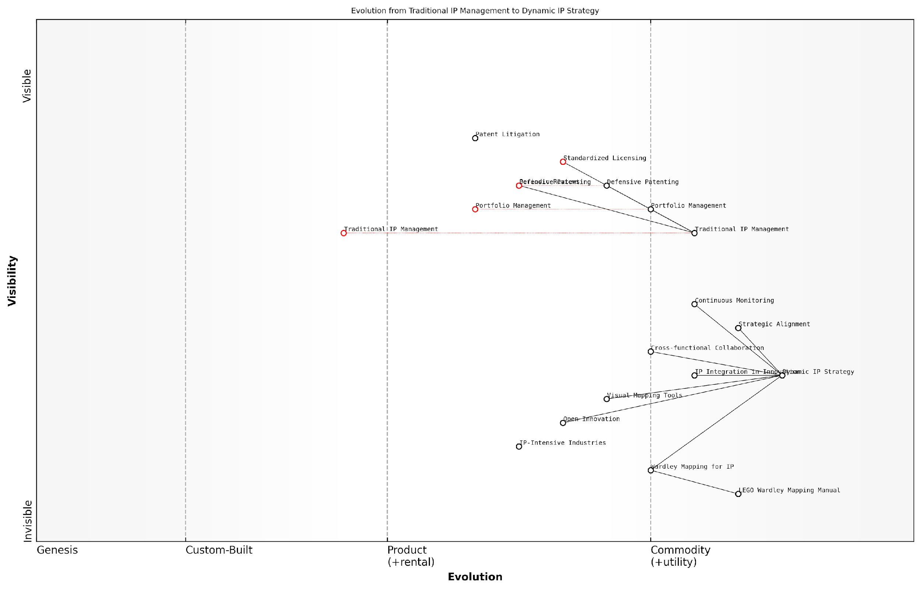

*Draft Wardley Map: [Insert Wardley Map: Traditional IP Management vs. Dynamic IP Strategy]*

[Edit this draft Wardley Map](https://create.wardleymaps.ai/#clone:3f347cdf3c021892eb)

Wardley Map Assessment

This Wardley Map reveals a significant shift in the IP management landscape, moving from traditional, defensive practices to more dynamic, strategic approaches. Organisations that can successfully navigate this transition, leveraging tools like Wardley Mapping for IP and integrating their IP strategy with innovation processes, will likely gain a competitive advantage. The map highlights the importance of developing new capabilities in strategic IP management and visual strategy tools, while also emphasising the need for greater cross-functional collaboration and alignment with broader innovation ecosystems. As the field evolves, those who can effectively implement Dynamic IP Strategy and leverage emerging tools and methodologies will be best positioned to create and capture value from their intellectual property assets.

[View full Wardley Map report](http://markdown_wardley_map_reports/wardley_map_report_01_Traditional_IP_Management_vs._Dynamic_IP_Strategy.md)

As organisations navigate the transition from traditional IP management to dynamic IP strategy, it’s crucial to recognise that this is not a binary choice but a continuum. Many organisations will find themselves at different points along this spectrum, with some aspects of their IP management remaining traditional while others become more dynamic and strategic.

The key to success lies in adopting a flexible, iterative approach that allows for continuous learning and adaptation. By embracing the principles of The LEGO Wardley Mapping manual for horizons of intellectual property, organisations can develop IP strategies that are not only responsive to current market conditions but also anticipatory of future trends and opportunities.

The future of IP strategy is not about predicting a single outcome, but about building the capability to adapt to multiple possible futures. The LEGO Wardley Mapping approach gives us the tools to do just that.

This insight from a leading IP consultant encapsulates the essence of dynamic IP strategy. As we move forward, the organisations that thrive will be those that can effectively leverage tools like LEGO Wardley Mapping to navigate the complex, ever-changing landscape of intellectual property, turning potential threats into opportunities for innovation and growth.

### The Need for Visual Mapping in IP Planning

In the rapidly evolving landscape of intellectual property (IP), traditional methods of IP management are increasingly inadequate to address the complex, interconnected nature of modern innovation. The need for visual mapping in IP planning has become paramount, offering a powerful tool to navigate the intricate web of patents, trademarks, copyrights, and trade secrets that form the backbone of organisational value. By leveraging the principles of Wardley Mapping in conjunction with LEGO-inspired visualisation techniques, we can construct a new paradigm for IP strategy that is both comprehensive and adaptable.

Visual mapping in IP planning serves several critical functions:

* Clarity and Communication: Visual representations of IP portfolios and strategies facilitate clearer understanding and more effective communication among stakeholders, from legal teams to C-suite executives.
* Strategic Alignment: Maps help align IP strategies with broader business objectives, ensuring that IP assets are developed and managed in ways that support organisational goals.
* Opportunity Identification: Visual mapping can reveal gaps in IP coverage, potential licensing opportunities, and areas for strategic IP development.
* Risk Management: By visualising the IP landscape, organisations can more easily identify potential infringement risks and develop mitigation strategies.
* Dynamic Strategy Development: Visual maps allow for the dynamic updating of IP strategies as market conditions, technological landscapes, and competitive environments evolve.

The integration of Wardley Mapping principles with IP strategy provides a robust framework for understanding the evolution of IP assets and their strategic importance. Wardley Maps, originally developed for analysing business and technology landscapes, offer a unique perspective when applied to IP:

* Value Chain Visualisation: Mapping the value chain of IP assets helps organisations understand how different IP components contribute to overall value creation.
* Evolution Axis: The evolution axis in Wardley Maps can be adapted to represent the maturity of IP assets, from novel innovations to industry-standard technologies.
* Positioning: Visual mapping allows for strategic positioning of IP assets relative to competitors and market demands.
* Movement: The concept of movement in Wardley Maps can be applied to track the changing relevance and value of IP assets over time.

The LEGO-inspired approach to visual mapping adds an additional layer of flexibility and intuitiveness to IP planning. By conceptualising IP assets as modular, interconnectable ‘blocks’, organisations can:

* Build Complex IP Portfolios: Construct comprehensive IP strategies by combining and reconfiguring individual IP ‘blocks’.
* Visualise Relationships: Use connecting pieces to represent relationships between different IP assets, licensing agreements, or collaborative innovations.
* Scenario Planning: Easily reconfigure IP ‘structures’ to model different strategic scenarios or respond to market changes.
* Iterative Development: Adopt an agile approach to IP strategy, continuously refining and expanding the IP portfolio as new opportunities or challenges emerge.

Visual mapping in IP strategy is not just about creating pretty pictures. It’s about constructing a dynamic, adaptable framework that allows organisations to navigate the complex IP landscape with agility and foresight.

In practice, the implementation of visual mapping in IP planning requires a shift in mindset and approach. Organisations must move beyond static spreadsheets and text-heavy reports to embrace a more dynamic, visual representation of their IP assets and strategies. This shift can be challenging, particularly for organisations with established IP management practices. However, the benefits in terms of strategic clarity, stakeholder alignment, and adaptive capacity far outweigh the initial investment in new tools and methodologies.

A case study from the public sector illustrates the power of visual mapping in IP strategy. A government research institution, facing challenges in commercialising its innovations, adopted a LEGO Wardley Mapping approach to visualise its IP portfolio. By mapping its patents, research collaborations, and potential commercial applications, the institution identified several key opportunities:

* Gaps in patent coverage that, when filled, could significantly enhance the value of existing IP.
* Potential cross-licensing opportunities with private sector partners.
* Areas where defensive publishing could be more strategically advantageous than patent filing.
* Emerging technology domains where early IP positioning could yield significant long-term benefits.

This visual approach not only clarified the institution’s IP position but also facilitated more strategic discussions with potential commercial partners, ultimately leading to several successful technology transfer agreements.

As we move forward in an increasingly complex and fast-paced innovation landscape, the need for visual mapping in IP planning will only grow. Organisations that embrace these tools and methodologies will be better positioned to navigate the challenges and opportunities of the evolving IP ecosystem. By combining the strategic insights of Wardley Mapping with the flexibility and intuitiveness of LEGO-inspired visualisation, we can construct IP strategies that are not only robust and comprehensive but also adaptable and future-proof.

In the realm of intellectual property, where intangible assets drive tangible value, visual mapping is not just a tool—it’s a strategic imperative. It allows us to see the unseen, connect the disconnected, and build the future of innovation, one block at a time.

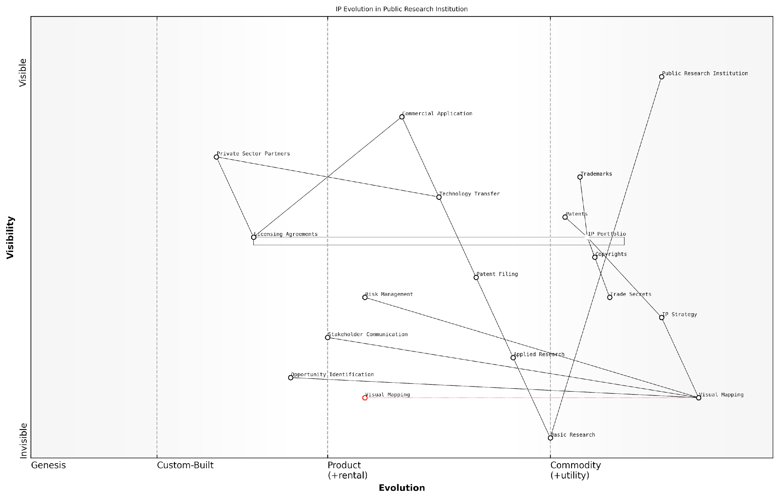

*Draft Wardley Map: [Insert Wardley Map: The Need for Visual Mapping in IP Planning]*

[Edit this draft Wardley Map](https://create.wardleymaps.ai/#clone:f079ffaab87e2a712a)

Wardley Map Assessment

The map reveals a public research institution with a solid foundation in IP management but significant opportunities for enhancement through the strategic use of Visual Mapping and a more dynamic IP Strategy. By focusing on these areas, the institution can improve its entire value chain from basic research to commercial application, potentially leading to more valuable IP portfolios and more effective technology transfer. The emphasis on Visual Mapping is particularly noteworthy and could become a key differentiator in the industry. However, careful attention must be paid to potential bottlenecks in Patent Filing and Technology Transfer to ensure the full value of research outputs is realised.

[View full Wardley Map report](http://markdown_wardley_map_reports/wardley_map_report_02_The_Need_for_Visual_Mapping_in_IP_Planning.md)

### LEGO and Wardley: A Powerful Combination

In the rapidly evolving landscape of intellectual property (IP) strategy, the fusion of LEGO’s modular approach with Wardley Mapping techniques presents a groundbreaking paradigm for visualising and managing IP assets. This powerful combination offers a unique lens through which organisations can navigate the complexities of IP portfolios, innovation horizons, and strategic positioning in an increasingly competitive global market.

The synergy between LEGO’s building block methodology and Wardley’s mapping principles creates a flexible, intuitive framework for IP strategists. This approach allows for the construction of dynamic, adaptable IP strategies that can respond to market shifts, technological advancements, and regulatory changes with unprecedented agility.

The LEGO Wardley Mapping approach to IP strategy is akin to building a living, breathing ecosystem of intellectual assets. It allows organisations to visualise their IP landscape as a collection of interconnected, modular components that can be reconfigured and optimised in real-time.

Let’s delve into the key aspects that make this combination so effective:

* Modularity and Flexibility
* Visual Representation of Complex Systems
* Evolution and Movement Tracking
* Scenario Planning and Strategy Testing

Modularity and Flexibility: LEGO’s core principle of modular construction aligns seamlessly with the dynamic nature of IP portfolios. Each IP asset can be represented as a LEGO brick, allowing for easy reconfiguration as market conditions change. This modularity enables IP strategists to quickly adapt their portfolios, combining and recombining assets to create new value propositions or respond to competitive threats.

Visual Representation of Complex Systems: Wardley Mapping’s strength lies in its ability to visually represent complex systems and their evolution over time. When combined with LEGO’s intuitive building block approach, it becomes possible to create three-dimensional, colour-coded representations of IP landscapes. This visual clarity is invaluable for communicating complex IP strategies to stakeholders across various levels of an organisation.

Evolution and Movement Tracking: Wardley Maps excel at tracking the evolution of components within a system. In the context of IP strategy, this allows organisations to visualise how their IP assets are moving along the value chain, from genesis to commodity. By representing these movements with LEGO bricks, strategists can physically manipulate and experiment with different scenarios, making the abstract concept of IP evolution tangible and accessible.

Scenario Planning and Strategy Testing: The combination of LEGO’s hands-on approach with Wardley Mapping’s strategic foresight capabilities creates a powerful tool for scenario planning. IP strategists can build multiple versions of their IP landscape, testing different configurations and strategies in a low-risk, high-insight environment. This approach is particularly valuable when navigating uncertain regulatory environments or emerging technology sectors.

The beauty of the LEGO Wardley Mapping approach lies in its ability to transform abstract IP concepts into tangible, manipulable objects. This tactile dimension adds a new layer of understanding and insight to the strategic planning process.

Practical Applications in Government and Public Sector:

In the government and public sector context, the LEGO Wardley Mapping approach to IP strategy offers unique benefits. Public sector organisations often manage diverse IP portfolios that span multiple domains, from scientific research to public service innovations. The modular nature of this approach allows for easy collaboration between different departments and agencies, fostering a more holistic view of national IP assets.

For example, a government research institution could use this method to map out its patent portfolio, visually representing how different patents relate to each other and to the broader innovation ecosystem. By using different coloured LEGO bricks to represent various technology domains or potential applications, decision-makers can quickly identify areas of strength, gaps in the portfolio, and opportunities for cross-sector collaboration.

Moreover, in the realm of public policy, this approach can be invaluable for modelling the impact of different IP regulations or incentive structures. Policymakers can use LEGO Wardley Maps to simulate how changes in IP law might affect the innovation landscape, providing a tangible basis for evidence-based policymaking.

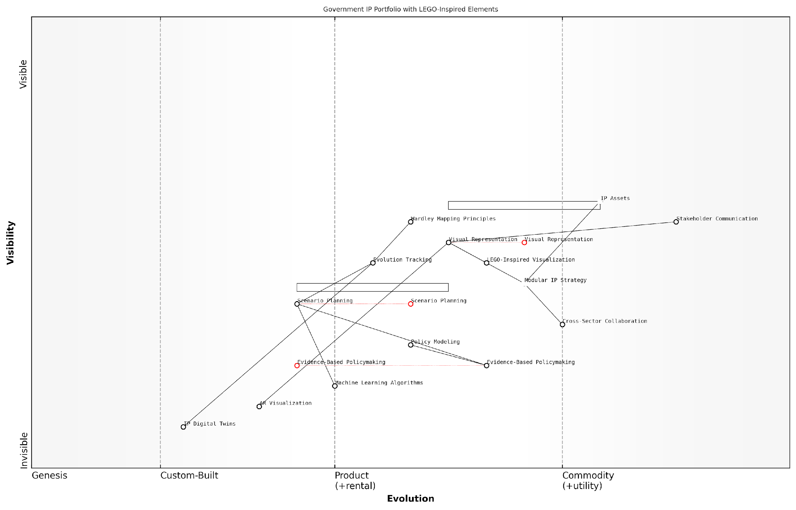

*Draft Wardley Map: [Insert Wardley Map: LEGO and Wardley: A Powerful Combination]*

[Edit this draft Wardley Map](https://create.wardleymaps.ai/#clone:e9d4d039299dc6ea24)

Wardley Map Assessment

This Wardley Map represents an innovative and forward-thinking approach to government IP portfolio management. By integrating LEGO-inspired visualisation techniques with Wardley Mapping principles, it creates a unique framework for developing, communicating, and evolving IP strategies. The focus on modularity and visual representation, combined with the incorporation of emerging technologies, positions this approach at the forefront of IP strategy innovation. However, careful management of the balance between established practices and cutting-edge technologies will be crucial for success. The government has the opportunity to lead in redefining how IP strategies are developed and implemented, potentially influencing practices across various sectors and fostering a more dynamic, collaborative innovation ecosystem.

[View full Wardley Map report](http://markdown_wardley_map_reports/wardley_map_report_03_LEGO_and_Wardley:_A_Powerful_Combination.md)

Challenges and Considerations:

While the LEGO Wardley Mapping approach offers numerous benefits, it’s important to acknowledge potential challenges in its implementation. The primary hurdle often lies in the initial learning curve. Stakeholders must be trained not only in the principles of Wardley Mapping but also in how to effectively use the LEGO-inspired visualisation techniques.

Additionally, there’s a risk of oversimplification. While the modular, visual nature of this approach is one of its strengths, it’s crucial to ensure that the complexity and nuances of IP strategy are not lost in translation. Skilled facilitators are often necessary to guide the process and ensure that the resulting maps accurately reflect the intricacies of the IP landscape.

The key to success with the LEGO Wardley Mapping approach is striking the right balance between simplicity and complexity. It should simplify without oversimplifying, clarify without obscuring the nuances that make IP strategy so challenging and rewarding.

Future Directions:

As we look to the future, the potential for enhancing the LEGO Wardley Mapping approach with emerging technologies is immense. Augmented reality (AR) could allow for interactive, 3D visualisations of IP landscapes that can be manipulated and explored in real-time. Machine learning algorithms could be employed to suggest optimal configurations or predict the evolution of IP assets based on historical data and market trends.

Furthermore, as the concept of digital twins gains traction in various industries, we could see the development of ‘IP Digital Twins’ – virtual representations of an organisation’s IP portfolio that update in real-time based on market data, legal developments, and internal innovation activities.

In conclusion, the combination of LEGO’s modular, intuitive building system with Wardley’s strategic mapping principles offers a powerful new tool for IP strategy. By making the abstract world of intellectual property tangible and visual, this approach enables more agile, collaborative, and insightful strategic planning. As we navigate the increasingly complex landscape of global innovation, such tools will be invaluable in helping organisations and governments alike to build robust, adaptive IP strategies for the future.

## Foundations of Wardley Mapping

### Core Concepts and Components

The foundations of Wardley Mapping are essential to understanding its application in intellectual property strategy, particularly when combined with LEGO-inspired visualisation techniques. This powerful combination provides a unique approach to mapping and strategising IP assets across innovation horizons. As we delve into the core concepts and components, we’ll explore how these elements form the bedrock of our LEGO Wardley Mapping manual for IP horizons.

Wardley Mapping, developed by Simon Wardley, is a strategic planning technique that helps organisations visualise their business environment and make informed decisions. When applied to intellectual property, it becomes a potent tool for understanding the evolving landscape of IP assets, their interdependencies, and their strategic value. Let’s break down the key components:

* Value Chain: The backbone of a Wardley Map, representing the series of activities required to create value for the end user.
* Evolution Axis: Depicts the maturity of components from genesis to commodity.
* Visibility Axis: Represents how visible components are to the end user.
* Anchors: The user needs that drive the map.
* Components: Individual elements within the value chain.
* Links: Connections between components, showing dependencies.
* Movement: Arrows indicating the direction of evolution for components.

In the context of IP strategy, these components take on specific meanings. The value chain might represent the journey from initial idea to protected, commercialised intellectual property. Components could include specific patents, trademarks, or trade secrets. The evolution axis becomes particularly crucial, as it can indicate the lifecycle of IP assets from novel innovations to industry standards.

Wardley Mapping provides a visual language for strategy that is particularly well-suited to the complex and dynamic nature of intellectual property management.

The LEGO aspect of our approach adds another layer of versatility and intuition to Wardley Mapping. By using LEGO-inspired visualisation techniques, we can create tangible, modular representations of IP landscapes that are easy to manipulate and understand. This approach aligns perfectly with the modular nature of IP portfolios and the need for flexible, adaptable strategies.

Key LEGO-inspired elements include:

* Colour-coding: Using different coloured blocks to represent various types of IP (e.g., blue for patents, red for trademarks).
* Stacking: Building vertical structures to show the layering of IP strategies or the strength of protection.
* Connectors: Using LEGO connectors to show relationships between different IP assets or strategies.
* Baseplate: Representing the market or technological landscape on which IP assets are positioned.

By combining Wardley Mapping with LEGO-inspired visualisation, we create a powerful tool for IP strategists. This approach allows for:

* Dynamic scenario planning: Easily rearrange components to explore different strategic options.
* Collaborative strategy development: Teams can work together to build and modify IP landscapes.
* Intuitive communication: Complex IP strategies become more accessible to non-specialists.
* Iterative refinement: Strategies can be quickly adjusted as new information or opportunities arise.

In practice, this combination has proven particularly effective in government and public sector contexts. For example, a national innovation agency used this approach to map out its country’s IP landscape across various technology sectors. The visual nature of the LEGO Wardley Map allowed policymakers to quickly identify areas where additional IP protection or investment was needed, and to strategise about how to position the country’s IP assets in the global market.

The LEGO Wardley Mapping approach to IP strategy has revolutionised how we visualise and plan for the future of our national innovation ecosystem.

As we progress through this manual, we’ll explore how to apply these core concepts and components to specific IP challenges across different innovation horizons. We’ll see how this approach can help organisations navigate the complexities of patent thickets, manage diverse IP portfolios, and align IP strategy with broader business goals.

Understanding these foundational elements is crucial for anyone looking to leverage the power of LEGO Wardley Mapping for IP strategy. As we move forward, we’ll build upon these concepts, demonstrating how they can be applied to create dynamic, adaptable, and visually intuitive IP strategies that can drive innovation and competitive advantage across multiple horizons.

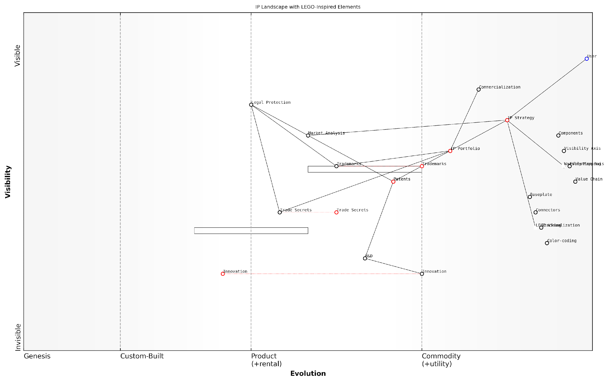

*Draft Wardley Map: [Insert Wardley Map: Core Concepts and Components]*

[Edit this draft Wardley Map](https://create.wardleymaps.ai/#clone:83df7c47c89c003dd8)

Wardley Map Assessment

This Wardley Map reveals a sophisticated approach to IP strategy with innovative visualisation techniques, but highlights a potential imbalance between strategic sophistication and operational execution. The key opportunity lies in evolving Innovation and R&D processes to match the maturity of strategic elements, while leveraging unique visualisation and mapping capabilities to drive competitive advantage. By addressing these gaps and fully integrating novel approaches like LEGO Visualization, the organisation can position itself as a leader in holistic, user-centric IP management.

[View full Wardley Map report](http://markdown_wardley_map_reports/wardley_map_report_04_Core_Concepts_and_Components.md)

### Value Chain Visualization

Value Chain Visualisation is a cornerstone of Wardley Mapping and plays a crucial role in understanding and strategising intellectual property (IP) within the context of The LEGO Wardley Mapping manual for horizons of intellectual property. This technique allows organisations to visually represent the components and dependencies that contribute to the creation and delivery of value, with a particular focus on IP assets and their evolution.

In the realm of IP strategy, value chain visualisation serves as a powerful tool for identifying, analysing, and optimising the various elements that contribute to an organisation’s intellectual property portfolio. By mapping these components, decision-makers can gain a comprehensive understanding of their IP landscape, identify potential opportunities and threats, and make informed strategic decisions.

Value chain visualisation in Wardley Mapping is not just about creating pretty pictures; it’s about revealing the hidden structures and relationships that drive value creation in your IP portfolio.

Let’s delve into the key aspects of value chain visualisation for IP strategy:

* Identifying IP Components
* Mapping Dependencies
* Visualising Evolution
* LEGO-inspired Representation
* Strategic Insights

Identifying IP Components: The first step in value chain visualisation for IP strategy is to identify all the relevant components of your intellectual property portfolio. This includes patents, trademarks, copyrights, trade secrets, and any other forms of IP that contribute to your organisation’s value proposition. Each of these components should be represented as a distinct element on your map.

Mapping Dependencies: Once you’ve identified your IP components, the next crucial step is to map out the dependencies between them. This involves understanding how different IP assets relate to and support each other. For example, a core patent might be supported by several auxiliary patents, or a trademark might be closely linked to specific copyrighted materials. By visualising these dependencies, you can better understand the interconnected nature of your IP portfolio and identify potential vulnerabilities or strengths.

Visualising Evolution: One of the unique aspects of Wardley Mapping is its incorporation of the evolution axis. In the context of IP strategy, this allows you to represent how different IP components are evolving over time. For instance, a cutting-edge patent might be positioned towards the ‘genesis’ end of the spectrum, while well-established trademarks could be placed closer to the ‘commodity’ end. This evolutionary perspective is crucial for anticipating future trends and adapting your IP strategy accordingly.

The evolution axis in IP value chain visualisation is like a crystal ball for your intellectual property portfolio. It helps you see not just where your IP assets are today, but where they’re headed tomorrow.

LEGO-inspired Representation: Drawing inspiration from LEGO’s modular and visual approach, we can enhance our value chain visualisation for IP strategy. By using different colours, shapes, or sizes to represent various types of IP assets, we can create a more intuitive and engaging visual representation. For example, patents could be represented by red blocks, trademarks by blue blocks, and copyrights by green blocks. The size of each block could indicate the relative importance or value of the IP asset.

Furthermore, we can use LEGO-style connectors to show relationships between different IP components, creating a three-dimensional representation of our IP value chain. This approach not only makes the visualisation more engaging but also allows for a more nuanced representation of complex IP portfolios.

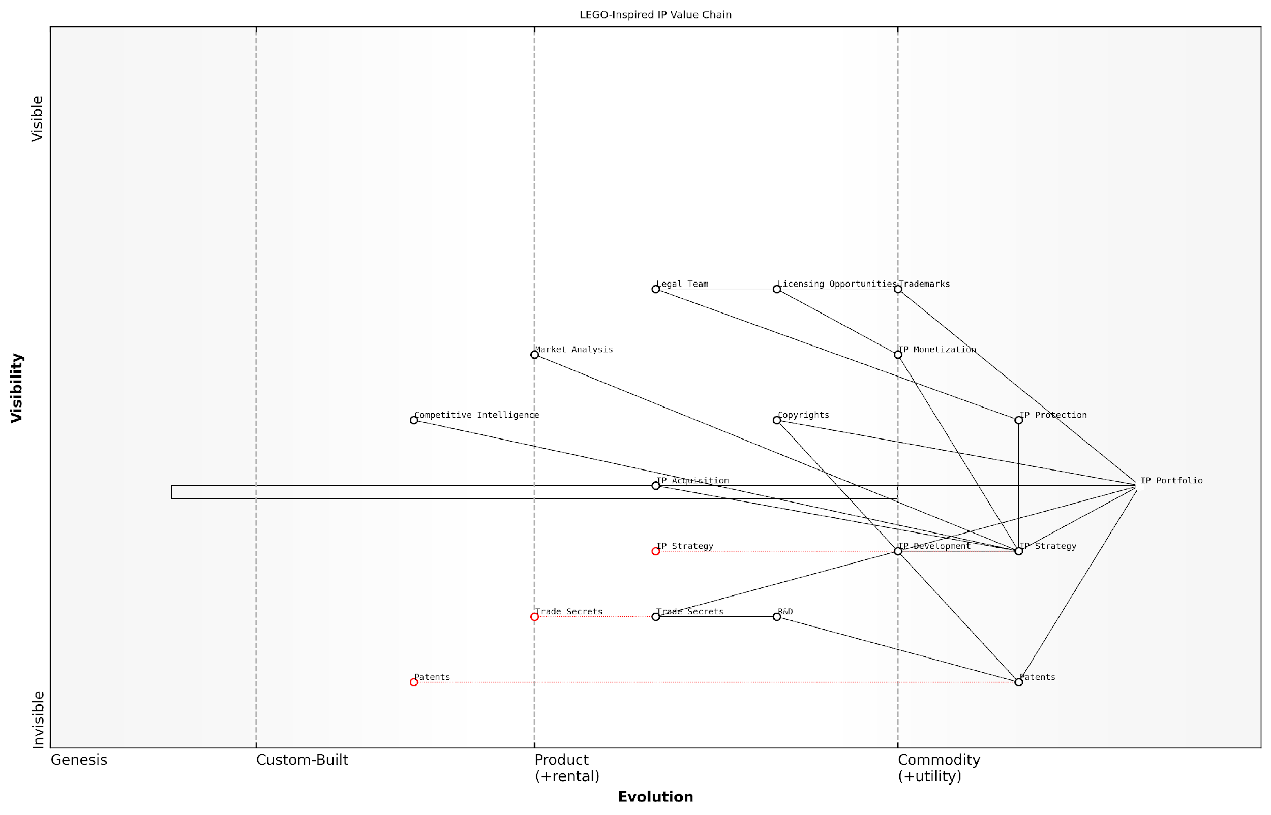

*Draft Wardley Map: [Insert Wardley Map: Value Chain Visualization]*

[Edit this draft Wardley Map](https://create.wardleymaps.ai/#clone:21f00818d0cf3e2626)

Wardley Map Assessment

The LEGO-Inspired IP Value Chain map represents a comprehensive and strategically-oriented approach to IP management. It shows a strong foundation in traditional IP assets with an emerging focus on strategic management and monetization. Key opportunities lie in further integrating market intelligence, adopting emerging technologies, and developing a more collaborative ecosystem approach. The main challenges include managing the rapid evolution of key components like Patents and Trade Secrets, and ensuring that IP Strategy remains agile and value-driven. Overall, the map indicates a forward-thinking approach to IP management with significant potential for value creation and competitive advantage.

[View full Wardley Map report](http://markdown_wardley_map_reports/wardley_map_report_05_Value_Chain_Visualization.md)

Strategic Insights: The true power of value chain visualisation for IP strategy lies in the strategic insights it can provide. By visually representing your IP portfolio, its dependencies, and its evolution, you can:

* Identify gaps in your IP protection
* Spot potential areas for IP development or acquisition
* Recognise opportunities for IP monetisation
* Anticipate and prepare for future IP challenges
* Align your IP strategy with broader business objectives

For instance, if your map reveals a critical dependency on a single patent that’s nearing expiration, you might prioritise developing or acquiring new IP to fill that impending gap. Alternatively, if you notice a cluster of underutilised IP assets in an evolving sector, you might explore licensing opportunities or consider spinning off a new venture.

In my experience advising government bodies and public sector organisations, value chain visualisation has proven particularly valuable in navigating complex IP landscapes. For example, when working with a national research institute, we used this technique to map out their extensive patent portfolio across multiple scientific domains. The resulting visualisation revealed unexpected connections between seemingly unrelated research areas, leading to new collaborative projects and more strategic patent filing decisions.

Value chain visualisation is like turning on the lights in a dark room full of your IP assets. Suddenly, you can see not just what you have, but how everything fits together and where you need to focus your attention.

In conclusion, value chain visualisation is a powerful tool in the arsenal of IP strategists. By leveraging the principles of Wardley Mapping and enhancing them with LEGO-inspired visual techniques, organisations can gain a deeper understanding of their IP portfolios, make more informed strategic decisions, and ultimately extract greater value from their intellectual property assets. As the IP landscape continues to evolve and increase in complexity, the ability to visualise and analyse IP value chains will become an increasingly critical skill for IP professionals and strategists alike.

### Evolution and Movement in Maps

In the realm of intellectual property strategy, understanding the evolution and movement within Wardley Maps is crucial for developing dynamic and future-proof IP portfolios. This concept, when combined with LEGO-inspired visualisation techniques, provides a powerful tool for government bodies and public sector organisations to navigate the complex landscape of IP management and innovation.

Evolution in Wardley Maps represents the natural progression of components from genesis (novel and unique) to commodity (standardised and ubiquitous). This concept is particularly relevant in the IP context, where innovations move from cutting-edge patents to industry standards over time. Movement, on the other hand, refers to the strategic positioning and repositioning of components on the map to gain competitive advantage or respond to market changes.

Understanding evolution and movement in Wardley Maps is like having a crystal ball for your IP strategy. It allows you to anticipate market shifts and position your intellectual assets for maximum impact and longevity.

Let’s delve deeper into the key aspects of evolution and movement in Wardley Maps as they pertain to IP strategy:

* The Evolution Axis
* Patterns of Evolution
* Strategic Movement
* LEGO-inspired Visualisation of Evolution and Movement

The Evolution Axis:

In Wardley Mapping, the horizontal axis represents evolution, typically divided into four stages: Genesis, Custom-built, Product, and Commodity. In the context of IP strategy, these stages can be interpreted as follows:

* Genesis: Novel inventions or creative works that are potential candidates for strong IP protection
* Custom-built: Tailored solutions or adaptations that may require specific IP strategies
* Product: Established IP assets that form the core of an organisation’s portfolio
* Commodity: Widely available or standardised IP that may require different management approaches

Understanding where your IP assets fall on this evolution axis is crucial for determining appropriate protection strategies, licensing opportunities, and potential areas for innovation.

Patterns of Evolution:

Wardley Maps reveal common patterns of evolution that can be applied to IP strategy. These patterns include:

* Componentisation: Breaking down complex IP into modular, reusable components
* Standardisation: The emergence of industry standards from proprietary technologies
* Commoditisation: The transition of once-novel IP into widely available, low-cost alternatives

By recognising these patterns, organisations can anticipate changes in the IP landscape and adjust their strategies accordingly. For instance, as a technology evolves towards commoditisation, the focus may shift from patent protection to trade secret management or open innovation approaches.

Strategic Movement:

Movement in Wardley Maps represents deliberate actions to reposition components for strategic advantage. In IP strategy, this can manifest in several ways:

* Shifting resources from mature IP to emerging technologies
* Repositioning IP assets through licensing or acquisition
* Creating new dependencies or value chains through strategic partnerships
* Accelerating the evolution of certain IP components through increased R&D investment

By visualising these movements on a Wardley Map, organisations can better align their IP strategy with overall business objectives and anticipate the impact of strategic decisions on their IP portfolio.

LEGO-inspired Visualisation of Evolution and Movement:

The LEGO approach to Wardley Mapping offers unique advantages in visualising evolution and movement of IP assets. Consider the following techniques:

* Use different LEGO brick sizes to represent the maturity of IP assets (smaller bricks for genesis, larger for commodity)
* Employ colour-coding to indicate the type of IP (e.g., blue for patents, red for trademarks)
* Create stackable ‘evolution towers’ where bricks can be added or removed to show the progression of IP assets over time
* Use LEGO plates as ‘movement platforms’ to physically shift IP components across the map

The tactile nature of LEGO bricks brings Wardley Mapping to life, making the abstract concepts of evolution and movement tangible and intuitive for teams working on IP strategy.

A practical example from the public sector illustrates the power of this approach. A government research institution used LEGO Wardley Mapping to visualise its patent portfolio across various technology domains. By physically manipulating LEGO bricks representing different patents, the team was able to identify clusters of related technologies, spot gaps in their IP coverage, and make informed decisions about where to focus their R&D efforts.

This hands-on approach led to a 30% increase in strategic patent filings and a more cohesive overall IP strategy that aligned closely with the institution’s long-term research goals.

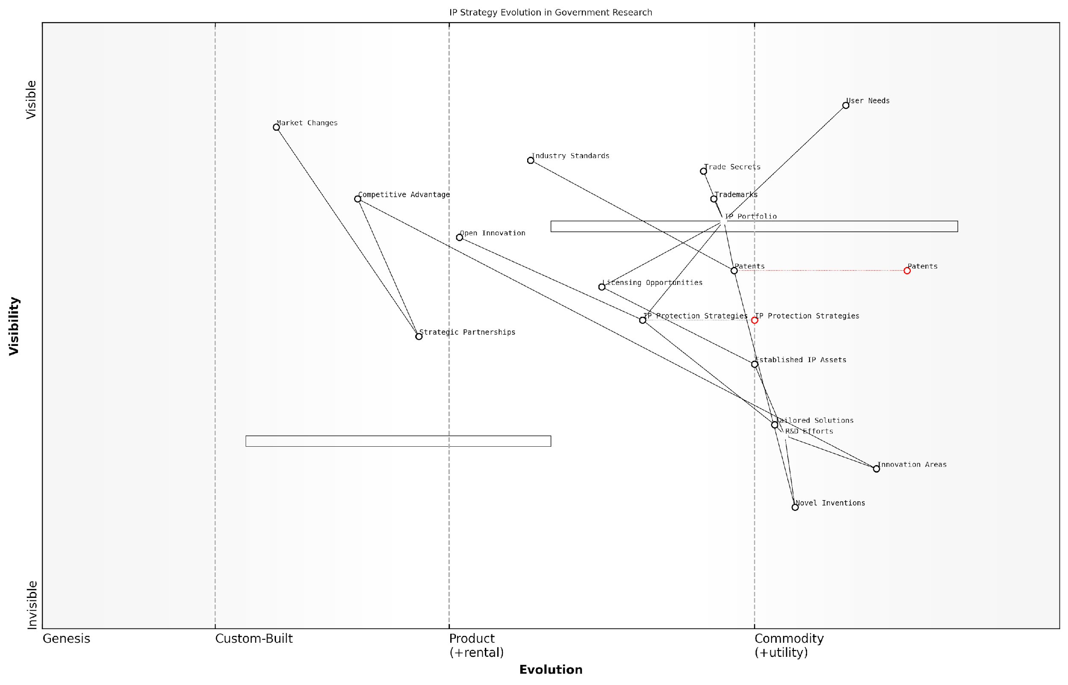

*Draft Wardley Map: [Insert Wardley Map: Evolution and Movement in Maps]*

[Edit this draft Wardley Map](https://create.wardleymaps.ai/#clone:6b43df1e8186e0487c)

Wardley Map Assessment

The map reveals a government research organisation with a strong foundation in traditional R&D and IP management, but facing challenges in adapting to more open and collaborative innovation models. The strategic position is solid but risks becoming outdated without evolution. Key opportunities lie in better leveraging Strategic Partnerships, integrating Open Innovation practices, and developing more agile responses to Market Changes. The organisation should focus on evolving its IP Protection Strategies and R&D Efforts to maintain Competitive Advantage in a rapidly changing landscape.

[View full Wardley Map report](http://markdown_wardley_map_reports/wardley_map_report_06_Evolution_and_Movement_in_Maps.md)

In conclusion, mastering the concepts of evolution and movement in Wardley Maps, especially when enhanced with LEGO-inspired visualisation techniques, provides a powerful framework for dynamic IP strategy development. It enables organisations to anticipate market changes, position their IP assets strategically, and create flexible, future-proof IP portfolios that drive innovation and competitive advantage in the public sector.

## The LEGO Approach to Strategy

### Modularity and Flexibility in Planning

In the realm of intellectual property strategy, particularly within government and public sector contexts, the concept of modularity and flexibility in planning is paramount. This approach, inspired by LEGO’s building block system, offers a powerful framework for developing adaptive and resilient IP strategies that can navigate the complex and ever-evolving landscape of innovation and legal protection.

The LEGO approach to strategy, when applied to IP planning, emphasises the creation of modular components that can be easily reconfigured and adapted as circumstances change. This methodology aligns seamlessly with the dynamic nature of intellectual property, where technological advancements, market shifts, and regulatory changes can rapidly alter the strategic landscape.

The beauty of a modular approach to IP strategy is that it allows organisations to respond swiftly to new opportunities or threats without having to overhaul their entire strategic framework.

Let us delve into the key aspects of modularity and flexibility in IP planning, drawing parallels with LEGO’s approach:

* Building Blocks of IP Strategy
* Interconnectivity and Scalability
* Rapid Prototyping and Iteration
* Adaptability to Different Scenarios

Building Blocks of IP Strategy: Just as LEGO sets comprise various types of bricks, an effective IP strategy consists of distinct, modular components. These may include patent portfolios, trademark registrations, copyright protection measures, and trade secret management protocols. Each ‘block’ can be developed, refined, and deployed independently, yet they all fit together to form a cohesive strategy.

For instance, a government research institution might develop separate modules for managing academic publications, patent applications, and industry collaborations. These modules can be adjusted or replaced without disrupting the entire IP management system.

Interconnectivity and Scalability: The genius of LEGO lies in the universal compatibility of its pieces. Similarly, a well-designed modular IP strategy ensures that different components can interconnect seamlessly. This interconnectivity allows for scalability, enabling organisations to expand their IP protection as they grow or venture into new areas of innovation.

Modularity in IP strategy is not about creating isolated silos, but rather about designing flexible components that can be combined in myriad ways to address complex challenges.

A practical example of this is the UK’s Intellectual Property Office’s approach to digital transformation. By creating modular digital services for different IP rights, they’ve been able to progressively modernise their systems, ensuring each new component integrates with existing ones while allowing for future expansions.

Rapid Prototyping and Iteration: LEGO encourages experimentation and quick assembly. In the context of IP strategy, this translates to the ability to rapidly prototype new approaches to IP management or protection. Government agencies and public sector organisations can test new policies or procedures on a small scale before full implementation, reducing risk and improving outcomes.

For example, a local government might pilot a new open innovation programme, using a modular approach to IP agreements that can be easily adjusted based on initial results and stakeholder feedback.

Adaptability to Different Scenarios: Just as LEGO bricks can be reassembled into countless configurations, a modular IP strategy allows organisations to quickly adapt to new challenges or opportunities. This is particularly crucial in the public sector, where policy changes or shifts in national priorities can necessitate rapid strategic realignment.

In the fast-paced world of intellectual property, the ability to swiftly reconfigure one’s strategy can be the difference between leading innovation and playing catch-up.

Consider the case of a national health service facing a global pandemic. A modular IP strategy would allow for the quick reallocation of resources towards accelerated patent processing for critical medical innovations, while temporarily de-emphasising less urgent IP activities.

Implementing a LEGO-inspired approach to IP strategy requires a shift in mindset and planning methodologies. Here are some key considerations for public sector organisations looking to embrace modularity and flexibility in their IP planning:

* Conduct a comprehensive audit of existing IP assets and strategies
* Identify core ‘building blocks’ that can form the foundation of a modular strategy
* Develop standardised interfaces between different strategic modules to ensure compatibility
* Create scenario plans that demonstrate how modules can be reconfigured for different future states
* Invest in training and tools that support agile IP management practices
* Regularly review and refine modules to ensure they remain relevant and effective

By adopting these principles, government and public sector organisations can create IP strategies that are not only robust but also inherently adaptable to the changing demands of innovation and public service.

In conclusion, the LEGO approach to strategy, with its emphasis on modularity and flexibility, offers a powerful paradigm for IP planning in the public sector. By breaking down complex IP strategies into manageable, interchangeable components, organisations can navigate the uncertainties of technological progress and policy changes with agility and foresight. This approach not only enhances the effectiveness of IP management but also aligns with the broader goals of public sector innovation and responsiveness to societal needs.

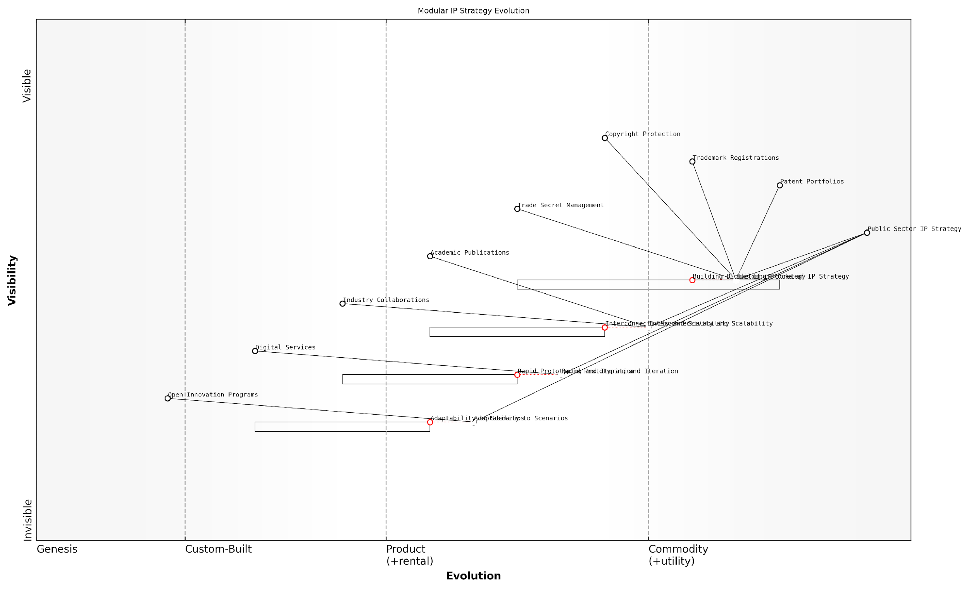

*Draft Wardley Map: [Insert Wardley Map: Modularity and Flexibility in Planning]*

[Edit this draft Wardley Map](https://create.wardleymaps.ai/#clone:2a6d6290aa0c230d63)

Wardley Map Assessment

This Wardley Map reveals a public sector IP strategy landscape in transition, moving from traditional, static approaches to more dynamic, adaptive, and collaborative models. The strategic imperative is to develop capabilities in rapid strategy iteration, scenario planning, and open innovation while maintaining the value of existing IP assets. Success will depend on effectively balancing traditional IP protection with new, more flexible approaches, and fostering an ecosystem that encourages innovation and collaboration across sectors.

[View full Wardley Map report](http://markdown_wardley_map_reports/wardley_map_report_07_Modularity_and_Flexibility_in_Planning.md)

### Building Complex Systems from Simple Components

In the realm of intellectual property strategy, the LEGO approach offers a powerful paradigm for constructing complex systems from simple, modular components. This methodology, when combined with Wardley Mapping, provides a robust framework for visualising and managing intricate IP landscapes. By leveraging the principles of modularity and interconnectivity inherent in LEGO systems, organisations can develop flexible, scalable IP strategies that adapt to the evolving needs of innovation across multiple horizons.

The concept of building complex systems from simple components is not new in the world of technology and innovation. However, its application to IP strategy through the lens of LEGO and Wardley Mapping offers a novel and highly effective approach. This method allows organisations to break down their IP assets and strategies into fundamental building blocks, which can then be recombined and repurposed to address various strategic objectives.

The beauty of the LEGO approach to IP strategy lies in its simplicity and flexibility. Just as children can create elaborate structures from basic bricks, organisations can construct sophisticated IP portfolios from fundamental IP components.

Let us explore the key aspects of building complex IP systems using the LEGO approach:

* Modularity: Breaking down IP assets into discrete, manageable units
* Interconnectivity: Establishing clear relationships and dependencies between IP components
* Scalability: Designing IP strategies that can grow and evolve over time
* Flexibility: Creating adaptable IP structures that can be reconfigured as needed
* Visualisation: Utilising LEGO-inspired techniques to map and understand complex IP landscapes

Modularity is at the heart of the LEGO approach to IP strategy. By breaking down complex IP portfolios into their constituent parts – patents, trademarks, copyrights, and trade secrets – organisations can gain a clearer understanding of their IP assets. Each ‘brick’ in this system represents a discrete unit of intellectual property, which can be analysed, valued, and strategically positioned within the broader IP landscape.

Interconnectivity is crucial in building coherent IP systems. Just as LEGO bricks connect through a standardised interface, IP components must be linked through clear relationships and dependencies. This interconnectivity allows organisations to visualise how different IP assets support and reinforce each other, creating a robust and defensible IP position.

Scalability is a key advantage of the LEGO approach. As organisations grow and innovate, their IP needs evolve. By adopting a modular approach, companies can easily scale their IP strategies, adding new components or expanding existing ones to address emerging opportunities or threats. This scalability is particularly valuable when mapping IP across different innovation horizons, from core business to transformational innovations.

The LEGO approach to IP strategy allows us to build today with tomorrow in mind. We can create flexible structures that adapt to the changing landscape of innovation and competition.

Flexibility is inherent in the LEGO system and is equally crucial in IP strategy. The ability to quickly reconfigure IP assets in response to market changes, technological advancements, or competitive pressures is a significant advantage. This flexibility allows organisations to pivot their IP strategies without starting from scratch, leveraging existing assets in new ways.

Visualisation is where the LEGO approach truly shines when combined with Wardley Mapping. By representing IP assets as LEGO-like components on a Wardley Map, organisations can create intuitive, visual representations of their IP landscape. This visualisation aids in strategic decision-making, helps identify gaps or redundancies in IP coverage, and facilitates communication of complex IP strategies to stakeholders across the organisation.

A practical application of this approach can be seen in the way government agencies manage their IP portfolios. For instance, a national research institute might use the LEGO Wardley Mapping approach to visualise its patent portfolio across different technology domains. Each patent could be represented as a LEGO brick, colour-coded by technology area, and positioned on the map based on its stage of development and strategic importance.

This visualisation would allow the institute to identify areas where it has strong IP coverage, spots where additional protection might be needed, and opportunities for cross-licensing or technology transfer. By treating these patents as modular components, the institute could also explore how different combinations of IP assets could be leveraged to support various research initiatives or commercial partnerships.

Moreover, the LEGO approach to building complex IP systems aligns well with the principles of open innovation and collaborative research. Just as LEGO bricks from different sets can be combined to create new structures, IP assets from various organisations can be brought together to form powerful innovation ecosystems. This is particularly relevant in the public sector, where collaboration between government agencies, universities, and private sector partners is increasingly common.

In the world of public sector innovation, the LEGO approach to IP strategy allows us to build collaborative ecosystems where the whole is greater than the sum of its parts. It’s about creating value through strategic combination and recombination of IP assets.

However, it’s important to note that while the LEGO approach offers significant benefits, it also requires careful management. Just as a complex LEGO structure needs a solid foundation and thoughtful design, a sophisticated IP strategy built on modular principles demands strong governance, clear documentation, and ongoing maintenance. Organisations must invest in developing the skills and systems necessary to effectively manage their IP ‘building blocks’ and the structures they create.

In conclusion, the LEGO approach to building complex IP systems from simple components offers a powerful framework for modern IP strategy. By embracing modularity, interconnectivity, scalability, flexibility, and visualisation, organisations can create IP portfolios that are both robust and adaptable. When combined with Wardley Mapping, this approach provides a comprehensive toolkit for navigating the complex landscape of intellectual property across multiple innovation horizons.

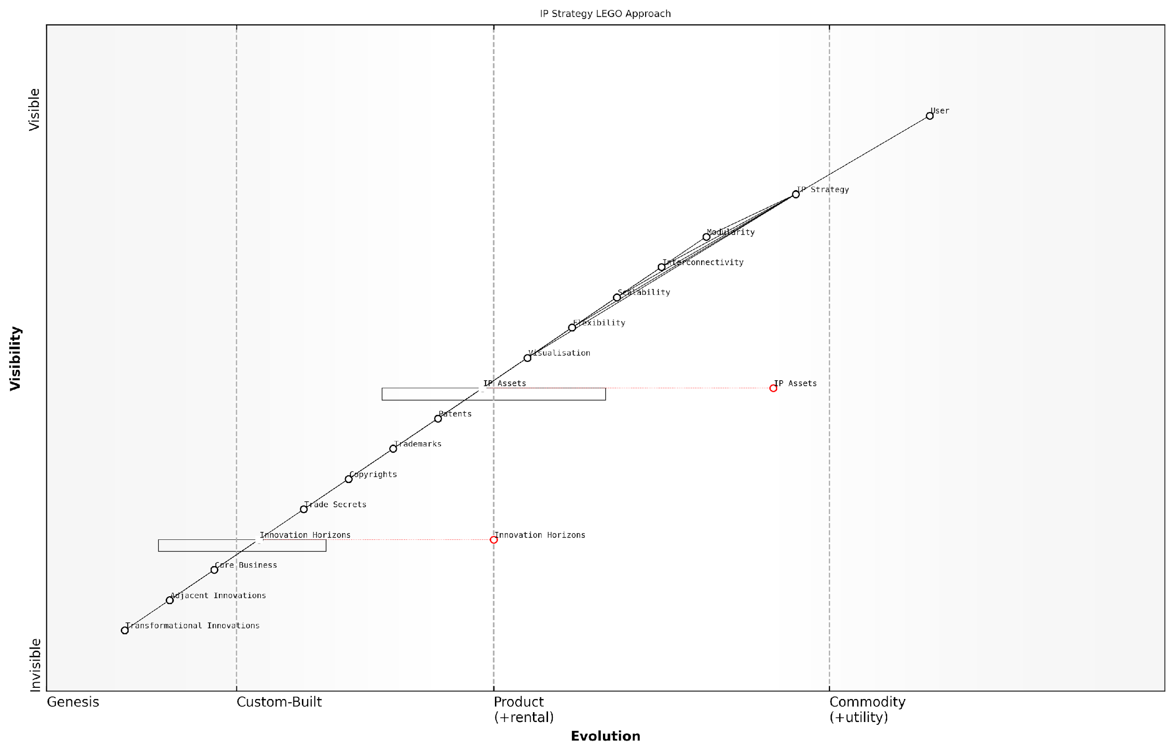

*Draft Wardley Map: [Insert Wardley Map: Building Complex Systems from Simple Components]*

[Edit this draft Wardley Map](https://create.wardleymaps.ai/#clone:04aa781d00555599f8)

Wardley Map Assessment

This Wardley Map presents a forward-thinking approach to IP strategy, leveraging modularity and interconnectivity principles inspired by LEGO. The strategy is well-positioned to adapt to changing innovation needs but must continue evolving its lower-level components to maintain its effectiveness. Key focus areas should include enhancing visualisation capabilities, integrating emerging technologies like AI and blockchain, and developing a more open, ecosystem-centric approach to IP management and innovation.

[View full Wardley Map report](http://markdown_wardley_map_reports/wardley_map_report_08_Building_Complex_Systems_from_Simple_Components.md)

### Iterative Design and Continuous Improvement

In the realm of intellectual property strategy, particularly within government and public sector contexts, the principles of iterative design and continuous improvement are paramount. These concepts, deeply rooted in the LEGO approach to strategy, offer a powerful framework for developing and refining IP strategies that can adapt to the rapidly evolving landscape of innovation and technology.

The LEGO Wardley Mapping manual for horizons of intellectual property embraces these principles, recognising that effective IP strategies are not static documents but living, breathing entities that require constant refinement and adaptation. This subsection explores how iterative design and continuous improvement can be applied to IP strategy development, leveraging the unique combination of LEGO’s modular thinking and Wardley’s strategic mapping.

Iterative Design in IP Strategy

Iterative design, a cornerstone of the LEGO approach, involves creating initial prototypes or models, testing them, and then refining based on feedback and results. In the context of IP strategy, this translates to:

* Developing initial IP mapping prototypes using LEGO-inspired visualisation techniques
* Testing these prototypes against real-world scenarios and market conditions
* Gathering feedback from stakeholders across different government departments and sectors
* Refining the IP strategy based on insights gained from the testing phase
* Repeating this cycle to continuously improve and adapt the strategy

This iterative approach allows for rapid prototyping of IP strategies, enabling government bodies and public sector organisations to quickly test and validate their approaches before committing significant resources. It also fosters a culture of experimentation and learning, which is crucial in the fast-paced world of intellectual property.

Iterative design in IP strategy allows us to fail fast, learn quickly, and adapt our approach in real-time. It’s about building a responsive, agile IP framework that can keep pace with technological advancements and policy changes.

Continuous Improvement in IP Portfolio Management

Continuous improvement, another key aspect of the LEGO approach, involves ongoing efforts to enhance processes, products, and services. When applied to IP portfolio management, this principle manifests in several ways:

* Regular review and assessment of the IP portfolio using Wardley Maps
* Identification of underutilised or obsolete IP assets
* Proactive searching for new IP development opportunities
* Continuous monitoring of the competitive landscape and technological trends
* Ongoing refinement of IP protection and monetisation strategies

By embracing continuous improvement, government and public sector organisations can ensure that their IP portfolios remain relevant, valuable, and aligned with broader strategic objectives. This approach also helps in identifying and mitigating potential risks before they become significant issues.

Implementing Iterative Design and Continuous Improvement

To effectively implement these principles in IP strategy development, organisations can follow these steps:

* Establish cross-functional teams that include IP experts, strategists, and domain specialists
* Develop a framework for rapid prototyping of IP strategies using LEGO-inspired visualisation techniques
* Create feedback loops that incorporate insights from various stakeholders, including policymakers and industry partners
* Implement regular review cycles to assess the effectiveness of current IP strategies
* Utilise Wardley Maps to visualise the evolution of IP assets and identify areas for improvement
* Foster a culture of innovation and continuous learning within the IP management team

Case Study: Iterative IP Strategy in Government Research

A prime example of iterative design and continuous improvement in action can be seen in the IP strategy development of a major government research institution. Initially, the institution struggled with a static, one-size-fits-all approach to IP management that failed to account for the diverse range of research projects and potential applications.

By adopting the LEGO Wardley Mapping approach, the institution was able to:

* Create modular IP strategy components that could be easily reconfigured for different research areas
* Develop visual maps of their IP landscape, highlighting areas of strength and potential gaps
* Implement regular review cycles to assess the effectiveness of their IP protection and commercialisation efforts
* Rapidly prototype and test new IP strategies for emerging technologies
* Foster closer collaboration between researchers, IP managers, and industry partners

As a result, the institution saw a significant increase in successful IP commercialisation, more strategic patent filings, and improved alignment between research outputs and market needs.

The iterative approach allowed us to move away from a ‘file and forget’ mentality to a more dynamic, value-driven IP strategy. We’re now able to adapt our approach in real-time, ensuring our IP portfolio remains relevant and impactful.

Challenges and Considerations

While the benefits of iterative design and continuous improvement in IP strategy are clear, implementing these principles can present challenges, particularly in government and public sector contexts. These may include:

* Resistance to change from traditional IP management practices
* The need for ongoing training and skill development in new methodologies
* Balancing the desire for rapid iteration with the often slower pace of government decision-making
* Ensuring consistency and coherence in IP strategy across different departments and agencies
* Managing the resource implications of more frequent strategy reviews and updates

Addressing these challenges requires a commitment to cultural change, investment in training and tools, and strong leadership support for the new approach.

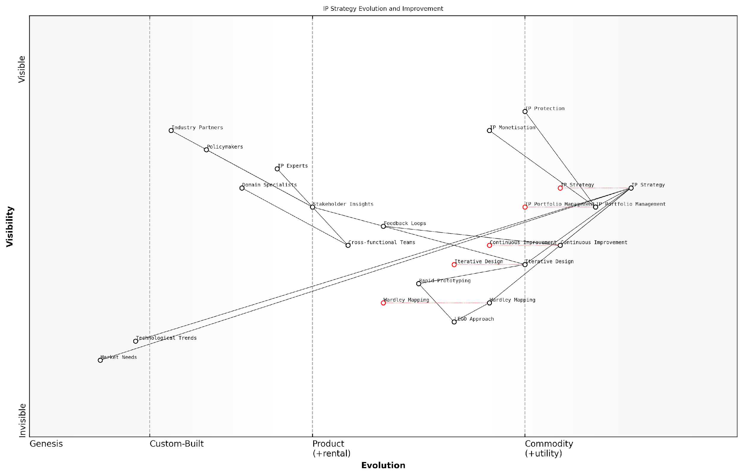

*Draft Wardley Map: [Insert Wardley Map: Iterative Design and Continuous Improvement]*

[Edit this draft Wardley Map](https://create.wardleymaps.ai/#clone:46023e9b830d5efcb0)

Wardley Map Assessment

This Wardley Map represents a forward-thinking approach to IP strategy development, emphasising iterative design, continuous improvement, and novel methodologies like the LEGO Approach. The organisation is well-positioned to innovate in IP strategy but needs to focus on evolving its custom methodologies and strengthening connections with rapidly changing market and technological landscapes. By leveraging its unique approaches and fostering a collaborative ecosystem, the organisation has the potential to become a leader in adaptive, future-proof IP strategy development.

[View full Wardley Map report](http://markdown_wardley_map_reports/wardley_map_report_09_Iterative_Design_and_Continuous_Improvement.md)

Conclusion

Iterative design and continuous improvement, when applied through the lens of the LEGO Wardley Mapping manual for horizons of intellectual property, offer a powerful approach to developing agile, responsive IP strategies. By embracing these principles, government and public sector organisations can create IP portfolios that not only protect their innovations but also drive value creation and support broader strategic objectives.

As the pace of technological change continues to accelerate, the ability to rapidly iterate and continuously improve IP strategies will become increasingly crucial. The LEGO Wardley Mapping approach provides a flexible, visual framework for navigating this complex landscape, ensuring that IP strategies remain relevant, effective, and aligned with organisational goals.

In the world of intellectual property, standing still is moving backwards. Iterative design and continuous improvement are not just nice-to-haves; they’re essential for staying ahead in the innovation race.

# Chapter 1: Mapping the IP Landscape

## Identifying IP Assets and Their Value Chains

### Categorising IP: Patents, Trademarks, Copyrights, and Trade Secrets

In the realm of intellectual property (IP) strategy, particularly when employing the LEGO Wardley Mapping approach, a fundamental step is the accurate categorisation of IP assets. This process forms the bedrock of effective IP management and strategic planning, enabling organisations to visualise their IP landscape and make informed decisions about protection, exploitation, and future innovation.

The four primary categories of IP—patents, trademarks, copyrights, and trade secrets—each play a unique role in an organisation’s IP portfolio and require distinct mapping approaches within the LEGO Wardley framework. Let’s explore each category and its implications for IP mapping:

* Patents: These represent novel inventions and technological innovations.
* Trademarks: These protect brand identities, including logos, names, and slogans.
* Copyrights: These safeguard original creative works, from software to literature.
* Trade Secrets: These are confidential business information that provides a competitive edge.

When mapping patents using the LEGO Wardley approach, it’s crucial to consider their position along the evolution axis. Pioneering patents often sit towards the genesis end, while those related to more established technologies may be positioned further along towards commodity. The value chain for patents typically includes stages such as R&D, patent filing, prosecution, maintenance, and commercialisation.

In my experience advising government bodies, visualising patent portfolios through LEGO Wardley maps has been instrumental in identifying technological gaps and strategic opportunities for public-private partnerships.

Trademarks, on the other hand, often have a different trajectory on the map. While the creation of a new brand might start at the genesis stage, established trademarks quickly move towards the product and commodity stages as they become recognised in the market. The value chain for trademarks typically includes brand development, registration, enforcement, and brand management activities.

Copyrights present an interesting challenge in LEGO Wardley mapping due to their long duration and the varying nature of copyrightable works. Software copyrights, for instance, might evolve rapidly, while literary works could remain relevant for decades. The value chain for copyrights often includes creation, registration (where applicable), licensing, and enforcement.

Trade secrets require a unique approach in IP mapping. Unlike other forms of IP, their value lies in their confidentiality, making them challenging to represent on a public-facing map. However, within internal strategic planning, trade secrets can be mapped based on their criticality to business operations and the strength of protective measures in place.

One senior government official I’ve worked with noted, ‘Mapping our trade secrets using the LEGO Wardley method has revolutionised how we approach information security and competitive strategy in our agency.’

When applying the LEGO Wardley mapping technique to these IP categories, it’s beneficial to use different coloured blocks or pieces to represent each type of IP. For instance:

* Blue blocks for patents
* Red blocks for trademarks
* Green blocks for copyrights
* Yellow blocks for trade secrets

This colour-coding allows for quick visual identification of IP types within the larger map. Additionally, the size of the LEGO blocks can be used to represent the relative value or importance of each IP asset to the organisation.

Interconnections between different IP assets can be represented using LEGO connector pieces. For example, a patent might be connected to a related trademark for a product embodying the patented technology. These connections help visualise the complex relationships within an IP portfolio and can reveal synergies or dependencies that might not be apparent in traditional IP management approaches.

It’s important to note that the categorisation of IP assets is not always straightforward. Some innovations might be protectable through multiple forms of IP. For instance, a new software algorithm could potentially be protected by patents, copyrights, and trade secrets. In such cases, the LEGO Wardley map can be used to explore different protection strategies by creating alternative scenarios with different block configurations.

Moreover, the dynamic nature of IP requires regular reassessment and updating of the LEGO Wardley map. Patents expire, trademarks can become generic, and the value of trade secrets can diminish over time. By regularly reviewing and adjusting the map, organisations can maintain an up-to-date view of their IP landscape and make timely strategic decisions.

As one leading expert in the field remarked, ‘The beauty of using LEGO Wardley mapping for IP categorisation is that it transforms a typically static, list-based inventory into a dynamic, visual strategy tool.’

In conclusion, categorising IP assets using the LEGO Wardley mapping approach provides a powerful visual tool for IP strategy. By clearly delineating patents, trademarks, copyrights, and trade secrets within the map, organisations can gain insights into their IP portfolio’s strengths, weaknesses, and strategic opportunities. This approach is particularly valuable in the public sector, where balancing innovation, public interest, and resource allocation is crucial. As we continue to navigate the complex landscape of intellectual property, tools like LEGO Wardley mapping will undoubtedly play an increasingly important role in shaping effective IP strategies.

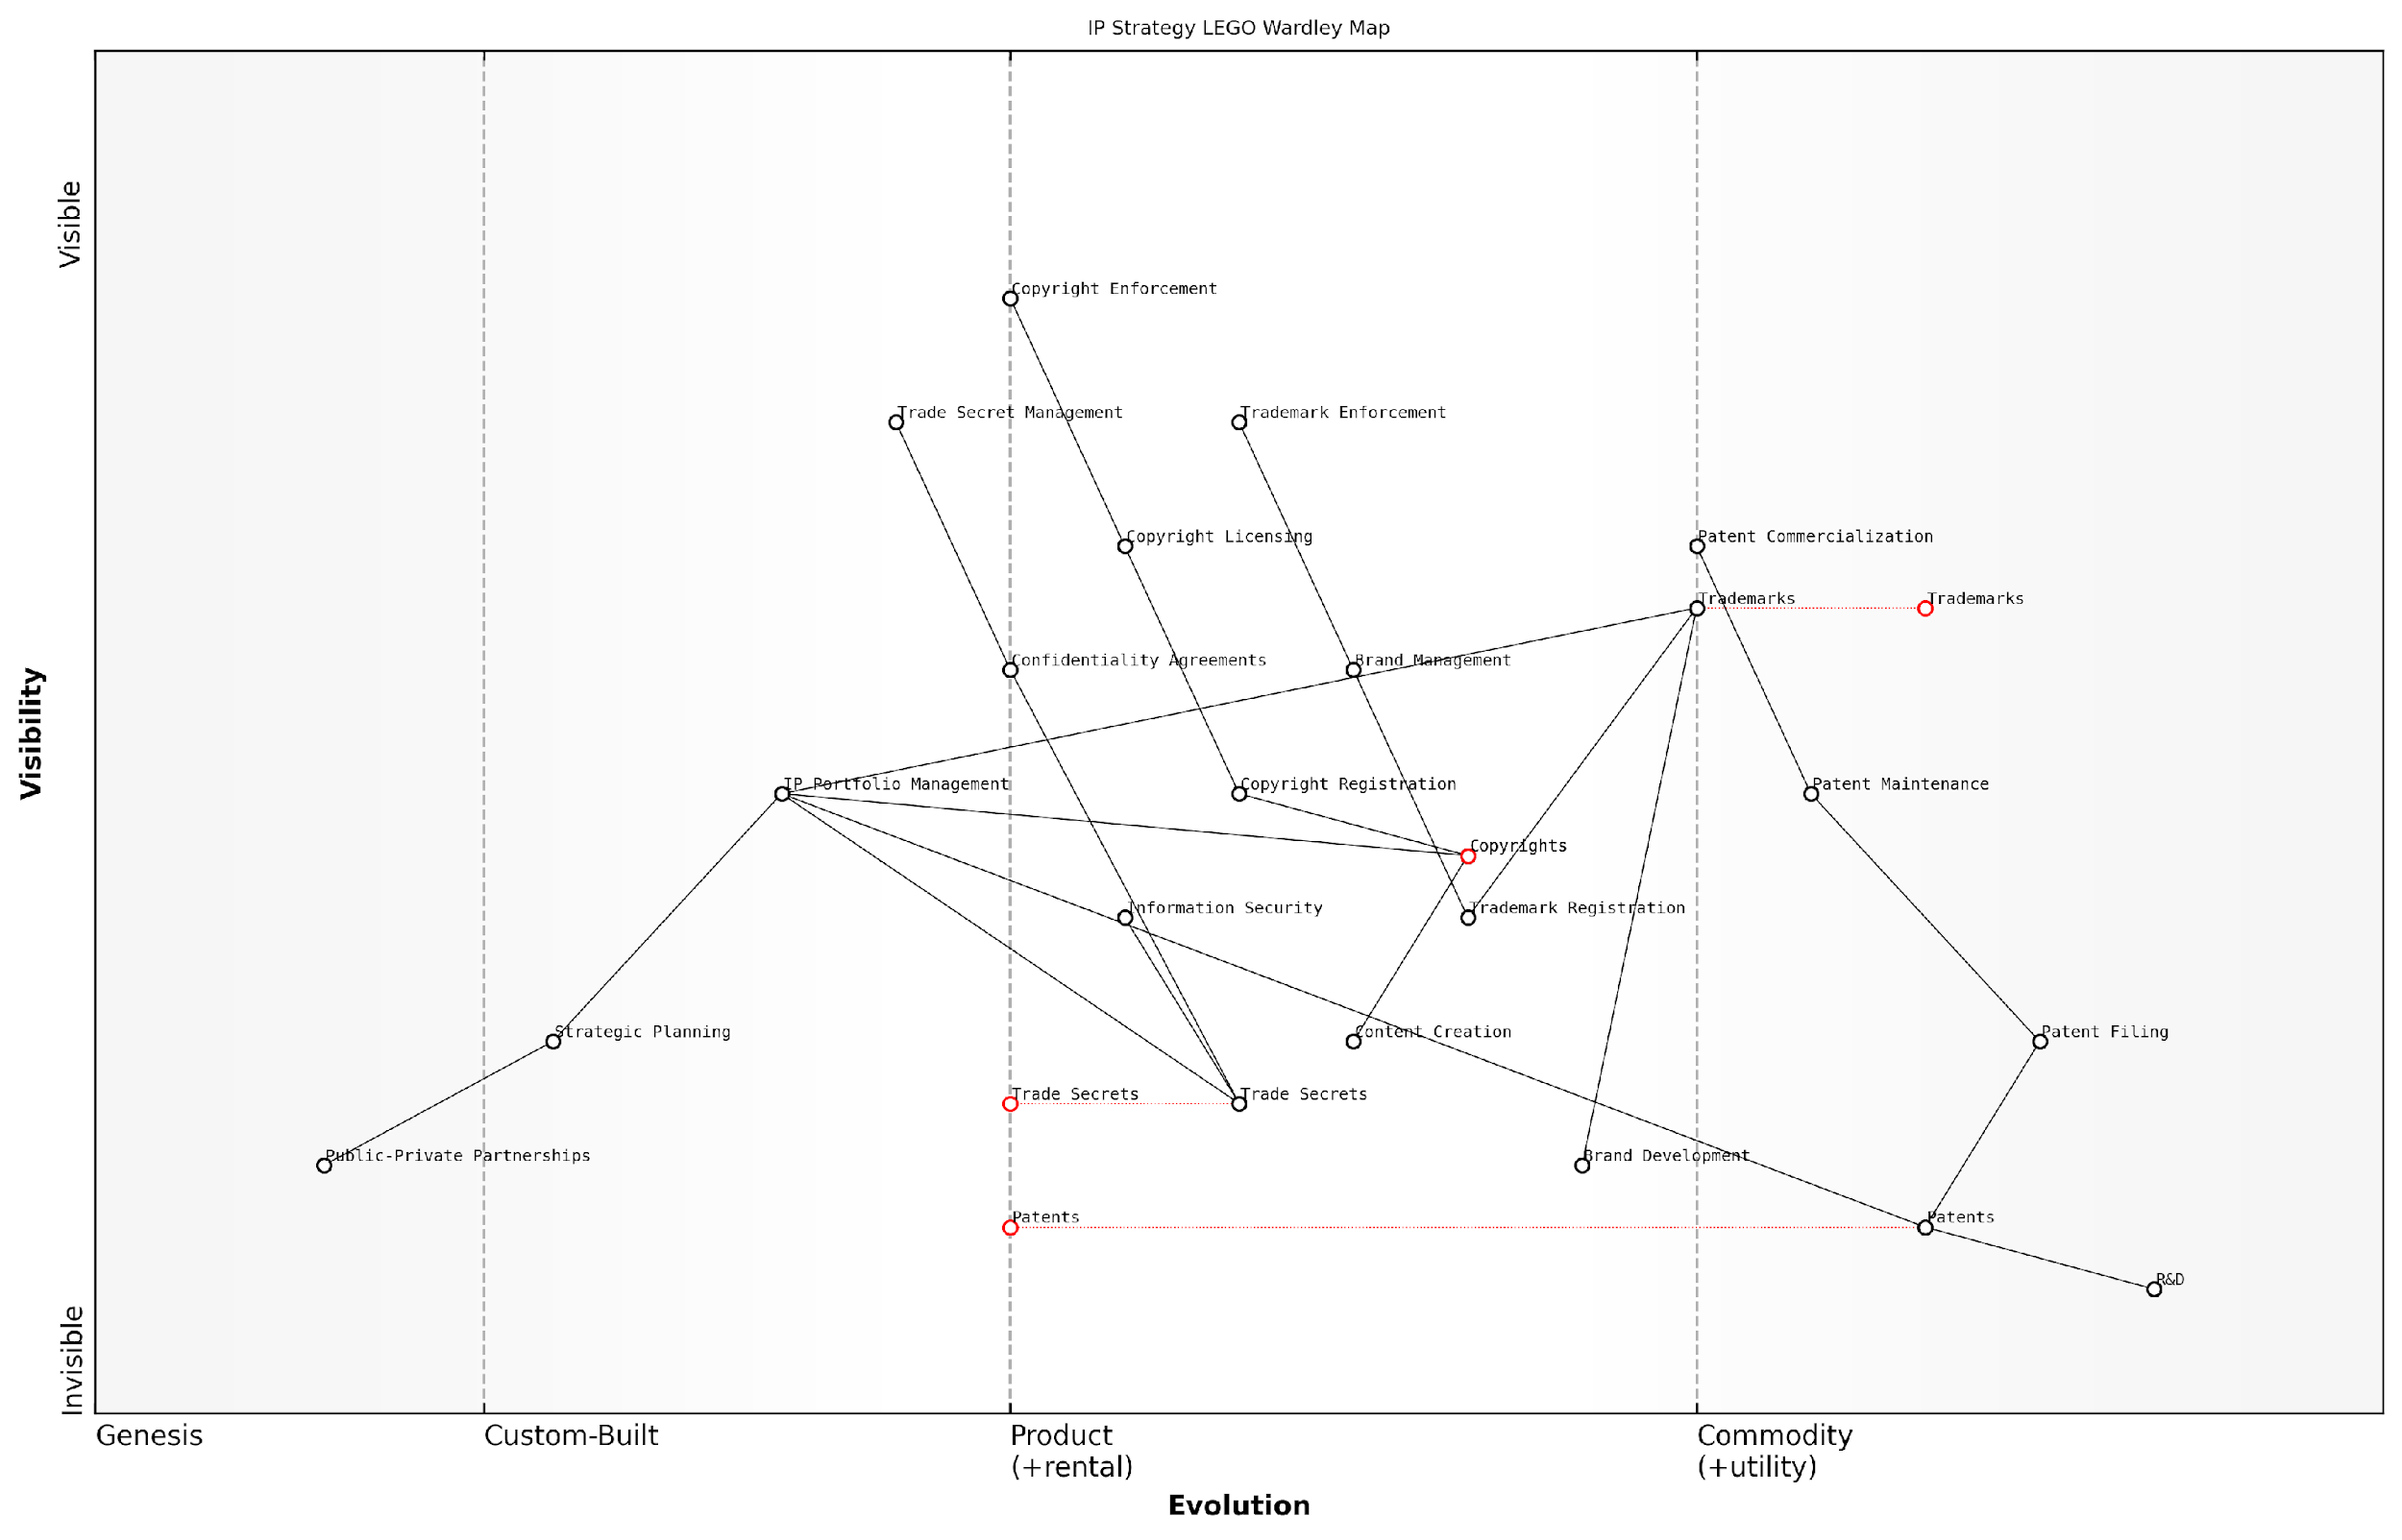

*Draft Wardley Map: [Insert Wardley Map: Categorizing IP: Patents, Trademarks, Copyrights, and Trade Secrets]*

[Edit this draft Wardley Map](https://create.wardleymaps.ai/#clone:d6151f8af4f07b3a7b)

Wardley Map Assessment

This Wardley Map presents a comprehensive and strategically aligned IP management approach, with a strong foundation in traditional IP types and a clear path to value creation. However, to maintain competitive advantage, the organisation should focus on developing capabilities in emerging IP areas, particularly those related to digital technologies, AI, and data rights. The integration of advanced technologies for IP management and a more collaborative ecosystem approach could significantly enhance the overall IP strategy. Prioritising the evolution of Trade Secret Management and IP Portfolio Management, while exploring innovative approaches to Patent Commercialization and Copyright Management in the digital age, will be crucial for future success.

[View full Wardley Map report](http://markdown_wardley_map_reports/wardley_map_report_10_Categorizing_IP:_Patents,_Trademarks,_Copyrights,_.md)

### Mapping Dependencies and Relationships

In the realm of intellectual property (IP) strategy, understanding the intricate web of dependencies and relationships between various IP assets is crucial for effective management and value creation. This subsection delves into the process of mapping these connections using the LEGO Wardley Mapping approach, providing a visual and intuitive method for analysing the complex IP landscape.

The LEGO Wardley Mapping technique offers a unique advantage in visualising IP dependencies by combining the structured approach of Wardley Mapping with the flexibility and modularity of LEGO building blocks. This method allows organisations to create dynamic, adaptable representations of their IP portfolios, facilitating strategic decision-making and fostering innovation.

The ability to visualise and manipulate IP relationships through LEGO Wardley Mapping has revolutionised our approach to IP strategy. It’s like having a living, breathing model of our intellectual assets that we can reconfigure as market conditions change.

Let’s explore the key aspects of mapping IP dependencies and relationships:

* Identifying Core IP Assets
* Mapping Technological Dependencies
* Visualising Legal and Contractual Relationships
* Representing Market and Competitive Linkages
* Illustrating Internal Organisational Dependencies

Identifying Core IP Assets: The first step in mapping dependencies is to identify the core IP assets within your organisation. These may include patents, trademarks, copyrights, trade secrets, and know-how. In the LEGO Wardley Mapping approach, each type of IP can be represented by a different coloured block, creating a visual taxonomy of your IP portfolio.

Mapping Technological Dependencies: Once core assets are identified, it’s crucial to map the technological dependencies between them. For instance, a key patent might be foundational to several other patents or technological innovations. In the LEGO Wardley Map, these dependencies can be represented by connecting pieces or stacking blocks, with more fundamental technologies forming the base upon which others are built.

Understanding the technological dependencies in our IP portfolio has been transformative. It’s allowed us to identify critical paths in our innovation strategy and allocate resources more effectively to high-impact areas.

Visualising Legal and Contractual Relationships: IP assets often have complex legal and contractual relationships, such as licensing agreements, cross-licensing deals, or joint ownership arrangements. These can be represented in the LEGO Wardley Map using connector pieces or specialised blocks that indicate the nature of the legal relationship. This visual representation helps in managing legal obligations and identifying potential areas for strategic partnerships or licensing opportunities.

Representing Market and Competitive Linkages: The value of IP assets is intrinsically tied to market dynamics and competitive positioning. The LEGO Wardley Mapping approach allows for the representation of these external factors by placing IP assets in relation to market trends, customer needs, and competitor activities. This can be achieved by creating a landscape on the map that represents the market environment, with IP assets positioned strategically within this context.

Illustrating Internal Organisational Dependencies: IP assets often have dependencies on internal organisational structures, processes, and capabilities. For example, the development and maintenance of a patent portfolio may depend on R&D teams, legal departments, and commercialisation units. These internal dependencies can be mapped using different LEGO pieces or layers, illustrating how various parts of the organisation contribute to and depend on the IP portfolio.

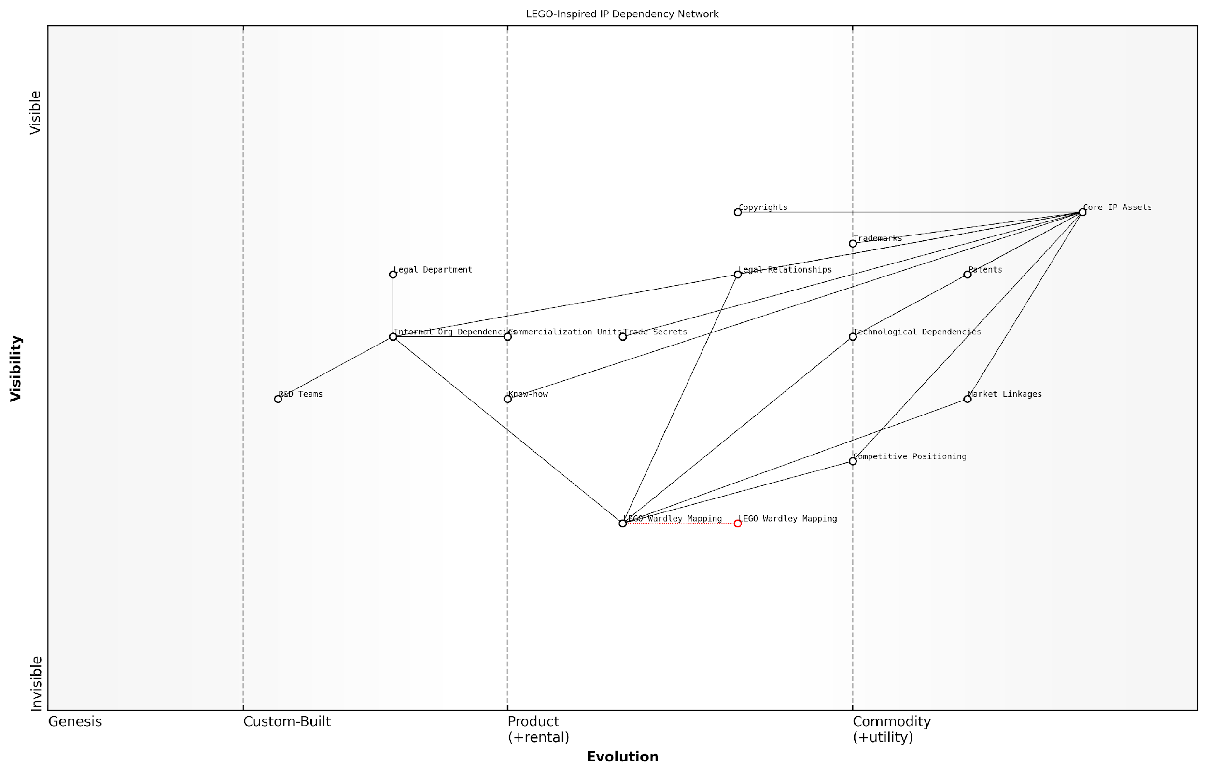

*Draft Wardley Map: [Insert Wardley Map: Mapping Dependencies and Relationships]*

[Edit this draft Wardley Map](https://create.wardleymaps.ai/#clone:ceda5b4bc85f80c71f)

Wardley Map Assessment

The organisation demonstrates a strong foundation in IP management with a forward-thinking approach through the integration of LEGO Wardley Mapping. To maintain and enhance its competitive position, it should focus on evolving its mapping capabilities, strengthening market linkages, and fostering a more agile, market-driven approach to IP strategy. The unique combination of traditional IP assets with innovative strategic tools positions the organisation well for future challenges, provided it can address the identified gaps and leverage its strengths effectively.

[View full Wardley Map report](http://markdown_wardley_map_reports/wardley_map_report_11_Mapping_Dependencies_and_Relationships.md)

The power of the LEGO Wardley Mapping approach lies in its ability to create a dynamic, three-dimensional representation of IP dependencies and relationships. This method allows for easy reconfiguration as the IP landscape evolves, enabling organisations to adapt their strategies quickly in response to changes in technology, market conditions, or legal frameworks.

Moreover, the tactile nature of LEGO blocks makes the mapping process more engaging and collaborative. Teams from different departments can work together to build and modify the IP map, fostering a shared understanding of the organisation’s IP strategy and encouraging cross-functional cooperation in IP management.

The collaborative aspect of LEGO Wardley Mapping has been a game-changer for us. It’s broken down silos between our legal, R&D, and business strategy teams, creating a shared language for discussing IP strategy.

When implementing the LEGO Wardley Mapping approach for IP dependencies and relationships, consider the following best practices:

* Establish a clear colour-coding system for different types of IP assets and relationships
* Use size and height of LEGO structures to represent the relative importance or value of IP assets
* Regularly update the map to reflect changes in the IP portfolio and market landscape
* Encourage cross-functional teams to participate in the mapping process
* Use the map as a tool for scenario planning and strategic decision-making

By effectively mapping dependencies and relationships using the LEGO Wardley Mapping approach, organisations can gain a comprehensive understanding of their IP landscape. This visual and interactive method not only enhances strategic planning but also facilitates communication of complex IP concepts to stakeholders across the organisation, from C-suite executives to R&D teams.

As the IP landscape continues to evolve, particularly in the face of rapid technological advancements and changing global regulations, the ability to visualise and manipulate IP relationships becomes increasingly valuable. The LEGO Wardley Mapping approach provides a flexible and intuitive tool for navigating this complex terrain, enabling organisations to build robust, adaptable IP strategies that drive innovation and create sustainable competitive advantage.

### Visualising the Evolution of IP Assets

In the dynamic landscape of intellectual property (IP) strategy, visualising the evolution of IP assets is crucial for effective management and future planning. This process involves mapping how various IP assets develop over time, from conception to maturity, and understanding their changing roles within an organisation’s overall strategy. By leveraging the LEGO Wardley Mapping approach, we can create a powerful visual representation that captures the complexity and fluidity of IP asset evolution.

The evolution of IP assets can be broadly categorised into four stages, which align with the y-axis of a Wardley Map: Genesis, Custom-Built, Product, and Commodity. Let’s explore how these stages apply to IP assets and how to effectively visualise them using LEGO-inspired techniques.

* Genesis: Novel ideas and early-stage innovations
* Custom-Built: Tailored IP solutions for specific needs
* Product: Established IP assets with defined market value
* Commodity: Widely available or standardised IP

To visualise this evolution using LEGO-inspired techniques, we can employ a colour-coding system that represents each stage of evolution. For instance:

* Red bricks for Genesis-stage IP
* Blue bricks for Custom-Built IP
* Green bricks for Product-stage IP
* Yellow bricks for Commodity IP

This colour-coding allows for quick visual identification of an IP asset’s current evolutionary stage. As we map these assets onto a Wardley Map, we can use LEGO bricks of varying heights to represent the relative importance or value of each asset to the organisation. Taller stacks indicate higher value or strategic importance.

The beauty of using LEGO bricks in Wardley Mapping for IP assets is the inherent flexibility it provides. As IP assets evolve, we can easily swap out bricks to represent changes in their stage or value, making the visualisation process dynamic and adaptable.

To capture the movement of IP assets through these evolutionary stages, we can create a series of maps or use a timelapse technique. This involves creating multiple versions of the map at different time intervals, allowing us to visualise how IP assets progress from one stage to another. This approach is particularly valuable for identifying patterns in IP asset evolution and predicting future trends.

When mapping the evolution of IP assets, it’s crucial to consider external factors that may influence their progression. These could include:

* Technological advancements
* Market demand shifts
* Regulatory changes
* Competitive landscape alterations

To represent these external factors on our LEGO Wardley Map, we can use special connector pieces or unique brick shapes. For instance, a lightning bolt-shaped piece could represent a disruptive technological advancement that accelerates the evolution of a particular IP asset.

One of the key benefits of visualising IP asset evolution using the LEGO Wardley Mapping approach is the ability to identify potential gaps or opportunities in an organisation’s IP portfolio. By examining the distribution of IP assets across different evolutionary stages, decision-makers can:

* Identify areas where additional R&D investment may be needed (e.g., a lack of Genesis-stage IP in a particular technology domain)
* Recognise opportunities for IP monetisation (e.g., Product-stage IP that could be licensed)
* Anticipate future challenges (e.g., Commodity-stage IP that may need to be replaced or updated)

Moreover, this visualisation technique allows for easy comparison of IP asset evolution across different business units, product lines, or even competitors. By creating multiple LEGO Wardley Maps side by side, organisations can gain valuable insights into their IP positioning relative to the broader market landscape.

The power of visualising IP asset evolution lies not just in understanding where your assets are today, but in anticipating where they will be tomorrow. It’s about building a dynamic, forward-looking IP strategy that can adapt to the ever-changing innovation landscape.

To effectively implement this visualisation technique, organisations should establish a regular review process for updating their IP asset maps. This could involve quarterly or bi-annual mapping sessions where key stakeholders come together to assess the current state of IP assets, discuss recent developments, and make predictions about future evolution. These sessions can be facilitated using physical LEGO bricks or digital tools that simulate the LEGO Wardley Mapping process.

It’s important to note that while the evolution of IP assets often follows a general progression from Genesis to Commodity, this is not always a linear or one-way process. In some cases, IP assets may move backwards in the evolutionary chain due to various factors such as technological obsolescence or changes in market demand. The flexibility of the LEGO Wardley Mapping approach allows for easy representation of these non-linear movements.

In conclusion, visualising the evolution of IP assets using the LEGO Wardley Mapping approach provides organisations with a powerful tool for strategic IP management. By combining the analytical rigour of Wardley Mapping with the intuitive, modular nature of LEGO bricks, this technique offers a unique and effective way to understand, plan for, and leverage the changing value of IP assets over time. As the intellectual property landscape continues to evolve, this visualisation method will become increasingly valuable for organisations seeking to maintain a competitive edge through effective IP strategy.

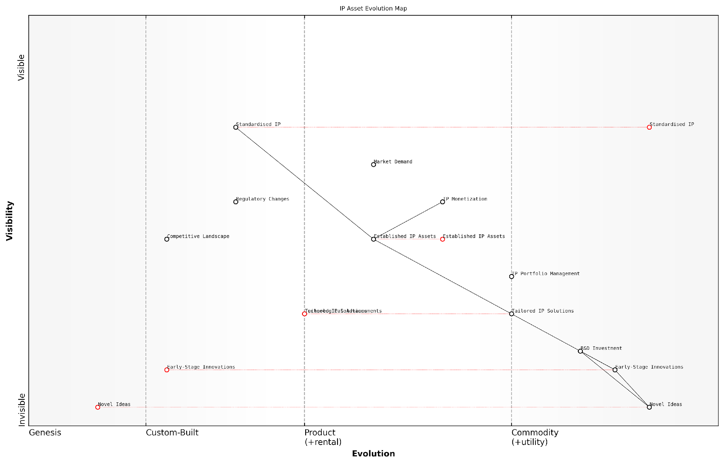

*Draft Wardley Map: [Insert Wardley Map: Visualising the Evolution of IP Assets]*

[Edit this draft Wardley Map](https://create.wardleymaps.ai/#clone:4d3264393a05112642)

Wardley Map Assessment

This Wardley Map presents a sophisticated view of IP asset evolution, highlighting the critical path from ideation to monetization. The strategic position is strong, with a clear understanding of the value chain and influencing factors. Key opportunities lie in optimising the transition between evolution stages, particularly from Early-Stage Innovations to Tailored IP Solutions. The integration of advanced technologies and predictive analytics into the IP development process could provide significant competitive advantages. To maintain leadership, focus should be on building agility into the IP development pipeline, strengthening connections between R&D and monetization, and developing a robust ecosystem approach to innovation.

[View full Wardley Map report](http://markdown_wardley_map_reports/wardley_map_report_12_Visualizing_the_Evolution_of_IP_Assets.md)

## LEGO-inspired Visualisation Techniques

### Using Colour-Coding for IP Types

In the realm of intellectual property (IP) strategy, visual representation is paramount for effective decision-making and communication. The integration of LEGO-inspired colour-coding techniques with Wardley Mapping provides a powerful tool for categorising and analysing different types of IP assets. This approach not only enhances the clarity of IP landscapes but also facilitates a more intuitive understanding of complex IP portfolios.

Colour-coding in IP Wardley Maps serves multiple purposes:

* Rapid identification of IP types
* Visual representation of IP density and distribution
* Highlighting relationships between different IP assets
* Facilitating strategic decision-making through visual patterns

Let’s explore how we can effectively implement colour-coding for various IP types within our LEGO Wardley Mapping framework.

Colour Scheme for IP Types:

* Patents: Blue
* Trademarks: Red
* Copyrights: Yellow
* Trade Secrets: Green
* Design Rights: Orange
* Geographical Indications: Purple

This colour scheme is not arbitrary; it is designed to reflect the nature and characteristics of each IP type. For instance, blue for patents represents the technical and innovative nature of patented inventions, while red for trademarks signifies the bold, attention-grabbing nature of brand identities.

The power of colour-coding in IP strategy cannot be overstated. It transforms abstract legal concepts into tangible, visual elements that can be easily manipulated and understood by both legal experts and non-specialists alike.

Implementing Colour-Coding in Practice:

1. Mapping IP Density: By using coloured LEGO bricks to represent different IP types on your Wardley Map, you can quickly visualise the concentration of various IP assets across your value chain. Areas with a high density of blue bricks, for example, indicate patent-heavy segments of your business.
2. Identifying IP Gaps: The absence of certain colours in specific areas of your map can reveal potential vulnerabilities or opportunities in your IP strategy. For instance, a lack of red bricks (trademarks) in a customer-facing segment might suggest a need for stronger brand protection.
3. Visualising IP Interactions: By placing different coloured bricks adjacent to or stacked upon each other, you can represent the interplay between various IP types. A yellow brick (copyright) atop a blue one (patent) might represent software code protected by both copyright and patent law.
4. Evolution Tracking: As you move elements across the evolution axis of your Wardley Map, the changing colours can represent the transformation of IP assets. For example, a green brick (trade secret) might evolve into a blue one (patent) as a company decides to publicly disclose and protect an innovation.

In my experience advising government bodies on IP strategy, the use of colour-coded LEGO bricks in Wardley Mapping sessions has consistently led to more engaged discussions and clearer strategic outcomes. It’s remarkable how a simple visual tool can bridge the gap between legal complexity and strategic clarity.

Case Study: Government Research Institution

In a recent project with a prominent government research institution, we employed colour-coded LEGO bricks to map their extensive IP portfolio. The visual representation revealed an unexpected imbalance: an abundance of blue bricks (patents) in early-stage research areas, but a scarcity of red (trademarks) and yellow (copyrights) in more mature, commercialisable sectors.

This visualisation prompted a strategic shift, leading the institution to focus on developing a stronger brand identity for its marketable innovations and improving copyright protection for its published research. The colour-coded map became a cornerstone for ongoing IP strategy discussions, allowing for quick updates and scenario planning.

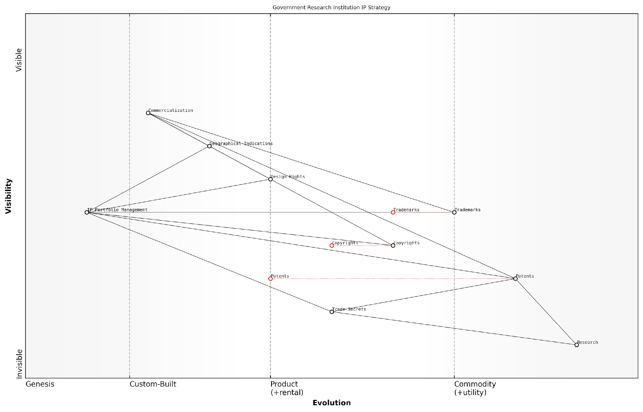

*Draft Wardley Map: [Insert Wardley Map: Using Colour-Coding for IP Types]*

[Edit this draft Wardley Map](https://create.wardleymaps.ai/#clone:5daf0be1043e5fe475)

Wardley Map Assessment

The map reveals a mature and well-structured IP strategy for a government research institution. While there’s a strong foundation in traditional IP types, there are opportunities to evolve the strategy to better align with emerging trends in technology and innovation. Key areas for improvement include strengthening trade secret management, optimising the use of copyrights, and preparing for the increasing importance of data-related IP. The institution is well-positioned to leverage its diverse IP portfolio for competitive advantage, but must remain vigilant in adapting to the rapidly evolving IP landscape, particularly in areas like AI and data rights. Strategic focus on enhancing IP portfolio management with advanced technologies and exploring new models of innovation could significantly boost the institution’s ability to generate value from its research outputs.

[View full Wardley Map report](http://markdown_wardley_map_reports/wardley_map_report_13_Using_Colour-Coding_for_IP_Types.md)

Best Practices for Colour-Coding in IP Wardley Maps:

* Maintain consistency in your colour scheme across all mapping exercises
* Use varying shades of each colour to represent the strength or importance of each IP asset
* Consider using patterns or textures in addition to colours to accommodate colour-blind team members
* Regularly review and update your colour-coded maps to reflect changes in your IP portfolio
* Use digital tools that allow for easy manipulation of colour-coded elements for scenario planning

Challenges and Considerations:

While colour-coding offers numerous benefits, it’s important to be aware of potential limitations. Over-reliance on visual representation may sometimes oversimplify complex legal nuances. Therefore, it’s crucial to use colour-coding as a complementary tool alongside detailed legal analysis, rather than a replacement for it.

Additionally, when working with international teams, be mindful of cultural differences in colour perception and meaning. What works in one cultural context may need adjustment in another to convey the same strategic insights effectively.

The art of IP strategy lies not just in the protection of assets, but in the clear communication of their value and interrelationships. Colour-coding in LEGO Wardley Mapping is a powerful brush in the IP strategist’s palette, allowing us to paint a vivid picture of complex IP landscapes.

In conclusion, the integration of colour-coding techniques inspired by LEGO into Wardley Mapping for IP strategy represents a significant advancement in the field. By leveraging the intuitive power of colour and the structural clarity of Wardley Maps, organisations can gain unprecedented insights into their IP portfolios, identify strategic opportunities, and communicate complex IP landscapes with ease. As we continue to navigate the increasingly complex world of intellectual property, such innovative visualisation techniques will undoubtedly play a crucial role in shaping the future of IP strategy and management.

### Stackable Blocks for Layered IP Strategies

In the realm of intellectual property strategy, particularly within government and public sector contexts, the ability to visualise complex, multi-layered strategies is paramount. The LEGO-inspired technique of using stackable blocks for layered IP strategies offers a powerful and intuitive method for mapping and understanding the intricate relationships between various IP assets and their strategic implications. This approach not only aligns with the modular nature of LEGO but also seamlessly integrates with the principles of Wardley Mapping, providing a robust framework for IP strategy visualisation.

The concept of stackable blocks in IP strategy mapping draws inspiration from the fundamental LEGO principle of building complex structures from simple, interlocking components. In the context of IP strategy, each block represents a distinct IP asset or strategic element, while the act of stacking these blocks symbolises the layered nature of comprehensive IP strategies. This visual metaphor allows strategists and policymakers to construct and analyse multi-dimensional IP portfolios with unprecedented clarity and flexibility.

The stackable block approach to IP strategy mapping is akin to constructing a LEGO model of your organisation’s intellectual assets. It allows you to build, deconstruct, and reconstruct your IP strategy with the same ease and creativity that LEGO bricks afford.

Let us delve into the key aspects and applications of this innovative visualisation technique:

* Hierarchical Representation of IP Assets
* Strategic Layering and Dependencies
* Modular Approach to IP Portfolio Management
* Dynamic Visualisation of IP Evolution

Hierarchical Representation of IP Assets: The stackable block method allows for a clear hierarchical representation of IP assets. At the foundation, one might place blocks representing core patents or fundamental technologies. Subsequent layers could represent improvements, applications, or derivative works. This hierarchical stacking provides an immediate visual cue to the relationships and relative importance of different IP assets within a portfolio.

For instance, in a government research institution, the bottom layer might represent foundational research patents, the middle layer could be application-specific patents, and the top layer might represent collaborative projects or licensing opportunities. This structure allows decision-makers to quickly grasp the full scope of their IP assets and their interrelationships.

Strategic Layering and Dependencies: By stacking blocks, strategists can visually represent the dependencies and strategic layering within their IP portfolio. For example, a block representing a key patent might support several blocks above it, indicating derivative technologies or market applications. This layering helps in identifying critical IP assets that underpin multiple strategic initiatives, as well as potential vulnerabilities where the removal of a single ‘block’ could impact the entire structure.

In IP strategy, as in LEGO construction, the strength of your structure depends not just on individual pieces, but on how they interconnect and support each other. The stackable block approach makes these connections tangible and actionable.

Modular Approach to IP Portfolio Management: The use of stackable blocks embodies a modular approach to IP portfolio management. Just as LEGO pieces can be easily rearranged to create new structures, IP strategy blocks can be reconfigured to explore different strategic scenarios. This modularity is particularly valuable in the fast-paced world of technology and innovation, where the ability to quickly adapt IP strategies is crucial.

For example, a government agency working on emerging technologies could use this approach to model different IP protection strategies. By rearranging blocks representing patents, trade secrets, and collaborative agreements, they can visualise and evaluate multiple strategic options quickly and effectively.

Dynamic Visualisation of IP Evolution: The stackable block method excels in representing the dynamic nature of IP portfolios over time. As new IP assets are developed or acquired, new blocks can be added to the structure. Conversely, as certain IP assets become obsolete or are divested, blocks can be removed. This dynamic visualisation helps in tracking the evolution of an IP portfolio and aids in future planning.

In practice, this could be used to map out the IP landscape for a long-term government initiative, such as a space exploration programme. The initial structure might represent current technologies and patents, while additional layers could be added to represent future developments, international collaborations, or spin-off technologies.

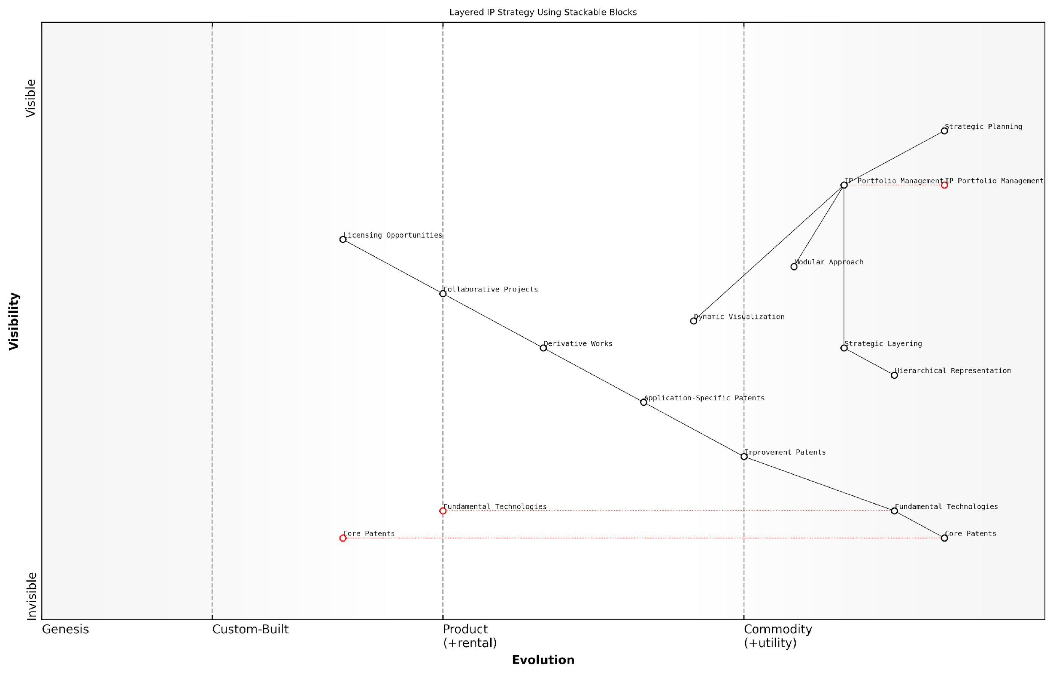

*Draft Wardley Map: [Insert Wardley Map: Stackable Blocks for Layered IP Strategies]*

[Edit this draft Wardley Map](https://create.wardleymaps.ai/#clone:28c9e51fd5e0dacdcf)

Wardley Map Assessment

This Wardley Map represents a sophisticated, layered approach to IP strategy that leverages modular, stackable concepts. It shows strong foundational IP assets and strategic planning capabilities, but indicates opportunities for improvement in value extraction and collaborative efforts. The emphasis on visualisation and modular approaches suggests a forward-thinking strategy that could provide significant competitive advantages if fully realised. Key areas for development include enhancing licensing capabilities, fostering more collaborative projects, and creating stronger links between high-level strategy and operational IP management. The integration of emerging technologies, particularly in portfolio management and visualisation, could further strengthen the overall IP strategy and position the organisation as a leader in innovative IP management practices.

[View full Wardley Map report](http://markdown_wardley_map_reports/wardley_map_report_14_Stackable_Blocks_for_Layered_IP_Strategies.md)

Implementing the Stackable Block Approach in Practice: To effectively utilise this visualisation technique, organisations should consider the following steps:

* Inventory and categorise all IP assets
* Assign each asset a ‘block’ with appropriate attributes (size, colour, etc.)
* Arrange blocks based on strategic importance and relationships
* Use connecting pieces to show interdependencies
* Regularly review and update the structure to reflect changes in the IP landscape

It’s worth noting that while this approach offers significant benefits in visualisation and strategic planning, it should be used in conjunction with traditional IP management tools and legal expertise. The stackable block method is a powerful aid to understanding and communication, but it does not replace the need for detailed legal and technical analysis of IP assets.

The true power of the stackable block approach lies not just in its ability to represent complex IP strategies visually, but in how it fosters creative thinking and collaborative strategy development among diverse stakeholders.

In conclusion, the use of stackable blocks for layered IP strategies represents a significant advancement in the visualisation and management of intellectual property portfolios. By combining the intuitive appeal of LEGO with the strategic depth of Wardley Mapping, this approach offers a unique and powerful tool for IP strategists, particularly in government and public sector contexts where complex, long-term planning is essential. As organisations continue to navigate the increasingly complex landscape of intellectual property, such innovative visualisation techniques will play a crucial role in developing robust, adaptable, and effective IP strategies.

### Connecting Pieces to Show IP Interactions

In the realm of intellectual property strategy, understanding the intricate web of interactions between various IP assets is crucial for effective management and value creation. The LEGO-inspired visualisation technique of connecting pieces to show IP interactions provides a powerful tool for mapping these complex relationships, enabling strategists and decision-makers to gain a holistic view of their IP landscape.

This approach leverages the intuitive nature of LEGO connections to represent the interdependencies, synergies, and potential conflicts within an IP portfolio. By visualising these connections, organisations can identify strategic opportunities, mitigate risks, and optimise their IP assets across different innovation horizons.

The ability to visually represent IP interactions is akin to seeing the forest and the trees simultaneously. It allows us to make informed decisions that consider both the individual strengths of our IP assets and their collective impact on our innovation strategy.

Let’s explore the key aspects of this visualisation technique and its applications in IP strategy:

* Types of Connections
* Strength of Relationships
* Directional Dependencies
* Cluster Identification
* Cross-Horizon Linkages

Types of Connections: In our LEGO-inspired IP mapping, different types of connections can represent various relationships between IP assets. For instance:

* Stud connections: Represent direct dependencies where one IP asset builds upon another
* Side-by-side connections: Indicate complementary IP assets that work together but are not directly dependent
* Overlapping plates: Symbolise IP assets that share common elements or protect different aspects of the same innovation

Strength of Relationships: The robustness of connections between LEGO pieces can be used to visualise the strength of relationships between IP assets. Stronger connections, such as those using multiple studs or technic pins, can represent critical dependencies or highly synergistic relationships. Weaker connections, like single-stud attachments, might indicate potential areas for strengthening or reevaluation.

Directional Dependencies: LEGO pieces can be arranged to show directional dependencies in IP interactions. For example, a smaller piece attached to the top of a larger one could represent a derivative work based on a core patent. This visualisation helps in understanding the flow of innovation and identifying key foundational IP assets that support multiple other innovations.

Visualising directional dependencies in our IP portfolio has been a game-changer. It’s allowed us to identify our most strategically important patents and focus our resources on protecting and leveraging these cornerstone assets.

Cluster Identification: By connecting related IP assets, natural clusters or ‘islands’ of innovation may emerge in the visualisation. These clusters can represent technological domains, product lines, or market segments. Identifying these clusters helps in developing targeted IP strategies for different areas of the business and spotting potential gaps or overlaps in IP coverage.

Cross-Horizon Linkages: One of the most powerful aspects of this visualisation technique is its ability to show connections between IP assets across different innovation horizons. By using different colours or sizes of LEGO pieces to represent each horizon, strategists can easily visualise how current IP assets might support or hinder future innovations.

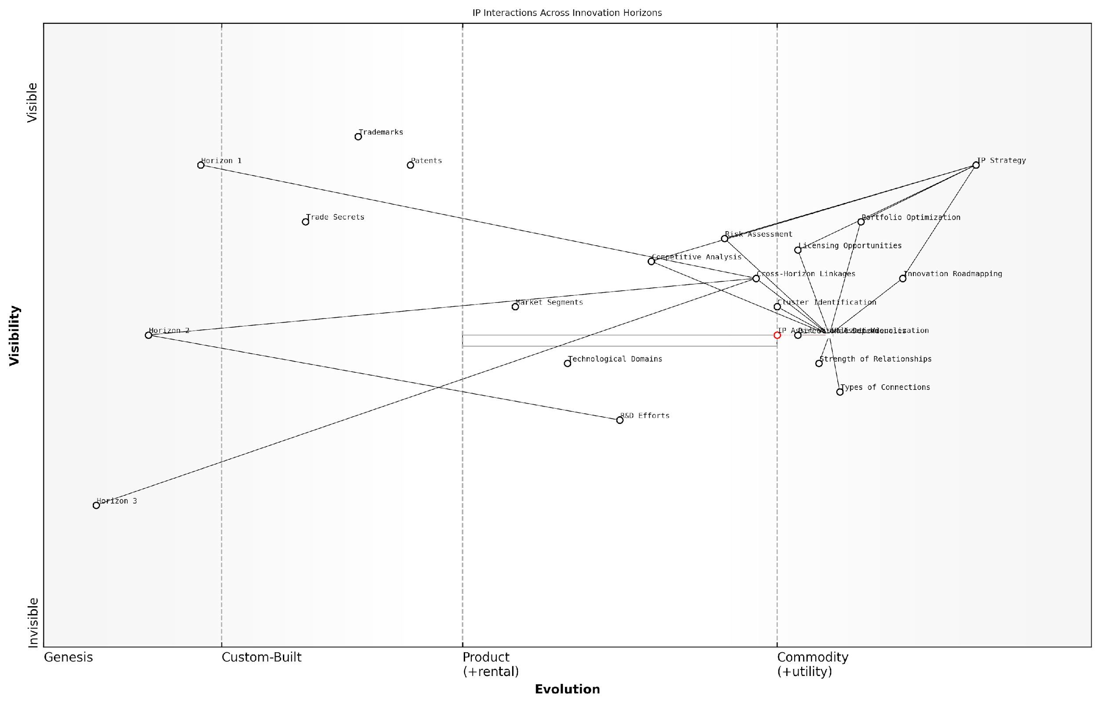

*Draft Wardley Map: [Insert Wardley Map: Connecting Pieces to Show IP Interactions]*

[Edit this draft Wardley Map](https://create.wardleymaps.ai/#clone:1f79a6791990fcdacd)

Wardley Map Assessment

This Wardley Map reveals a sophisticated approach to IP management that considers both current assets and future opportunities across innovation horizons. The strategic focus on IP Asset Visualization and Cross-Horizon Linkages provides a strong foundation for competitive advantage. However, there are opportunities to further enhance the connection between current and future IP assets, and to develop more advanced tools for cross-horizon analysis and portfolio optimization. By addressing these areas and leveraging emerging technologies, organisations can create a more dynamic and future-proof IP strategy that aligns closely with overall business objectives and drives long-term innovation success.

[View full Wardley Map report](http://markdown_wardley_map_reports/wardley_map_report_15_Connecting_Pieces_to_Show_IP_Interactions.md)

Practical Applications in IP Strategy:

* Portfolio Optimisation: By visualising connections, organisations can identify redundancies or gaps in their IP portfolio, allowing for more efficient resource allocation.
* Licensing Opportunities: Clusters of interconnected IP assets can highlight potential licensing packages that offer greater value than individual patents or trademarks.
* Risk Assessment: Visualising dependencies helps in identifying single points of failure or areas where the loss of a single IP asset could have cascading effects on the portfolio.
* Innovation Roadmapping: Cross-horizon connections can guide R&D efforts by showing how current IP assets might support or constrain future innovations.
* Competitive Analysis: By mapping competitors’ known IP assets and their potential connections, organisations can gain insights into rival strategies and identify areas for differentiation.

Case Study: Government Research Institution

In my work with a prominent government research institution, we employed this LEGO-inspired visualisation technique to map their extensive patent portfolio. The institution had accumulated hundreds of patents across various technological domains over decades of research.

By connecting the pieces representing individual patents, we uncovered several key insights:

* A cluster of interconnected patents in quantum computing that spanned all three innovation horizons, indicating a strong foundation for future advancements
* Several ‘bridge’ patents that connected otherwise disparate research areas, highlighting unexpected synergies and cross-disciplinary opportunities
* A group of patents with weak connections to the rest of the portfolio, prompting a reevaluation of their strategic value and potential for spin-off or licensing

This visualisation enabled the institution to realign its IP strategy, focusing resources on strengthening key patent clusters and exploring new research directions suggested by the identified connections.

The LEGO-inspired IP mapping opened our eyes to connections we hadn’t seen before. It’s transformed how we approach our research planning and IP management, ensuring we build on our strengths and explore new frontiers more strategically.

In conclusion, the technique of connecting pieces to show IP interactions provides a powerful tool for IP strategists. By leveraging the intuitive nature of LEGO connections, this approach offers a clear, visual representation of complex IP relationships. This enables more informed decision-making, fosters a deeper understanding of an organisation’s IP landscape, and ultimately supports the development of more robust and future-proof IP strategies.

## Creating Your First IP Wardley Map

### Step-by-Step Guide to Building an IP Map

Creating your first IP Wardley Map is a crucial step in developing a comprehensive intellectual property strategy. This guide will walk you through the process of constructing an IP map using the innovative combination of Wardley Mapping principles and LEGO-inspired visualisation techniques. By following these steps, you’ll gain a powerful tool for understanding your IP landscape and making informed strategic decisions.

Before we dive into the step-by-step process, it’s important to note that IP Wardley Mapping is an iterative process. Your first map will likely be imperfect, but it will serve as a valuable starting point for further refinement and discussion. As a senior adviser in IP strategy once remarked, ‘The map is not the territory, but it’s an invaluable guide for navigating it.’

* Step 1: Define Your User Need
* Step 2: Identify Your IP Assets
* Step 3: Map the Value Chain
* Step 4: Determine Evolution
* Step 5: Apply LEGO Visualisation Techniques
* Step 6: Analyse and Refine

Step 1: Define Your User Need

Begin by clearly articulating the user need that your IP strategy aims to address. This could be protecting a core technology, expanding into new markets, or defending against competitors. The user need forms the top of your map and provides context for all subsequent elements.

A clear user need is the foundation of any effective IP strategy. Without it, you’re building a map without a destination.

Step 2: Identify Your IP Assets

List all relevant IP assets that contribute to meeting the user need. This includes patents, trademarks, copyrights, trade secrets, and even non-traditional IP like data sets or customer relationships. Be comprehensive, as overlooking assets can lead to gaps in your strategy.

Step 3: Map the Value Chain

Arrange your IP assets along the value chain, from the most visible (top) to the most foundational (bottom). Consider how each asset contributes to the overall value proposition and its relationship to other assets. This step often reveals unexpected dependencies and opportunities.

Step 4: Determine Evolution

Assess the evolution stage of each IP asset along the x-axis, from genesis (left) to commodity (right). This crucial step helps identify which assets are ripe for innovation, which are becoming standardised, and where potential disruptions might occur.

Understanding the evolution of your IP assets is like having a crystal ball for your innovation strategy. It shows you where to invest and where to divest.

Step 5: Apply LEGO Visualisation Techniques

Now, enhance your map using LEGO-inspired visualisation techniques. Use different coloured blocks to represent various types of IP (e.g., red for patents, blue for trademarks). Stack blocks to show layered IP strategies or complex asset relationships. Use connector pieces to illustrate dependencies between assets.

This LEGO approach not only makes your map visually engaging but also allows for easy reconfiguration as your strategy evolves. It’s particularly effective when presenting to stakeholders who may not be IP experts.

Step 6: Analyse and Refine

With your initial map complete, step back and analyse what it reveals. Look for clusters of IP assets, gaps in protection, or areas where your IP is evolving faster or slower than expected. Use this analysis to refine your map and inform your IP strategy.

* Identify potential IP acquisition targets
* Spot areas where defensive publishing might be more effective than patenting
* Recognise opportunities for licensing or cross-licensing
* Highlight areas where trade secret protection might be more appropriate than patents

Remember, your IP Wardley Map is a living document. As your business environment changes and your IP portfolio evolves, your map should be updated accordingly. Regular review and refinement of your map will ensure it remains a valuable strategic tool.

An IP strategy is only as good as its ability to adapt. Your Wardley Map is the compass that guides that adaptation.

By following this step-by-step guide, you’ll create a powerful visual representation of your IP landscape. This map will serve as a foundation for strategic discussions, help identify opportunities and threats, and guide your organisation’s IP strategy in an increasingly complex and fast-moving business environment.

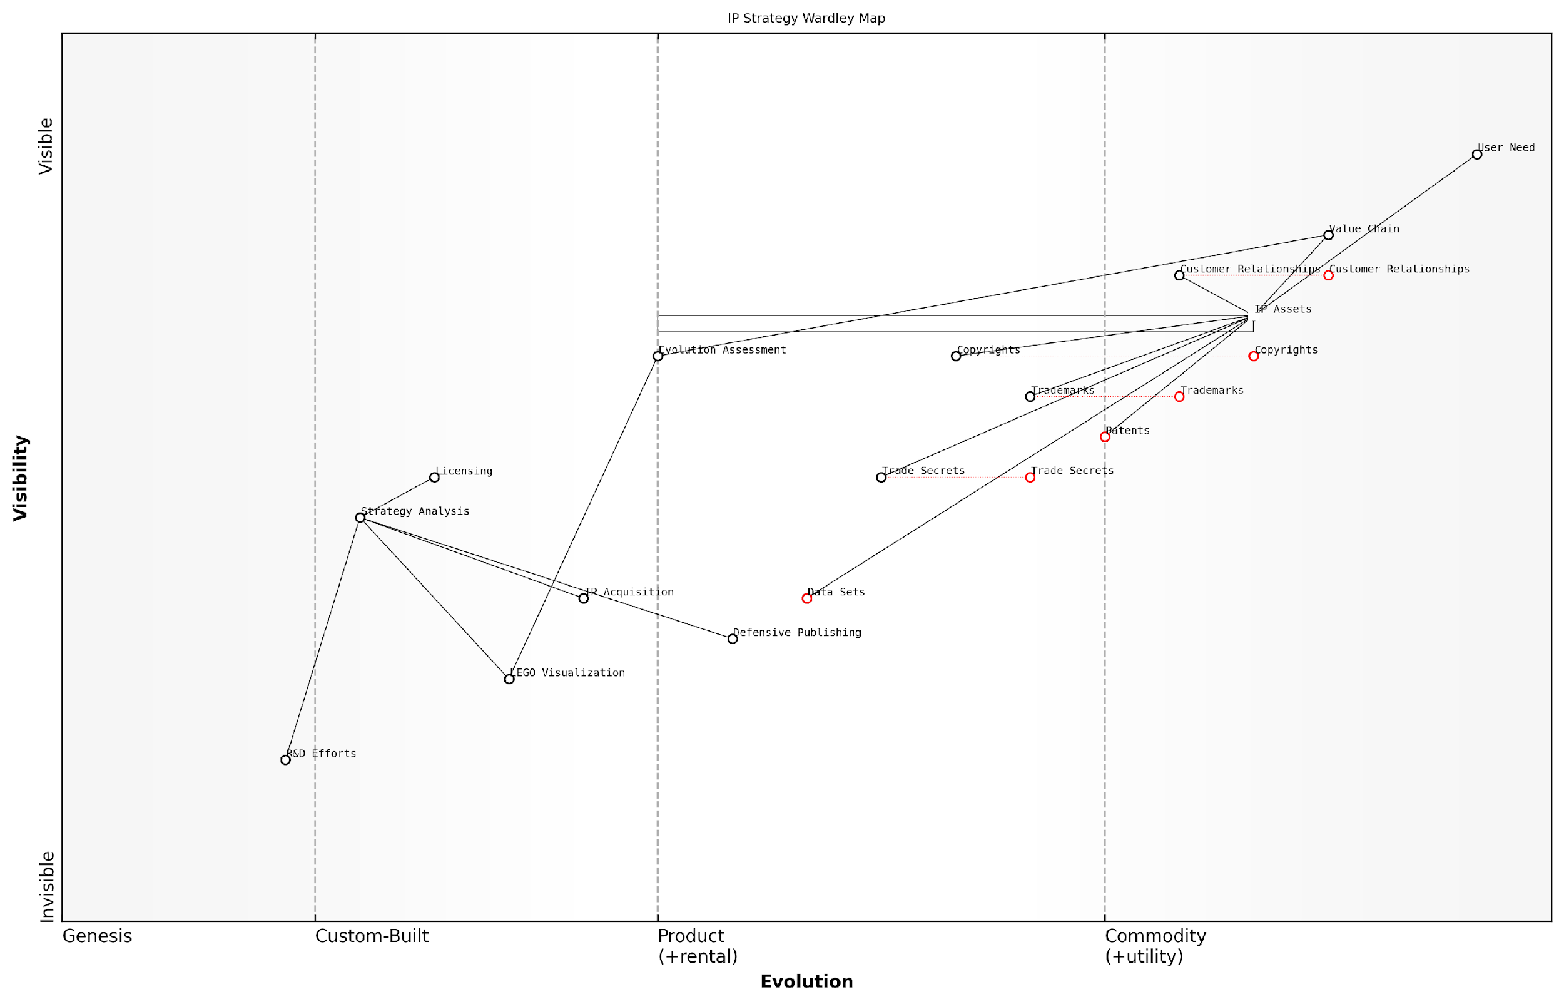

*Draft Wardley Map: [Insert Wardley Map: Step-by-Step Guide to Building an IP Map]*

[Edit this draft Wardley Map](https://create.wardleymaps.ai/#clone:5ef54fd4b63c2d77f0)

Wardley Map Assessment

This IP Strategy Wardley Map reveals a system in transition, balancing traditional IP assets with emerging strategic tools and data-driven approaches. The key opportunity lies in accelerating the evolution of data sets and strategy analysis capabilities, while leveraging novel visualisation techniques to enhance decision-making. To maintain competitive advantage, the organisation should prioritise data strategy development, integrate R&D more closely with IP processes, and fully embrace dynamic strategy tools like LEGO Visualization. The future of IP strategy, as indicated by this map, will likely be more data-centric, visually intuitive, and dynamically responsive to market changes.

[View full Wardley Map report](http://markdown_wardley_map_reports/wardley_map_report_16_Step-by-Step_Guide_to_Building_an_IP_Map.md)

As you become more proficient in creating and using IP Wardley Maps, you’ll find them invaluable for scenario planning, competitive analysis, and even guiding R&D efforts. The combination of Wardley Mapping principles with LEGO-inspired visualisation creates a uniquely powerful tool for navigating the complex world of intellectual property strategy.

### Common Pitfalls and How to Avoid Them

As we delve into the creation of your first IP Wardley Map using LEGO-inspired techniques, it’s crucial to be aware of common pitfalls that can hinder the effectiveness of your mapping process. By understanding these challenges and implementing strategies to avoid them, you can ensure that your IP Wardley Map becomes a powerful tool for strategic decision-making and innovation management.

Let’s explore the most frequent pitfalls encountered when creating IP Wardley Maps and discuss practical approaches to overcome them:

* Overcomplicating the Map
* Misplacing Components on the Evolution Axis
* Neglecting the Value Chain
* Failing to Consider Multiple Horizons
* Ignoring Interdependencies Between IP Assets
* Overlooking External Factors
* Static Thinking

1. Overcomplicating the Map:

One of the most common mistakes when creating an IP Wardley Map is trying to include too much information, resulting in a cluttered and confusing visualisation. This often stems from a desire to capture every nuance of your IP portfolio, but it can lead to a map that’s difficult to interpret and use effectively.

To avoid this pitfall, start with a simplified version of your IP landscape, focusing on the most critical assets and their immediate dependencies. Use the LEGO approach of building with basic blocks first, then iteratively add complexity as needed. Remember, the power of a Wardley Map lies in its ability to provide clear insights, not in the quantity of information it contains.

A senior IP strategist once remarked, ‘The most effective IP Wardley Maps are those that can tell a story at a glance. If you need a magnifying glass to read your map, you’ve probably included too much detail.’

1. Misplacing Components on the Evolution Axis:

The evolution axis in a Wardley Map represents the maturity of components from genesis (novel) to commodity (well-established). A common mistake is misplacing IP assets along this axis, often due to a lack of understanding of the broader IP landscape or overestimating the novelty of one’s own innovations.

To address this, conduct thorough research on the state of the art in your field before placing components on the map. Consider using colour-coded LEGO blocks to represent different stages of evolution, making it easier to visualise and adjust the positioning of IP assets. Regularly update your map as the IP landscape evolves to ensure accuracy.

1. Neglecting the Value Chain:

The value chain is a crucial element of a Wardley Map, representing how components contribute to meeting user needs. In IP mapping, it’s easy to focus solely on the technical aspects of your intellectual property without considering its place in the overall value chain.

To avoid this pitfall, start your mapping process by clearly defining the user need at the top of the value chain. Then, use LEGO-style connectors to link your IP assets to this need, ensuring that each component’s position reflects its contribution to value creation. This approach helps identify which IP assets are most critical to your business and where there might be gaps in your portfolio.

1. Failing to Consider Multiple Horizons:

IP strategy must account for both short-term protection and long-term innovation. A common mistake is focusing solely on current IP assets without considering future horizons of innovation and potential disruptions.

To address this, create separate layers in your LEGO Wardley Map for each innovation horizon. Use different colours or styles of LEGO blocks to represent IP assets in Horizon 1 (core business), Horizon 2 (emerging opportunities), and Horizon 3 (transformational innovations). This multi-horizon approach allows you to visualise how your IP strategy aligns with your innovation roadmap and identify areas where you may need to develop new IP to support future growth.

1. Ignoring Interdependencies Between IP Assets:

IP assets often have complex relationships and dependencies that can be overlooked in a simplified map. Failing to represent these connections can lead to incomplete strategic decisions.

Leverage the LEGO system’s connectors to visually represent these interdependencies. Use different types of connectors to show various relationships such as complementary patents, licensing agreements, or potential conflicts. This approach helps identify strategic IP clusters and potential vulnerabilities in your portfolio.

1. Overlooking External Factors:

IP strategy doesn’t exist in a vacuum. External factors such as regulatory changes, competitor actions, and technological advancements can significantly impact the value and positioning of your IP assets.

To account for these factors, consider adding a ‘landscape’ layer to your LEGO Wardley Map. Use special pieces or colours to represent key external influences, positioning them relative to your IP assets. This approach helps you anticipate potential threats and opportunities, allowing for more proactive IP management.

1. Static Thinking:

Perhaps the most significant pitfall in IP Wardley Mapping is treating the map as a static document rather than a dynamic tool for ongoing strategy development.

Embrace the iterative nature of LEGO building in your mapping process. Regularly review and update your map, rearranging components as the IP landscape evolves. Consider using digital tools that allow for easy manipulation of your LEGO Wardley Map, enabling quick scenario planning and strategy adjustments.

As a leading IP strategist often says, ‘Your IP Wardley Map should be a living document, evolving as quickly as the innovation landscape it represents.’

By being aware of these common pitfalls and implementing strategies to avoid them, you can create more effective IP Wardley Maps that drive strategic decision-making and foster innovation. Remember, the goal is not perfection but rather a useful tool that provides actionable insights for your IP strategy.

As you embark on creating your first IP Wardley Map, keep these pitfalls in mind and use the LEGO-inspired techniques we’ve discussed to overcome them. With practice and iteration, your mapping skills will improve, leading to more robust and insightful IP strategies that can drive your organisation’s success across multiple innovation horizons.

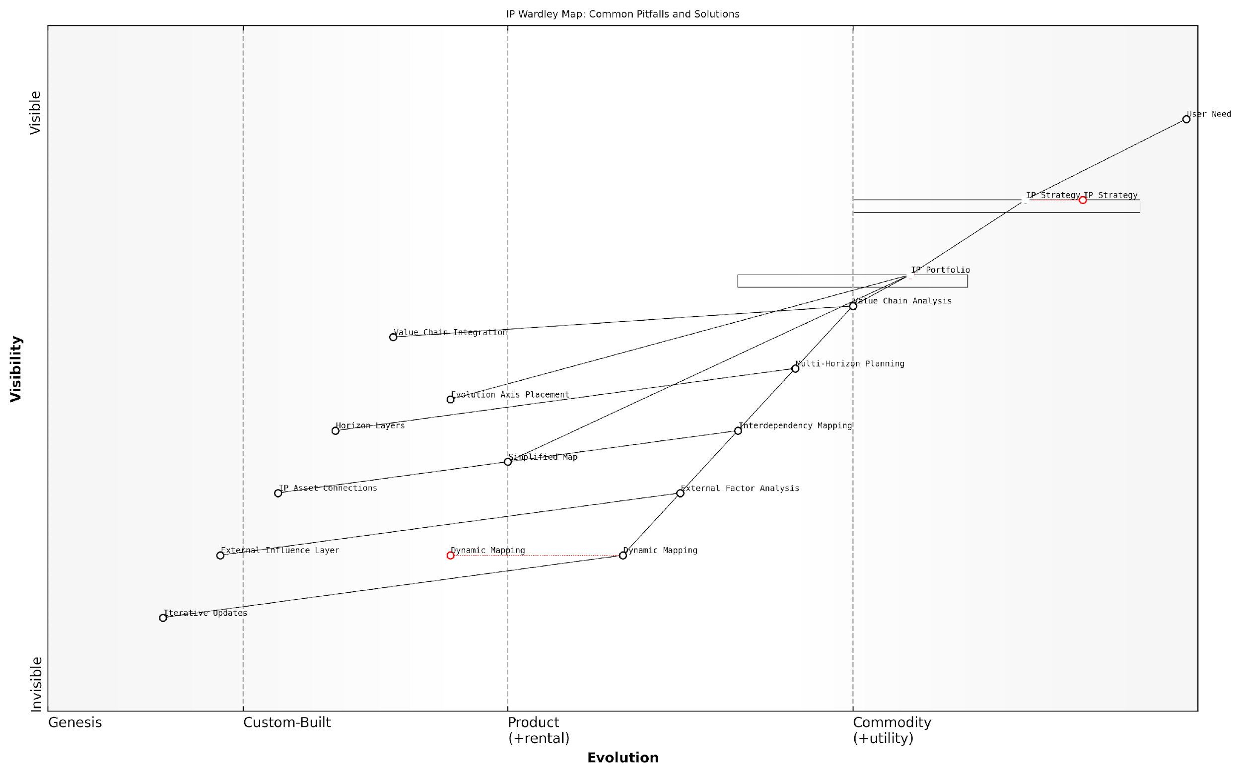

*Draft Wardley Map: [Insert Wardley Map: Common Pitfalls and How to Avoid Them]*

[Edit this draft Wardley Map](https://create.wardleymaps.ai/#clone:3d0d529517a27d16b5)

Wardley Map Assessment

This Wardley Map reveals a comprehensive approach to IP strategy that recognizes both traditional portfolio management and emerging dynamic practices. The key strategic opportunity lies in better integrating evolving components like Dynamic Mapping and External Factor Analysis with established practices, potentially leading to more adaptive and resilient IP strategies. Organisations should focus on developing capabilities in these emerging areas while ensuring robust connections across all components to create a more responsive and value-driven IP management system.

[View full Wardley Map report](http://markdown_wardley_map_reports/wardley_map_report_17_Common_Pitfalls_and_How_to_Avoid_Them.md)

### Interpreting Your IP Landscape

Interpreting your IP landscape is a crucial step in the process of creating and utilising your first IP Wardley Map. This interpretation phase transforms the visual representation of your intellectual property assets into actionable insights that can drive strategic decision-making. As we delve into this topic, we’ll explore how to extract meaningful information from your map, identify patterns and trends, and use these insights to inform your IP strategy within the context of the LEGO Wardley Mapping framework.

The power of the LEGO Wardley Mapping approach lies in its ability to provide a clear, modular visualisation of your IP landscape. By leveraging this unique combination of Wardley Mapping principles and LEGO-inspired visualisation techniques, we can uncover valuable insights that might otherwise remain hidden in traditional IP management approaches.

* Identifying IP Clusters and Gaps
* Assessing IP Evolution and Maturity
* Recognising IP Dependencies and Relationships
* Evaluating IP Positioning and Competitive Advantage

Let’s examine each of these aspects in detail to gain a comprehensive understanding of how to interpret your IP landscape effectively.

Identifying IP Clusters and Gaps: One of the first steps in interpreting your IP Wardley Map is to identify clusters of IP assets and areas where your IP coverage may be lacking. IP clusters often represent areas of strength or core competencies within your organisation. These clusters might be visualised as tightly grouped LEGO blocks of similar colours, representing patents, trademarks, or other IP assets in related technological or market areas.

IP clusters are like fortified castles in your innovation kingdom. They represent areas where you have built strong defences and can launch new ventures with confidence.

Conversely, gaps in your IP landscape may appear as empty spaces or sparsely populated areas on your map. These gaps could represent potential vulnerabilities or opportunities for future IP development. By identifying these gaps, you can prioritise areas for new R&D initiatives or consider strategic IP acquisitions to strengthen your position.

Assessing IP Evolution and Maturity: The Wardley Mapping component of our approach allows us to visualise the evolution of IP assets along the value chain. In the context of IP, this evolution might represent the journey from initial concept to granted patent, or from product launch to established brand. By examining the positioning of your IP assets along this evolution axis, you can gain insights into the maturity of your IP portfolio and identify areas that may require additional investment or attention.

For instance, a cluster of LEGO blocks representing early-stage patents in an emerging technology area might be positioned towards the left of your map, indicating a potential future competitive advantage. Conversely, well-established trademarks or mature patents might be positioned further to the right, representing stable, commoditised assets that provide ongoing value but may not drive future growth.

Understanding the evolution of your IP is like watching a time-lapse of your innovation landscape. It reveals not just where you are, but where you’re headed.

Recognising IP Dependencies and Relationships: The LEGO-inspired visualisation techniques in our approach allow for clear representation of dependencies and relationships between different IP assets. These connections might be visualised as connecting pieces between LEGO blocks, showing how different patents, trademarks, or trade secrets interact and support each other.

By analysing these relationships, you can identify key IP assets that serve as foundational elements for multiple products or services. These ‘keystone’ IP assets might be visualised as larger LEGO blocks with multiple connection points. Understanding these dependencies can inform decisions about which IP assets to prioritise for protection or further development.

Evaluating IP Positioning and Competitive Advantage: The positioning of your IP assets on the Wardley Map, combined with the LEGO-inspired visualisation, provides insights into your competitive advantage. IP assets positioned higher on the map (closer to the user) and further to the right (more evolved) often represent areas where you have a strong market position.

However, it’s crucial to consider the dynamic nature of the IP landscape. Assets that currently provide a strong competitive advantage may become commoditised over time. By regularly updating and reinterpreting your IP Wardley Map, you can anticipate these shifts and adjust your strategy accordingly.

In the game of IP strategy, it’s not just about where the pieces are now, but where they’ll be in the next move. Your Wardley Map is your chessboard, showing you the possible futures of your IP landscape.

Practical Application: Consider a government agency responsible for fostering innovation in the renewable energy sector. By creating an IP Wardley Map using our LEGO-inspired approach, they might identify a strong cluster of patents related to solar panel technology (represented by a group of blue LEGO blocks) but a gap in energy storage solutions (an empty space on the map).

The map might also reveal that while their solar panel IP is mature and well-positioned (blocks on the right side of the map), their emerging wind turbine technology IP (green blocks on the left) shows promise but requires further development to create a strong competitive advantage.

By interpreting this landscape, the agency could decide to allocate resources to develop their wind turbine IP portfolio and explore partnerships or funding opportunities to address the gap in energy storage solutions. This strategic approach, informed by their IP Wardley Map interpretation, could help position the country as a leader in comprehensive renewable energy solutions.

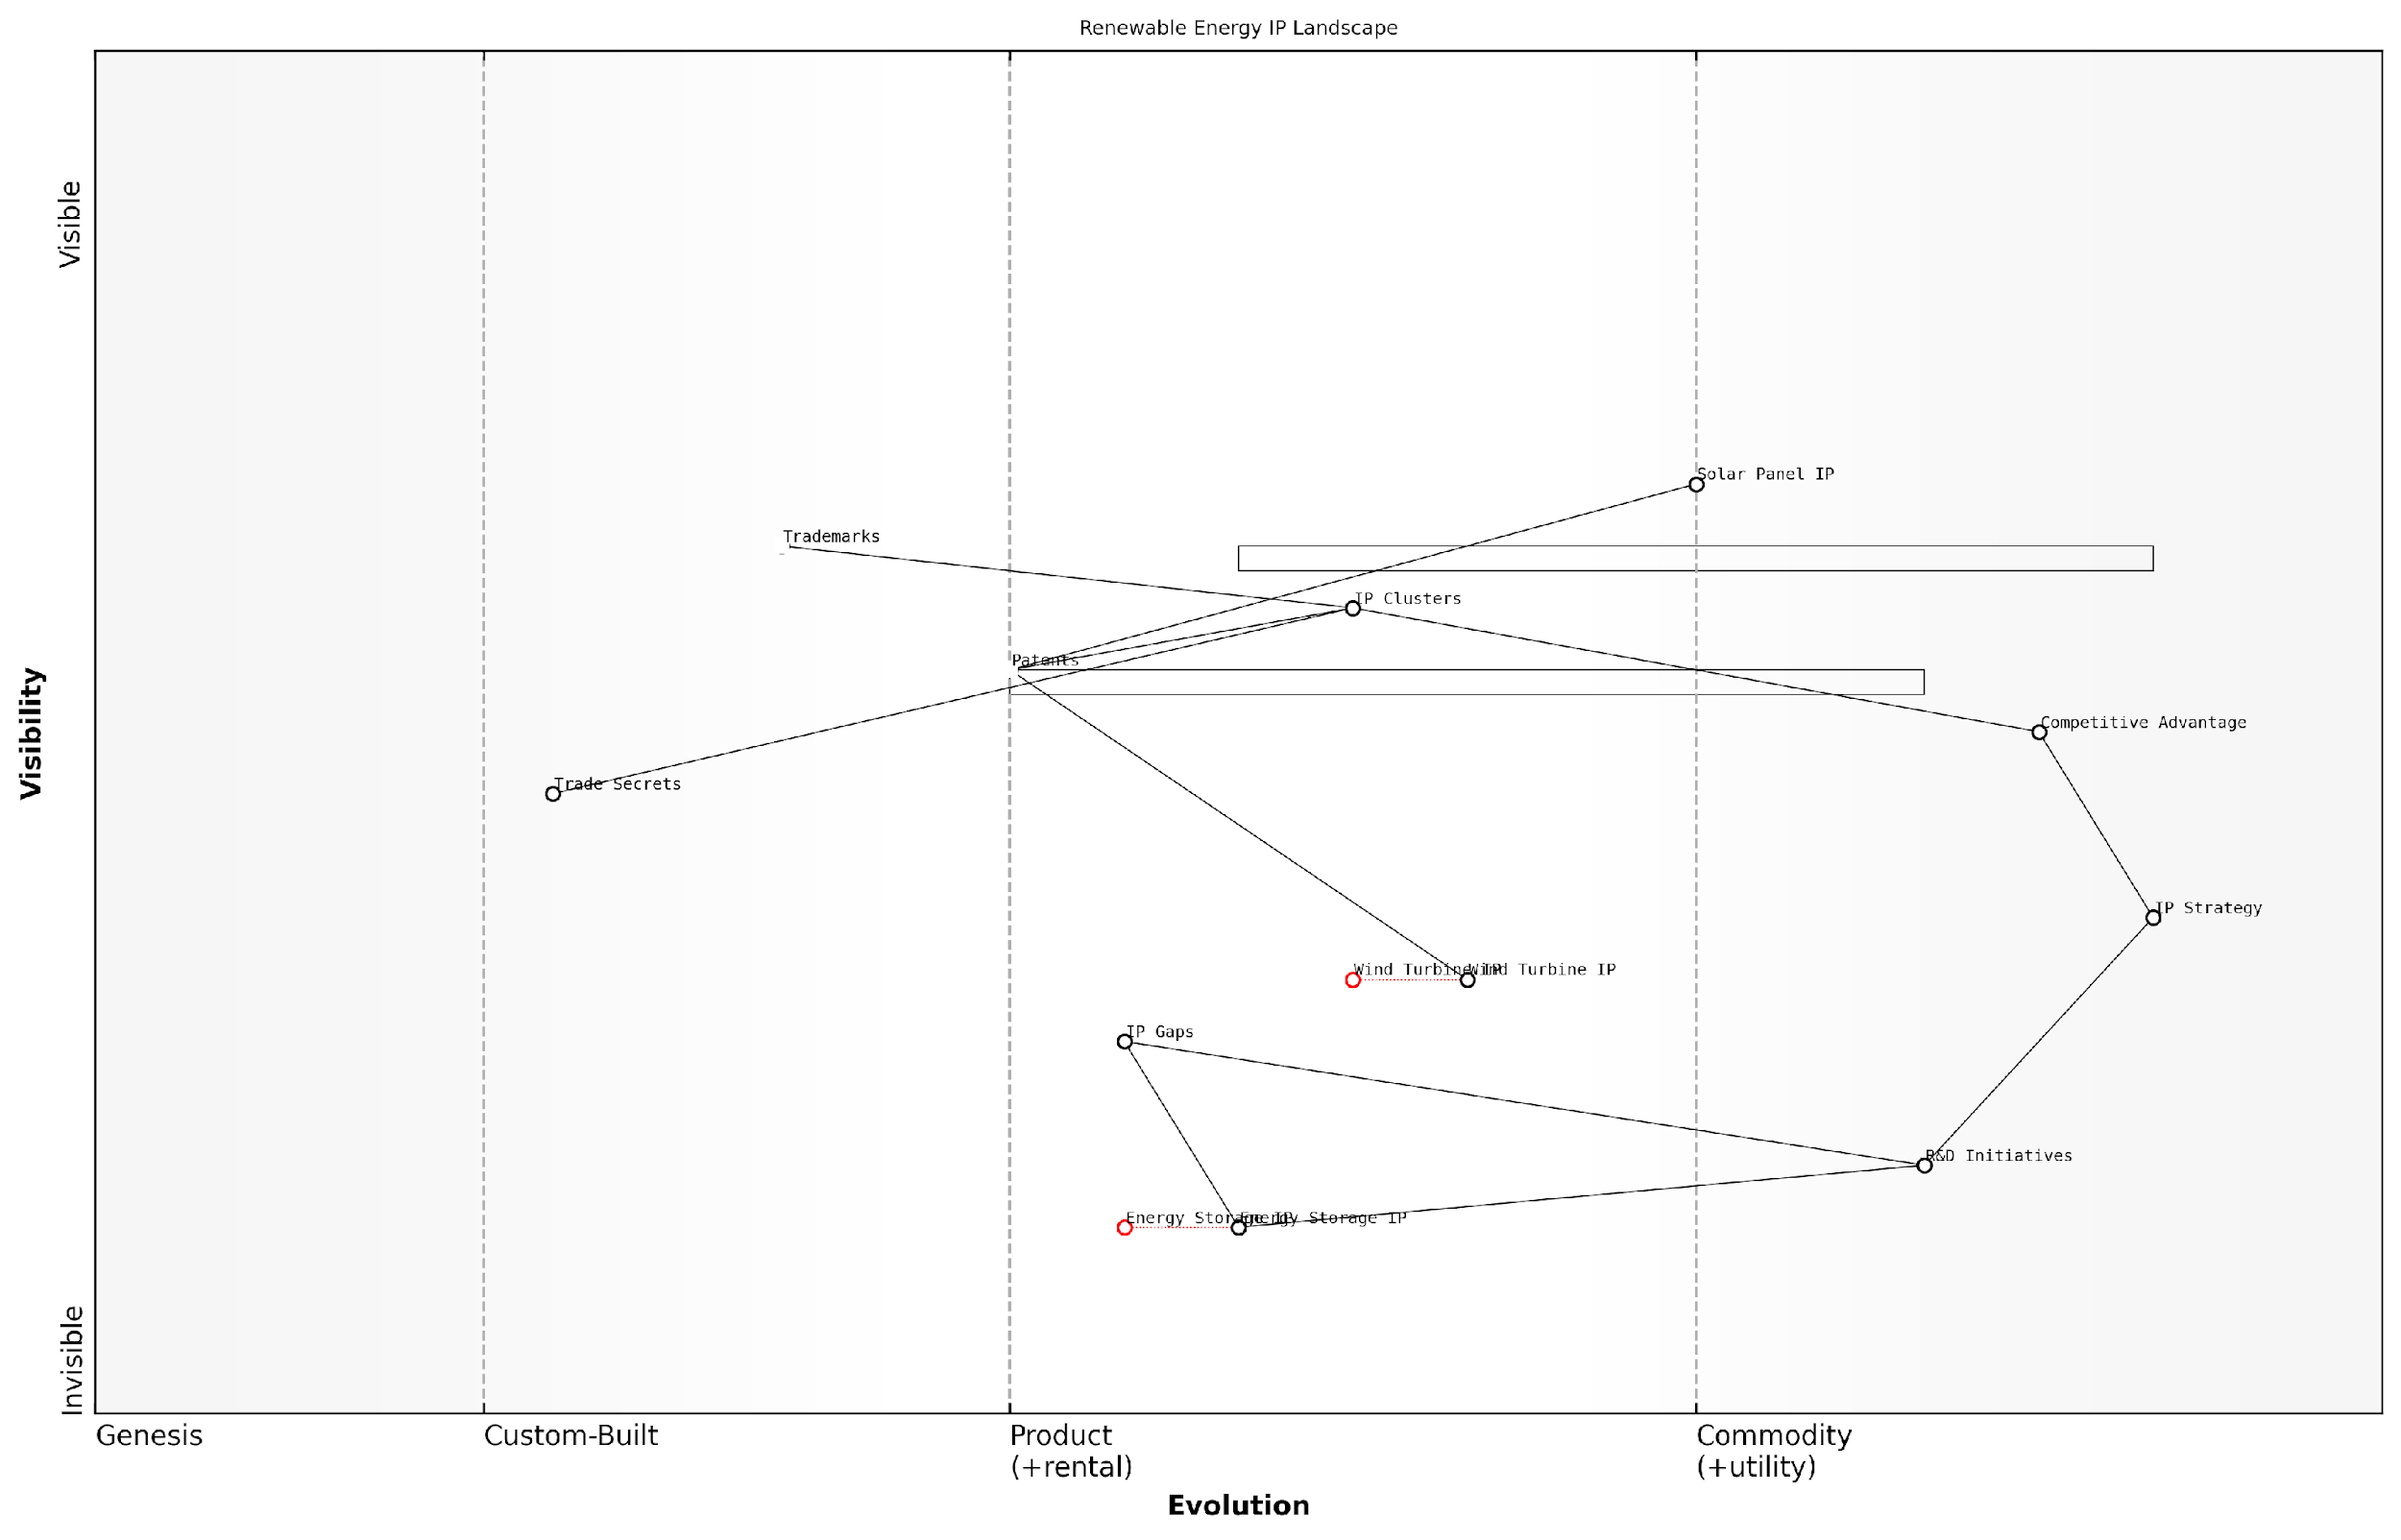

*Draft Wardley Map: [Insert Wardley Map: Interpreting Your IP Landscape]*

[Edit this draft Wardley Map](https://create.wardleymaps.ai/#clone:29cc9f2d76d8c078d0)

Wardley Map Assessment

The Renewable Energy IP Landscape map reveals a sector in transition, with mature technologies like Solar Panel IP coexisting with emerging opportunities in Energy Storage. The strategic positioning of IP Strategy and Competitive Advantage indicates a strong awareness of IP’s critical role in market success. However, the underdevelopment of Energy Storage IP presents both a significant risk and a major opportunity. To maintain and enhance competitive advantage, companies must aggressively pursue leadership in Energy Storage IP while optimising their existing IP portfolios. The explicit inclusion of IP Gaps in the map is commendable and should be leveraged to drive focused R&D efforts. Moving forward, success will depend on creating a more integrated and dynamic IP ecosystem that can rapidly adapt to technological advancements and market shifts in the renewable energy sector.

[View full Wardley Map report](http://markdown_wardley_map_reports/wardley_map_report_18_Interpreting_Your_IP_Landscape.md)

In conclusion, interpreting your IP landscape through the lens of a LEGO Wardley Map provides a powerful tool for strategic decision-making. By identifying clusters and gaps, assessing evolution and maturity, recognising dependencies and relationships, and evaluating positioning and competitive advantage, you can gain a comprehensive understanding of your IP portfolio. This understanding, in turn, enables you to make informed decisions about IP development, protection, and exploitation, ultimately driving innovation and competitive advantage in your organisation or sector.

# Chapter 2: Navigating Innovation Horizons

## Understanding Innovation Horizons

### Horizon 1: Core Business and Incremental Innovation

In the context of The LEGO Wardley Mapping manual for horizons of intellectual property, understanding Horizon 1 is crucial for organisations seeking to protect and leverage their core business assets while fostering incremental innovation. This horizon represents the foundation of an organisation’s IP strategy, focusing on existing products, services, and technologies that generate current revenue streams.

Horizon 1 in IP strategy encompasses several key elements:

* Protecting core IP assets
* Optimising existing IP portfolios
* Identifying opportunities for incremental improvements
* Maintaining competitive advantage in established markets

When applying LEGO Wardley Mapping techniques to Horizon 1, organisations can visualise their current IP landscape and identify areas for optimisation and incremental innovation. This approach allows for a modular and flexible strategy that can adapt to market changes while maintaining a strong foundation.

Horizon 1 is not about maintaining the status quo, but rather about continuously refining and strengthening your core IP assets to create a solid platform for future growth.

Let’s explore the key components of Horizon 1 in more detail:

1. Protecting Core IP Assets:

In Horizon 1, the primary focus is on safeguarding existing IP assets that form the backbone of the organisation’s current business model. This involves:

* Conducting regular IP audits to identify and catalogue all existing assets
* Implementing robust IP protection strategies, including patents, trademarks, and trade secrets
* Monitoring for potential infringements and taking appropriate legal action when necessary
* Developing clear IP ownership and usage policies within the organisation

Using LEGO Wardley Mapping, organisations can create a visual representation of their core IP assets, showing their relative positions in terms of value and evolution. This helps identify which assets require the most protection and where potential vulnerabilities may exist.

1. Optimising Existing IP Portfolios:

Horizon 1 also focuses on maximising the value of existing IP portfolios through:

* Identifying underutilised IP assets and finding new applications or markets for them
* Streamlining IP portfolios by divesting or abandoning low-value assets
* Exploring licensing opportunities to generate additional revenue streams
* Aligning IP strategy with overall business objectives to ensure resources are allocated effectively

LEGO Wardley Mapping can be used to visualise the connections between different IP assets and their potential applications, helping organisations identify new opportunities for optimisation and value creation.

1. Identifying Opportunities for Incremental Improvements:

While Horizon 1 primarily focuses on existing assets, it also encompasses incremental innovation that can enhance current products or services. This involves:

* Conducting regular market analysis to identify customer needs and preferences
* Encouraging internal innovation through R&D initiatives and employee suggestion programmes
* Monitoring technological advancements that could be applied to existing products or processes
* Implementing continuous improvement methodologies to refine and enhance IP assets

By using LEGO-inspired visualisation techniques, organisations can map out potential incremental improvements and their impact on existing IP assets, helping prioritise innovation efforts.

1. Maintaining Competitive Advantage in Established Markets:

A key aspect of Horizon 1 is ensuring that the organisation maintains its competitive edge in its core markets. This includes:

* Monitoring competitor activities and IP filings to stay ahead of market trends
* Developing defensive IP strategies to protect market share
* Leveraging IP assets to create barriers to entry for potential competitors
* Building strong brand recognition and customer loyalty through effective trademark and branding strategies

LEGO Wardley Mapping can be used to visualise the competitive landscape, showing the relative positions of the organisation’s IP assets compared to those of competitors. This helps identify areas where the organisation needs to strengthen its IP position to maintain its competitive advantage.

In Horizon 1, the goal is not just to protect what you have, but to create a strong foundation that can support future growth and innovation across all horizons.

Practical Application in Government and Public Sector Contexts:

In the government and public sector, Horizon 1 IP strategies often focus on:

* Protecting and leveraging IP generated through publicly funded research
* Optimising the use of government-owned IP assets to benefit citizens and stimulate economic growth
* Implementing open innovation strategies that balance IP protection with public access to information
* Developing IP policies that align with national innovation and economic development goals

For example, a government research institution might use LEGO Wardley Mapping to visualise its portfolio of patents resulting from various research projects. This could help identify opportunities for technology transfer to the private sector, areas where additional research funding could yield valuable IP, and potential collaborations with other institutions or industry partners.

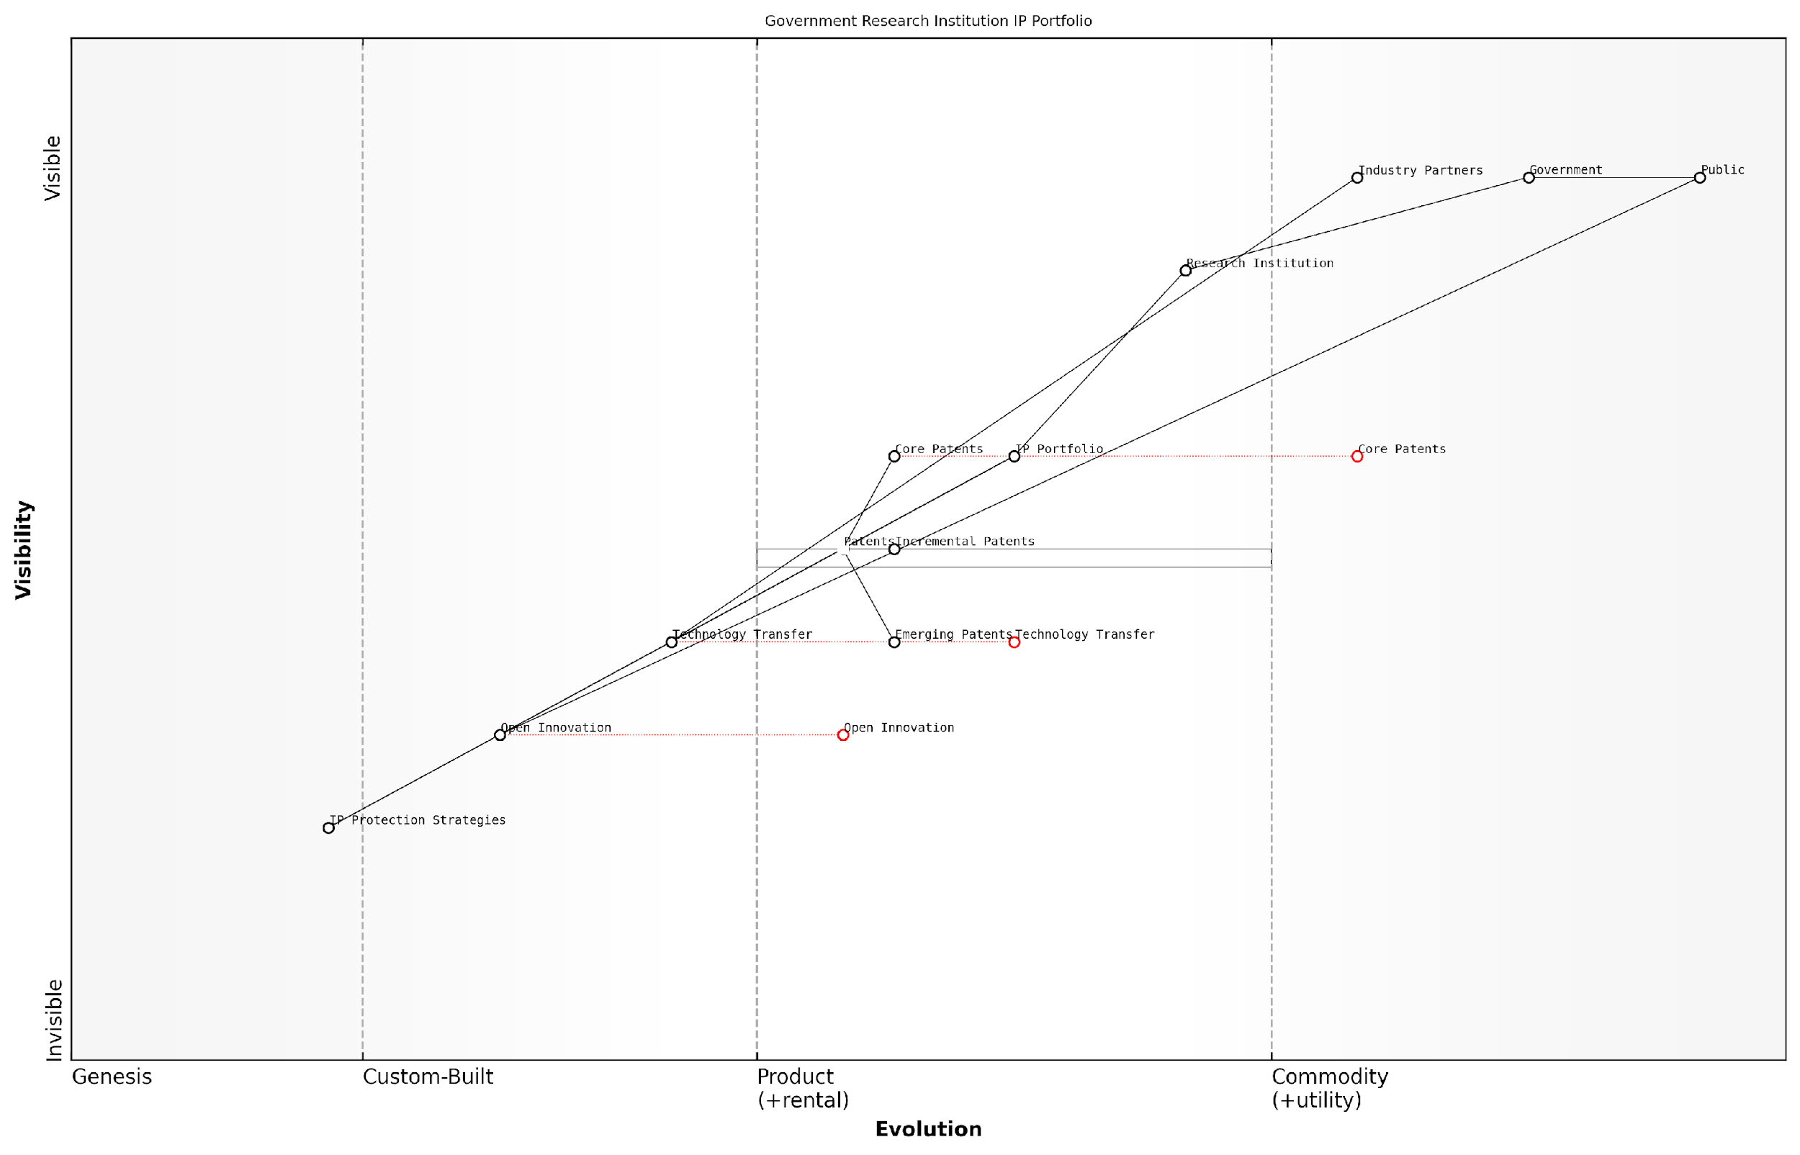

*Draft Wardley Map: [Insert Wardley Map: Horizon 1: Core Business and Incremental Innovation]*

[Edit this draft Wardley Map](https://create.wardleymaps.ai/#clone:8da3bbce5d02b8b14a)

Wardley Map Assessment

The Government Research Institution is at a critical juncture, balancing traditional IP strength with the need for more open and collaborative innovation. To maintain relevance and maximise impact, it must evolve its IP strategies, enhance technology transfer, and embrace open innovation while protecting core assets. The institution has a unique opportunity to lead in bridging public needs, cutting-edge research, and industry applications through a modernised approach to IP management and innovation practices.

[View full Wardley Map report](http://markdown_wardley_map_reports/wardley_map_report_19_Horizon_1:_Core_Business_and_Incremental_Innovatio.md)

By applying LEGO Wardley Mapping techniques to Horizon 1, government and public sector organisations can create more transparent, adaptable, and effective IP strategies that support their core missions while fostering innovation and economic development.

In conclusion, Horizon 1 forms the bedrock of an organisation’s IP strategy, focusing on protecting and optimising core assets while fostering incremental innovation. By leveraging LEGO Wardley Mapping techniques, organisations can gain a clearer understanding of their IP landscape, identify opportunities for improvement, and create a solid foundation for future growth and innovation across all horizons.

### Horizon 2: Emerging Opportunities and Adjacent Markets

Horizon 2 represents a critical juncture in the innovation landscape, where organisations leverage their existing intellectual property (IP) to explore emerging opportunities and adjacent markets. This horizon is particularly significant in the context of The LEGO Wardley Mapping manual for horizons of intellectual property, as it bridges the gap between core business activities and transformative innovations. Understanding and effectively mapping this horizon is crucial for government bodies and public sector organisations seeking to maintain relevance and drive innovation in an increasingly dynamic environment.

In the realm of IP strategy, Horizon 2 is characterised by the extension and adaptation of existing IP assets to new contexts, markets, or applications. This often involves identifying synergies between established IP portfolios and emerging technologies or market needs. The LEGO Wardley Mapping approach provides a unique and powerful framework for visualising these opportunities and planning strategic IP development.

Horizon 2 is where the seeds of future growth are planted. It’s the playground where established IP meets new possibilities, creating a fertile ground for innovation that can sustain an organisation’s competitive edge.

Let’s delve into the key aspects of Horizon 2 and how they can be effectively mapped using the LEGO Wardley approach:

* Identifying Adjacent Markets
* Adapting Existing IP for New Applications
* Collaborative Innovation and IP Sharing
* Risk Management in Emerging Opportunities

Identifying Adjacent Markets: In the context of government and public sector organisations, adjacent markets might include new service areas, citizen engagement platforms, or cross-departmental initiatives. Using the LEGO Wardley Mapping technique, we can visualise these potential markets as new ‘builds’ constructed from existing IP ‘bricks’. This approach allows strategists to identify how current IP assets can be reconfigured or extended to serve new purposes.

For instance, a government agency with robust data protection IP might identify adjacent opportunities in secure citizen identity verification for digital services. By mapping this potential market alongside existing IP assets, decision-makers can visualise the path from current capabilities to new value propositions.

Adapting Existing IP for New Applications: Horizon 2 often involves repurposing or adapting existing IP for novel uses. The LEGO Wardley Map can illustrate this process by showing how ‘bricks’ of IP can be reconfigured into new structures. This might involve combining patents in unexpected ways or applying copyright-protected software to new domains.

The art of innovation in Horizon 2 lies not in creating entirely new IP, but in seeing the potential for existing IP to solve emerging problems in creative ways.

Collaborative Innovation and IP Sharing: Horizon 2 presents unique opportunities for collaborative innovation, particularly in the public sector where cross-agency cooperation can yield significant benefits. The LEGO Wardley Mapping approach can visualise how IP from different departments or even external partners can be combined to create new value. This might involve mapping out potential licensing agreements, joint ventures, or open innovation initiatives.

For example, a map might show how a local government’s traffic management IP could be combined with a tech company’s AI algorithms to create a smart city solution. The visual nature of the LEGO Wardley Map makes it easier to identify potential synergies and negotiate IP sharing arrangements.

Risk Management in Emerging Opportunities: Exploring adjacent markets and new applications inevitably involves risk. The LEGO Wardley Mapping technique allows for the incorporation of risk assessment into the visual strategy. By using different colours or shapes to represent varying levels of risk or uncertainty, decision-makers can quickly identify areas that require additional due diligence or protective measures.

For instance, a map might use red LEGO bricks to represent high-risk areas where IP protection is uncertain, while green bricks could indicate low-risk, well-protected IP assets. This visual representation can guide resource allocation and risk mitigation strategies.

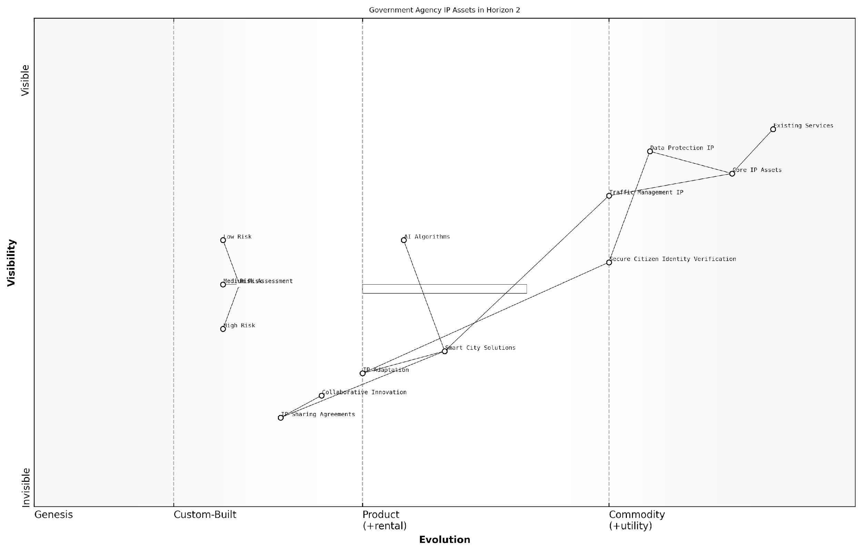

*Draft Wardley Map: [Insert Wardley Map: Horizon 2: Emerging Opportunities and Adjacent Markets]*

[Edit this draft Wardley Map](https://create.wardleymaps.ai/#clone:7494661d6327b4f18b)

Wardley Map Assessment

The government agency is at a critical juncture, with strong core IP assets but facing the challenge of adapting to rapidly evolving technologies and citizen expectations. The key to success lies in effectively bridging the gap between established assets and emerging opportunities through focused innovation, strategic partnerships, and a robust risk management approach. By prioritising IP adaptation, collaborative innovation, and the development of smart city solutions, the agency can leverage its strengths to create significant value in adjacent markets while maintaining its core responsibilities.

[View full Wardley Map report](http://markdown_wardley_map_reports/wardley_map_report_20_Horizon_2:_Emerging_Opportunities_and_Adjacent_Mar.md)

Implementing the LEGO Wardley Mapping approach for Horizon 2 IP strategy requires a shift in mindset from traditional IP management. It encourages a more dynamic, visual, and collaborative approach to IP strategy. Government and public sector leaders should consider the following best practices:

* Regularly review and update your IP Wardley Map to reflect changing market conditions and emerging opportunities
* Encourage cross-departmental collaboration in identifying and exploring adjacent markets
* Use the visual nature of the LEGO Wardley Map to communicate IP strategy to stakeholders at all levels
* Incorporate scenario planning into your mapping process to prepare for different potential futures
* Balance the pursuit of new opportunities with the need to protect and maintain existing IP assets

By effectively mapping and navigating Horizon 2, government and public sector organisations can ensure they are not only protecting their current IP assets but also positioning themselves to capitalise on emerging opportunities. The LEGO Wardley Mapping approach provides a powerful tool for visualising this complex landscape, enabling more informed decision-making and strategic IP development.

In the rapidly evolving landscape of public sector innovation, those who can effectively map and navigate Horizon 2 will be best positioned to deliver value to citizens and stay ahead of the curve.

As we move forward in this chapter, we will explore practical techniques for implementing these concepts and integrating Horizon 2 mapping into your overall IP strategy. By mastering this crucial middle ground between current operations and future possibilities, organisations can build a robust and adaptable IP portfolio that drives innovation and creates lasting value.

### Horizon 3: Transformational and Disruptive Innovation

Horizon 3 represents the frontier of innovation within the LEGO Wardley Mapping framework for intellectual property (IP) strategy. This horizon encompasses transformational and disruptive innovations that have the potential to reshape industries, create new markets, and fundamentally alter the competitive landscape. For government and public sector organisations, understanding and effectively navigating Horizon 3 is crucial for long-term strategic planning, fostering economic growth, and maintaining technological leadership on a national scale.

In the context of IP strategy, Horizon 3 innovations often present unique challenges and opportunities. These innovations may require entirely new approaches to IP protection, as they frequently push the boundaries of existing legal frameworks and technological paradigms. The LEGO Wardley Mapping approach provides a powerful tool for visualising and strategising around these transformative innovations, allowing organisations to anticipate and prepare for seismic shifts in the IP landscape.

Horizon 3 is where we plant the seeds of future industries. It’s the realm of ‘what if’ and ‘why not’, where truly game-changing innovations are born. For public sector leaders, mastering this horizon is about shaping the future, not just responding to it.

Let’s delve deeper into the key aspects of Horizon 3 within the LEGO Wardley Mapping framework for IP strategy:

* Identifying Transformational Opportunities
* Managing Uncertainty and Risk
* Developing Flexible IP Strategies
* Fostering Collaborative Innovation
* Anticipating Regulatory Challenges

Identifying Transformational Opportunities: In Horizon 3, the focus is on spotting potential breakthroughs that could redefine entire industries or create entirely new ones. This requires a keen understanding of emerging technologies, societal trends, and potential paradigm shifts. Within the LEGO Wardley Mapping framework, these opportunities are often represented as isolated components at the far right of the map, with few or no dependencies on existing systems.

For example, a government research institution might identify quantum computing as a Horizon 3 opportunity. On a Wardley Map, quantum computing might appear as a standalone component, far to the right, with potential connections to future applications in cryptography, drug discovery, or climate modelling.

Managing Uncertainty and Risk: Horizon 3 innovations are inherently uncertain and high-risk. The LEGO Wardley Mapping approach helps visualise this uncertainty by using different colours or patterns for Horizon 3 components, indicating their speculative nature. This visual representation can aid in communicating the risk profile to stakeholders and inform resource allocation decisions.

In Horizon 3, we’re not just managing risk; we’re embracing uncertainty as a catalyst for innovation. The key is to create an IP strategy that’s as adaptable and resilient as the technologies we’re pursuing.

Developing Flexible IP Strategies: Given the transformative nature of Horizon 3 innovations, traditional IP strategies may prove inadequate. The LEGO Wardley Mapping approach encourages the development of modular, adaptable IP strategies that can evolve alongside the innovation. This might involve creating ‘placeholder’ patents for foundational technologies, establishing strategic partnerships to pool IP resources, or developing entirely new forms of IP protection.

For instance, in the realm of artificial intelligence, where the pace of innovation often outstrips the speed of patent processes, organisations might use the LEGO Wardley Mapping framework to visualise a multi-layered IP strategy. This could combine rapid patent filing for core algorithms, trade secret protection for training data, and open-source initiatives for certain components to accelerate adoption and standard-setting.

Fostering Collaborative Innovation: Horizon 3 often requires collaboration across disciplines, sectors, and even national boundaries. The LEGO Wardley Mapping approach can help identify potential partners and collaborative opportunities by visualising the entire innovation ecosystem. This is particularly relevant for government entities looking to stimulate economic growth through public-private partnerships or international collaborations.

Anticipating Regulatory Challenges: Transformational innovations often outpace existing regulatory frameworks. The LEGO Wardley Mapping approach can help anticipate potential regulatory hurdles by mapping the evolving legal and policy landscape alongside technological developments. This foresight can inform proactive engagement with policymakers and help shape favourable regulatory environments for emerging technologies.

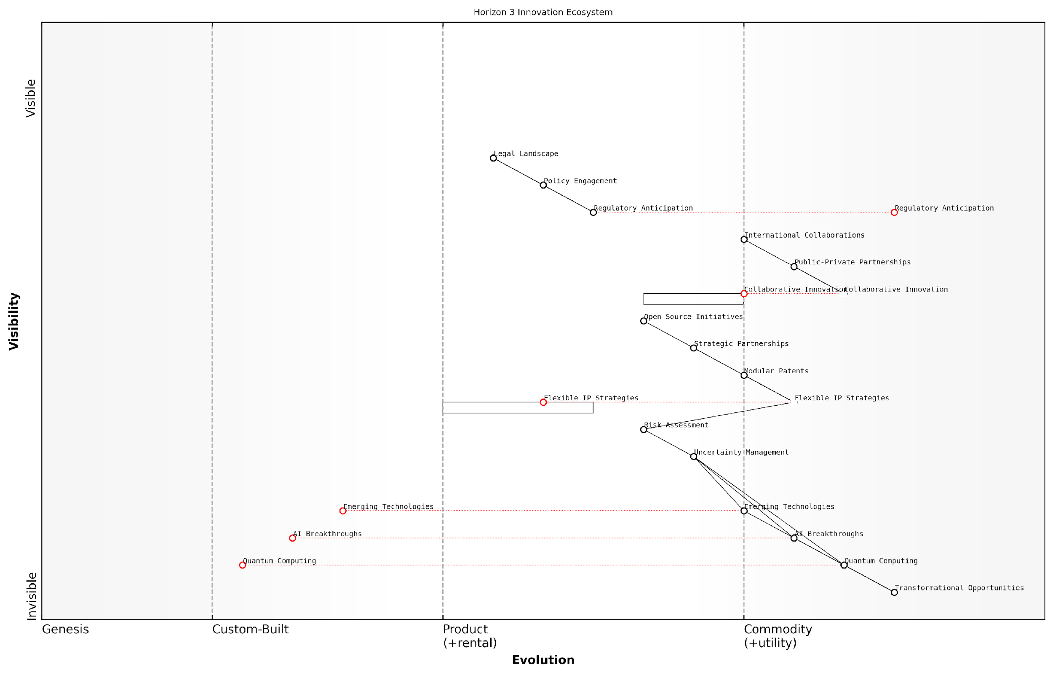

*Draft Wardley Map: [Insert Wardley Map: Horizon 3: Transformational and Disruptive Innovation]*

[Edit this draft Wardley Map](https://create.wardleymaps.ai/#clone:239a1a5f323857f974)

Wardley Map Assessment

This Wardley Map presents a comprehensive view of the Horizon 3 innovation landscape, highlighting the critical interplay between emerging technologies, strategic management practices, and the broader innovation ecosystem. The map emphasises the need for organisations to develop flexible, collaborative approaches to innovation while navigating high levels of uncertainty and rapid technological change. Key to success in this landscape will be the ability to balance cutting-edge technological development with strategic foresight, robust risk management, and adaptive IP strategies. Organisations that can effectively integrate these elements, while also engaging proactively with the regulatory environment, will be best positioned to capitalise on transformational opportunities and shape the industries of the future.

[View full Wardley Map report](http://markdown_wardley_map_reports/wardley_map_report_21_Horizon_3:_Transformational_and_Disruptive_Innovat.md)

In practice, navigating Horizon 3 using the LEGO Wardley Mapping approach for IP strategy requires a delicate balance of vision, flexibility, and pragmatism. It involves creating spaces for experimentation and failure, while also establishing mechanisms to quickly capitalise on breakthroughs when they occur.

For government and public sector organisations, mastering Horizon 3 is not just about staying competitive; it’s about shaping the future of entire industries and economies. By effectively mapping and strategising around transformational innovations, these organisations can play a pivotal role in driving national innovation agendas, fostering economic resilience, and positioning their countries at the forefront of technological revolutions.

Horizon 3 is where nations define their future. It’s where we lay the groundwork for the industries of tomorrow and secure our place in the global innovation landscape. With the right approach to IP strategy, we can turn visionary ideas into tangible economic and societal benefits.

As we continue to explore the LEGO Wardley Mapping manual for IP horizons, we’ll delve deeper into specific techniques for managing Horizon 3 innovations, including scenario planning, rapid prototyping of IP strategies, and creating adaptive governance models for transformative technologies. By mastering these approaches, government and public sector leaders can ensure they are not just prepared for the future, but actively shaping it through strategic IP management and innovation fostering.

## Mapping IP Across Horizons

### Aligning IP Strategy with Innovation Goals

In the dynamic landscape of intellectual property (IP) management, aligning IP strategy with innovation goals is crucial for organisations seeking to maintain a competitive edge. This alignment process is particularly complex when viewed through the lens of innovation horizons, which represent different timeframes and levels of uncertainty in an organisation’s innovation pipeline. The LEGO Wardley Mapping approach offers a powerful visual tool for navigating this complexity, enabling organisations to craft IP strategies that not only protect current assets but also pave the way for future innovations.

To effectively align IP strategy with innovation goals across horizons, we must first understand the distinct characteristics of each horizon and then apply the principles of Wardley Mapping, enhanced by LEGO-inspired visualisation techniques. This approach allows for a more intuitive and flexible representation of the IP landscape, facilitating better decision-making and strategic planning.

* Horizon 1: Core Business and Incremental Innovation
* Horizon 2: Emerging Opportunities and Adjacent Markets
* Horizon 3: Transformational and Disruptive Innovation

Let’s explore how to align IP strategy with each of these horizons using the LEGO Wardley Mapping approach:

Horizon 1: Core Business and Incremental Innovation

In this horizon, the focus is on protecting and optimising existing IP assets that support the core business. The Wardley Map for this horizon typically shows well-understood components with a high degree of certainty.

* Use red LEGO blocks to represent core patents that are critical to current products or services.
* Employ blue blocks for trademarks and brand assets that are well-established in the market.
* Utilise green blocks for copyrights on existing content or software.
* Connect these blocks with LEGO connectors to show interdependencies and potential cross-licensing opportunities.

By visualising the core IP assets in this way, organisations can identify areas where incremental innovations can be protected through strategic patent filings or trademark expansions. This approach also helps in identifying potential gaps in IP coverage that may leave the core business vulnerable to competition.

Horizon 2: Emerging Opportunities and Adjacent Markets

This horizon represents areas where the organisation is expanding into new markets or developing new capabilities. The Wardley Map for this horizon will show a mix of established and evolving components, with a higher degree of uncertainty compared to Horizon 1.

* Use yellow LEGO blocks to represent provisional patents or patent applications for emerging technologies.
* Employ orange blocks for trademarks being considered for new product lines or services.
* Utilise purple blocks for trade secrets that are being developed but not yet ready for patent filing.
* Use LEGO connector pieces with flexibility (such as hinges or ball joints) to show the potential for pivoting or adapting IP strategy as market conditions change.

This visualisation allows organisations to see how their emerging IP assets align with their innovation goals in adjacent markets. It can help identify areas where defensive publications might be more appropriate than patent filings, or where strategic partnerships could fill IP gaps more efficiently than internal development.

Horizon 3: Transformational and Disruptive Innovation

This horizon deals with long-term, potentially disruptive innovations. The Wardley Map for this horizon will have the highest degree of uncertainty, with many components in the genesis or custom-built stages.

* Use white LEGO blocks to represent conceptual IP that is still in the ideation phase.
* Employ transparent blocks for areas where the type of IP protection needed is still unclear.
* Utilise speciality LEGO pieces (like gears or levers) to represent potential game-changing innovations that could disrupt existing markets.
* Use long, flexible LEGO pieces to connect these blocks to the core business, showing how transformational innovations might eventually link back to existing IP assets.

This visualisation helps organisations to ‘future-proof’ their IP strategy by identifying areas where early patent filings or strategic acquisitions could secure a strong position in emerging fields. It also highlights the need for a flexible IP strategy that can adapt to rapid technological changes and market shifts.

The key to successful IP strategy alignment across horizons is not just in protecting what you have, but in preparing for what you might become. The LEGO Wardley Mapping approach provides a tangible way to visualise and manipulate these potential futures.

By using different colours, shapes, and connection methods in the LEGO Wardley Map, organisations can create a dynamic, three-dimensional representation of their IP strategy across all innovation horizons. This approach allows for easy reconfiguration as new information becomes available or as strategic priorities shift.

Moreover, the LEGO Wardley Mapping approach facilitates better communication of IP strategy across different departments within an organisation. The visual and tactile nature of the model makes it easier for non-IP specialists to understand and contribute to the strategic alignment process.

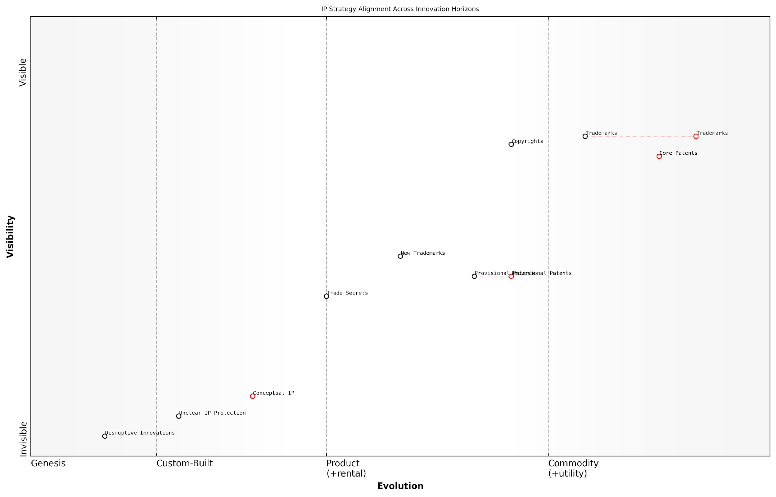

*Draft Wardley Map: [Insert Wardley Map: Aligning IP Strategy with Innovation Goals]*

[Edit this draft Wardley Map](https://create.wardleymaps.ai/#clone:15233bc643469a586f)

Wardley Map Assessment

The map reveals a well-structured IP strategy aligned with different innovation horizons. However, there’s a need to strengthen the transition between horizons, particularly in converting early-stage innovations into protected IP. The organisation is well-positioned in its core business but must develop more robust strategies for future markets to maintain long-term competitiveness. Key focus areas should include developing clear protection strategies for conceptual IP, accelerating the evolution of provisional patents, and creating flexible IP approaches for disruptive innovations. By addressing these areas, the organisation can create a more resilient and future-proof IP portfolio that supports innovation across all horizons.

[View full Wardley Map report](http://markdown_wardley_map_reports/wardley_map_report_22_Aligning_IP_Strategy_with_Innovation_Goals.md)

In conclusion, aligning IP strategy with innovation goals across horizons requires a holistic view of the organisation’s current assets, emerging opportunities, and long-term vision. The LEGO Wardley Mapping approach provides a flexible, intuitive tool for creating this view, enabling organisations to craft IP strategies that are both protective and proactive, ensuring they are well-positioned to navigate the complex landscape of innovation and intellectual property.

### Identifying IP Gaps and Opportunities

In the dynamic landscape of intellectual property strategy, identifying gaps and opportunities is crucial for organisations seeking to maintain a competitive edge. This process becomes even more powerful when combined with the LEGO Wardley Mapping approach, allowing for a visual and modular representation of an organisation’s IP portfolio across different innovation horizons.

The LEGO Wardley Mapping technique provides a unique advantage in this context, as it allows for the creation of a flexible, adaptable model that can evolve with the organisation’s IP strategy. By using this approach, we can effectively identify areas where IP protection is lacking or where new opportunities for IP development and acquisition may arise.

The beauty of the LEGO Wardley Mapping approach lies in its ability to make the invisible visible. It transforms abstract IP concepts into tangible, manipulable elements that can be easily understood and strategically positioned across innovation horizons.

Let’s explore the key aspects of identifying IP gaps and opportunities using the LEGO Wardley Mapping manual:

* Visualising the Current IP Landscape
* Identifying Gaps in IP Coverage
* Spotting Emerging Opportunities
* Aligning IP Strategy with Innovation Horizons
* Leveraging LEGO Techniques for Gap Analysis

Visualising the Current IP Landscape:

The first step in identifying IP gaps and opportunities is to create a comprehensive visual representation of your current IP portfolio using LEGO Wardley Mapping techniques. This involves mapping out all existing patents, trademarks, copyrights, and trade secrets across the value chain and innovation horizons.

By using different coloured LEGO blocks to represent various types of IP assets, and positioning them on a Wardley Map, you can quickly gain insights into the distribution and evolution of your IP portfolio. This visual representation allows for a holistic view of your IP landscape, making it easier to identify areas of strength and weakness.

Identifying Gaps in IP Coverage:

Once the current IP landscape is visualised, gaps in IP coverage become more apparent. These gaps may manifest in several ways:

* Unprotected areas of the value chain
* Lack of IP assets in certain innovation horizons
* Insufficient protection for key technologies or products
* Geographical gaps in IP coverage
* Expiring patents or other time-sensitive IP assets

By using the LEGO Wardley Mapping approach, these gaps can be represented as empty spaces or areas with sparse block coverage on your map. This visual cue makes it easier for stakeholders to identify and prioritise areas requiring attention.

Spotting Emerging Opportunities:

The LEGO Wardley Mapping technique is particularly effective in highlighting emerging opportunities for IP development or acquisition. By mapping potential future scenarios and emerging technologies, organisations can identify areas where new IP assets could provide significant competitive advantage.

These opportunities might include:

* Emerging technologies that align with your innovation strategy
* Potential new markets or applications for existing IP
* Collaborative opportunities for joint IP development
* Strategic acquisition targets to strengthen IP portfolio
* Areas where defensive IP strategies may be necessary

Aligning IP Strategy with Innovation Horizons:

One of the key benefits of using the LEGO Wardley Mapping approach is the ability to align IP strategy with different innovation horizons. By categorising IP assets and opportunities according to their position in the innovation lifecycle, organisations can ensure a balanced approach to IP development and protection.

* Horizon 1: Focus on protecting and optimising existing IP assets
* Horizon 2: Identify opportunities for IP development in adjacent markets or technologies
* Horizon 3: Explore and secure IP in potentially disruptive technologies or business models

This alignment allows for a more strategic allocation of resources and ensures that the IP portfolio supports both short-term needs and long-term innovation goals.

Leveraging LEGO Techniques for Gap Analysis:

The modular nature of LEGO blocks provides unique advantages when conducting IP gap analysis:

* Stackable blocks can represent the strength or depth of IP protection in specific areas
* Different block sizes can indicate the relative importance or value of IP assets
* Connector pieces can show relationships between different IP assets or potential synergies
* Colour coding can be used to differentiate between existing IP, planned IP, and potential acquisition targets

By manipulating these physical or virtual LEGO blocks on your Wardley Map, you can quickly experiment with different IP strategies and visualise their potential impact on your overall IP landscape.

The LEGO Wardley Mapping approach transforms IP strategy from a static, document-based exercise into a dynamic, interactive process. It allows teams to collaboratively explore scenarios, identify gaps, and seize opportunities in real-time.

In conclusion, the LEGO Wardley Mapping manual provides a powerful toolkit for identifying IP gaps and opportunities across innovation horizons. By visualising the current IP landscape, identifying gaps in coverage, spotting emerging opportunities, aligning with innovation horizons, and leveraging LEGO techniques for analysis, organisations can develop more robust and future-proof IP strategies.

This approach not only enhances the effectiveness of IP management but also fosters a culture of innovation and strategic thinking within the organisation. As the IP landscape continues to evolve, the flexibility and adaptability of the LEGO Wardley Mapping approach will prove invaluable in navigating the complexities of intellectual property strategy.

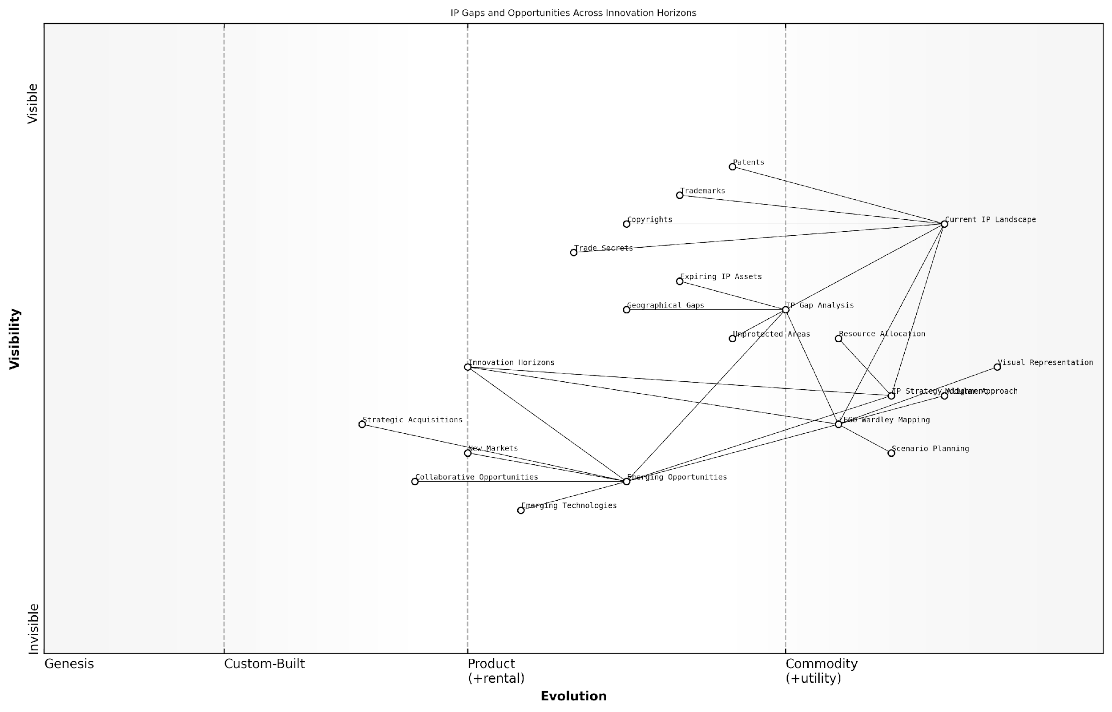

*Draft Wardley Map: [Insert Wardley Map: Identifying IP Gaps and Opportunities]*

[Edit this draft Wardley Map](https://create.wardleymaps.ai/#clone:f2ed52fdbe827700d1)

Wardley Map Assessment

This Wardley Map reveals a well-structured approach to IP management with a clear vision for future development. The integration of LEGO Wardley Mapping provides a unique advantage in strategic planning. Key focus areas should be bridging identified IP gaps, developing capabilities in emerging technologies, and fostering a more collaborative approach to IP creation and management. The balance between protecting current assets and investing in future opportunities is critical, with a need to potentially increase resources allocated to emerging opportunities. The map indicates a strong foundation for future growth, provided the organisation can effectively navigate the transition from current IP landscapes to future innovation horizons.

[View full Wardley Map report](http://markdown_wardley_map_reports/wardley_map_report_23_Identifying_IP_Gaps_and_Opportunities.md)

### Balancing Short-term Protection and Long-term Vision

In the dynamic landscape of intellectual property (IP) strategy, particularly within government and public sector contexts, balancing short-term protection with long-term vision is crucial. This subsection explores how the LEGO Wardley Mapping approach can be leveraged to achieve this delicate equilibrium, ensuring immediate IP safeguards while positioning for future innovation and value creation.

The challenge of balancing short-term protection and long-term vision in IP strategy is akin to playing a complex game of chess, where each move must serve both immediate tactical advantages and overarching strategic goals. By applying LEGO Wardley Mapping techniques, organisations can visualise and navigate this multidimensional challenge with greater clarity and precision.

Effective IP strategy is not about hoarding assets, but about strategically positioning them to create value now and in the future. It’s a delicate balance between protection and projection.

Let’s explore the key components of balancing short-term protection and long-term vision using LEGO Wardley Mapping:

* Mapping Current IP Assets
* Identifying Future Value Chains
* Bridging the Gap with Modular IP Strategies
* Continuous Reassessment and Adaptation

1. Mapping Current IP Assets:

The first step in achieving balance is to accurately map current IP assets using LEGO Wardley techniques. This involves creating a visual representation of existing patents, trademarks, copyrights, and trade secrets, positioning them along the value chain from genesis to commodity. By colour-coding different types of IP and using stackable LEGO blocks to represent the strength or importance of each asset, organisations can gain a clear picture of their current IP landscape.

This mapping exercise often reveals immediate protection needs, such as pending patent applications that require additional resources or trademarks that need to be defended against infringement. It also highlights areas where short-term licensing opportunities may exist, providing quick wins for the organisation.

1. Identifying Future Value Chains:

With the current IP landscape mapped, the next step is to project future value chains. This involves using Wardley’s evolution axis to anticipate how different components of the IP portfolio will move over time. By leveraging LEGO’s modular approach, organisations can build out potential future scenarios, connecting current assets to emerging opportunities.

For instance, a government research institution might map out how its current portfolio of renewable energy patents could evolve to support future smart city initiatives. This forward-looking approach helps identify areas where long-term IP investment is needed, even if immediate returns are not apparent.

The true power of IP strategy lies not in what you protect today, but in how you position yourself for the innovations of tomorrow.

1. Bridging the Gap with Modular IP Strategies:

The LEGO Wardley approach excels in creating modular, adaptable IP strategies that bridge short-term needs with long-term vision. By using connector pieces to link current IP assets with future value chains, organisations can develop flexible strategies that evolve over time.

For example, a public sector organisation might use LEGO blocks to represent a core patent, with smaller, attachable pieces representing potential applications in different sectors. This modular approach allows for immediate protection of the core technology while leaving room for future expansions and collaborations.

1. Continuous Reassessment and Adaptation:

Perhaps the most crucial aspect of balancing short-term protection and long-term vision is the commitment to continuous reassessment and adaptation. The LEGO Wardley approach encourages regular ‘play sessions’ where IP strategies can be reconfigured based on new information, market changes, or technological advancements.

This iterative process ensures that organisations remain agile in their IP strategy, able to respond to immediate threats or opportunities while staying aligned with long-term goals. It also helps in identifying when certain IP assets have become commoditised and may no longer require the same level of protection, freeing up resources for emerging areas of innovation.

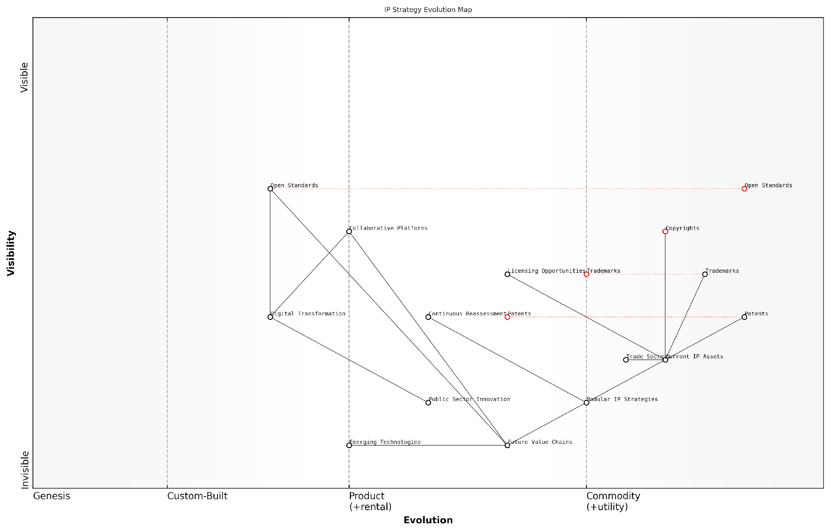

*Draft Wardley Map: [Insert Wardley Map: Balancing Short-term Protection and Long-term Vision]*

[Edit this draft Wardley Map](https://create.wardleymaps.ai/#clone:4e8e54c6f43a6bed7a)

Wardley Map Assessment

This Wardley Map reveals a strategic inflection point in IP management, where organisations must balance the protection of current IP assets with the need to adapt to a more open, collaborative innovation ecosystem. The key to success lies in developing modular, adaptable IP strategies and capabilities for continuous reassessment. Organisations that can effectively navigate this transition, leveraging both traditional IP protection and emerging collaborative models, will be best positioned to create and capture value in future technology landscapes. The integration of public sector innovation and the focus on digital transformation suggest a holistic approach to IP strategy that goes beyond traditional corporate boundaries, emphasising the need for ecosystem thinking in IP management.

[View full Wardley Map report](http://markdown_wardley_map_reports/wardley_map_report_24_Balancing_Short-term_Protection_and_Long-term_Visi.md)

Case Study: UK Government Digital Service

To illustrate these principles in action, consider the case of the UK Government Digital Service (GDS). When developing their digital transformation strategy, GDS used a LEGO Wardley mapping approach to balance immediate needs for secure, proprietary systems with a long-term vision of open standards and shared platforms.

By mapping their current IP assets, including bespoke software and data management systems, GDS identified areas requiring immediate protection. Simultaneously, they projected future value chains around open-source technologies and cross-departmental platforms. Using modular LEGO-like strategies, they created a flexible IP framework that allowed for short-term protection of critical systems while gradually transitioning towards more open, collaborative models.

This balanced approach enabled GDS to safeguard essential IP in the short term while positioning themselves as leaders in government digital transformation for the long term. Regular reassessments allowed them to adapt their strategy as technologies evolved and new opportunities emerged.

In the public sector, the goal of IP strategy isn’t just protection, but enabling innovation that serves the greater good. It’s about finding the right balance between safeguarding public investments and fostering an ecosystem of shared knowledge and collaborative progress.

In conclusion, balancing short-term protection and long-term vision in IP strategy is a complex but essential task, particularly in the government and public sector where the stakes are high and the impact far-reaching. The LEGO Wardley Mapping approach provides a powerful toolkit for visualising, planning, and adapting IP strategies that serve both immediate needs and future aspirations. By embracing this modular, iterative approach, organisations can build IP portfolios that are both robust and flexible, capable of weathering current challenges while positioning for future opportunities.

## LEGO Techniques for Horizon Planning

### Building Modular IP Portfolios

In the realm of intellectual property strategy, the concept of building modular IP portfolios represents a paradigm shift in how organisations approach the development and management of their intellectual assets. By leveraging LEGO-inspired techniques within the framework of Wardley Mapping, we can create flexible, adaptable, and strategically aligned IP portfolios that span multiple innovation horizons. This approach is particularly crucial for government and public sector entities, which must balance long-term vision with the need for immediate protection and value creation.

The modular IP portfolio approach draws inspiration from LEGO’s fundamental principle of interconnectedness and adaptability. Just as LEGO bricks can be assembled, disassembled, and reassembled in countless configurations, a modular IP portfolio allows organisations to reconfigure their intellectual assets to meet evolving strategic needs across different innovation horizons.

Modular IP portfolios are not just about accumulating patents or trademarks; they’re about creating a dynamic ecosystem of intellectual assets that can be rapidly reconfigured to address emerging opportunities and challenges across multiple time horizons.

Let’s explore the key components and strategies for building modular IP portfolios using LEGO Wardley Mapping techniques:

* Core IP Blocks: Identifying foundational intellectual assets
* Connector Pieces: Creating linkages between different IP elements
* Speciality Pieces: Developing unique, high-value IP assets
* Assembly Instructions: Crafting strategies for different scenarios
* Colour-Coding: Visualising IP types and their evolution

Core IP Blocks: These represent the fundamental intellectual assets that form the backbone of an organisation’s IP portfolio. In a Wardley Map, these would typically be positioned in the lower left quadrant, representing more mature and essential components. For a government agency, core IP blocks might include foundational patents related to critical infrastructure technologies or well-established trademarks for key public services.

Connector Pieces: In the LEGO Wardley Mapping approach, connector pieces symbolise the relationships and dependencies between different IP assets. These are crucial for creating a cohesive IP strategy that spans multiple innovation horizons. For instance, a connector piece might represent a licensing agreement that links a core technology patent (Horizon 1) with an emerging application in an adjacent market (Horizon 2).

Speciality Pieces: These represent unique, high-value IP assets that differentiate the organisation’s offering. In a Wardley Map, speciality pieces would often be positioned towards the top right, representing more custom and value-driving components. For a public sector entity, this might include cutting-edge AI algorithms for predictive policing or innovative green energy technologies developed through government-funded research.

Assembly Instructions: This concept refers to the strategic planning required to effectively combine and reconfigure IP assets across different scenarios and time horizons. By creating ‘instruction sets’ for various strategic outcomes, organisations can quickly adapt their IP portfolios to changing market conditions or policy priorities.

The true power of a modular IP portfolio lies not just in the individual assets, but in the myriad ways they can be combined and reconfigured to create value across different time horizons and strategic scenarios.

Colour-Coding: Utilising LEGO’s iconic colour system, we can visually represent different types of IP (patents, trademarks, copyrights, trade secrets) and their evolution across the Wardley Map. This visual approach allows stakeholders to quickly grasp the composition and strategic positioning of the IP portfolio across innovation horizons.

Implementing this modular approach requires a shift in mindset from traditional IP management practices. Instead of viewing IP assets as static entities, organisations must adopt a dynamic, systems-thinking approach that considers how each piece of IP fits into the larger strategic puzzle.

Case Study: UK Government’s Approach to AI and Data Ethics

Consider the UK government’s efforts to establish leadership in AI and data ethics. By applying the modular IP portfolio approach, they have:

* Core IP Blocks: Developed foundational ethical frameworks and guidelines for AI use in public services (Horizon 1)
* Connector Pieces: Created cross-departmental working groups to ensure consistent application of AI ethics across different government functions
* Speciality Pieces: Invested in cutting-edge research on explainable AI and algorithmic fairness (Horizon 3)
* Assembly Instructions: Crafted flexible policy frameworks that can adapt to rapid technological advancements
* Colour-Coding: Visualised the interplay between legal protections (patents), ethical guidelines (copyrights), and public-facing initiatives (trademarks) across the AI ethics landscape

This modular approach has allowed the UK government to build a comprehensive yet flexible IP strategy around AI ethics, positioning itself as a global leader in this critical field while maintaining the ability to adapt to future developments.

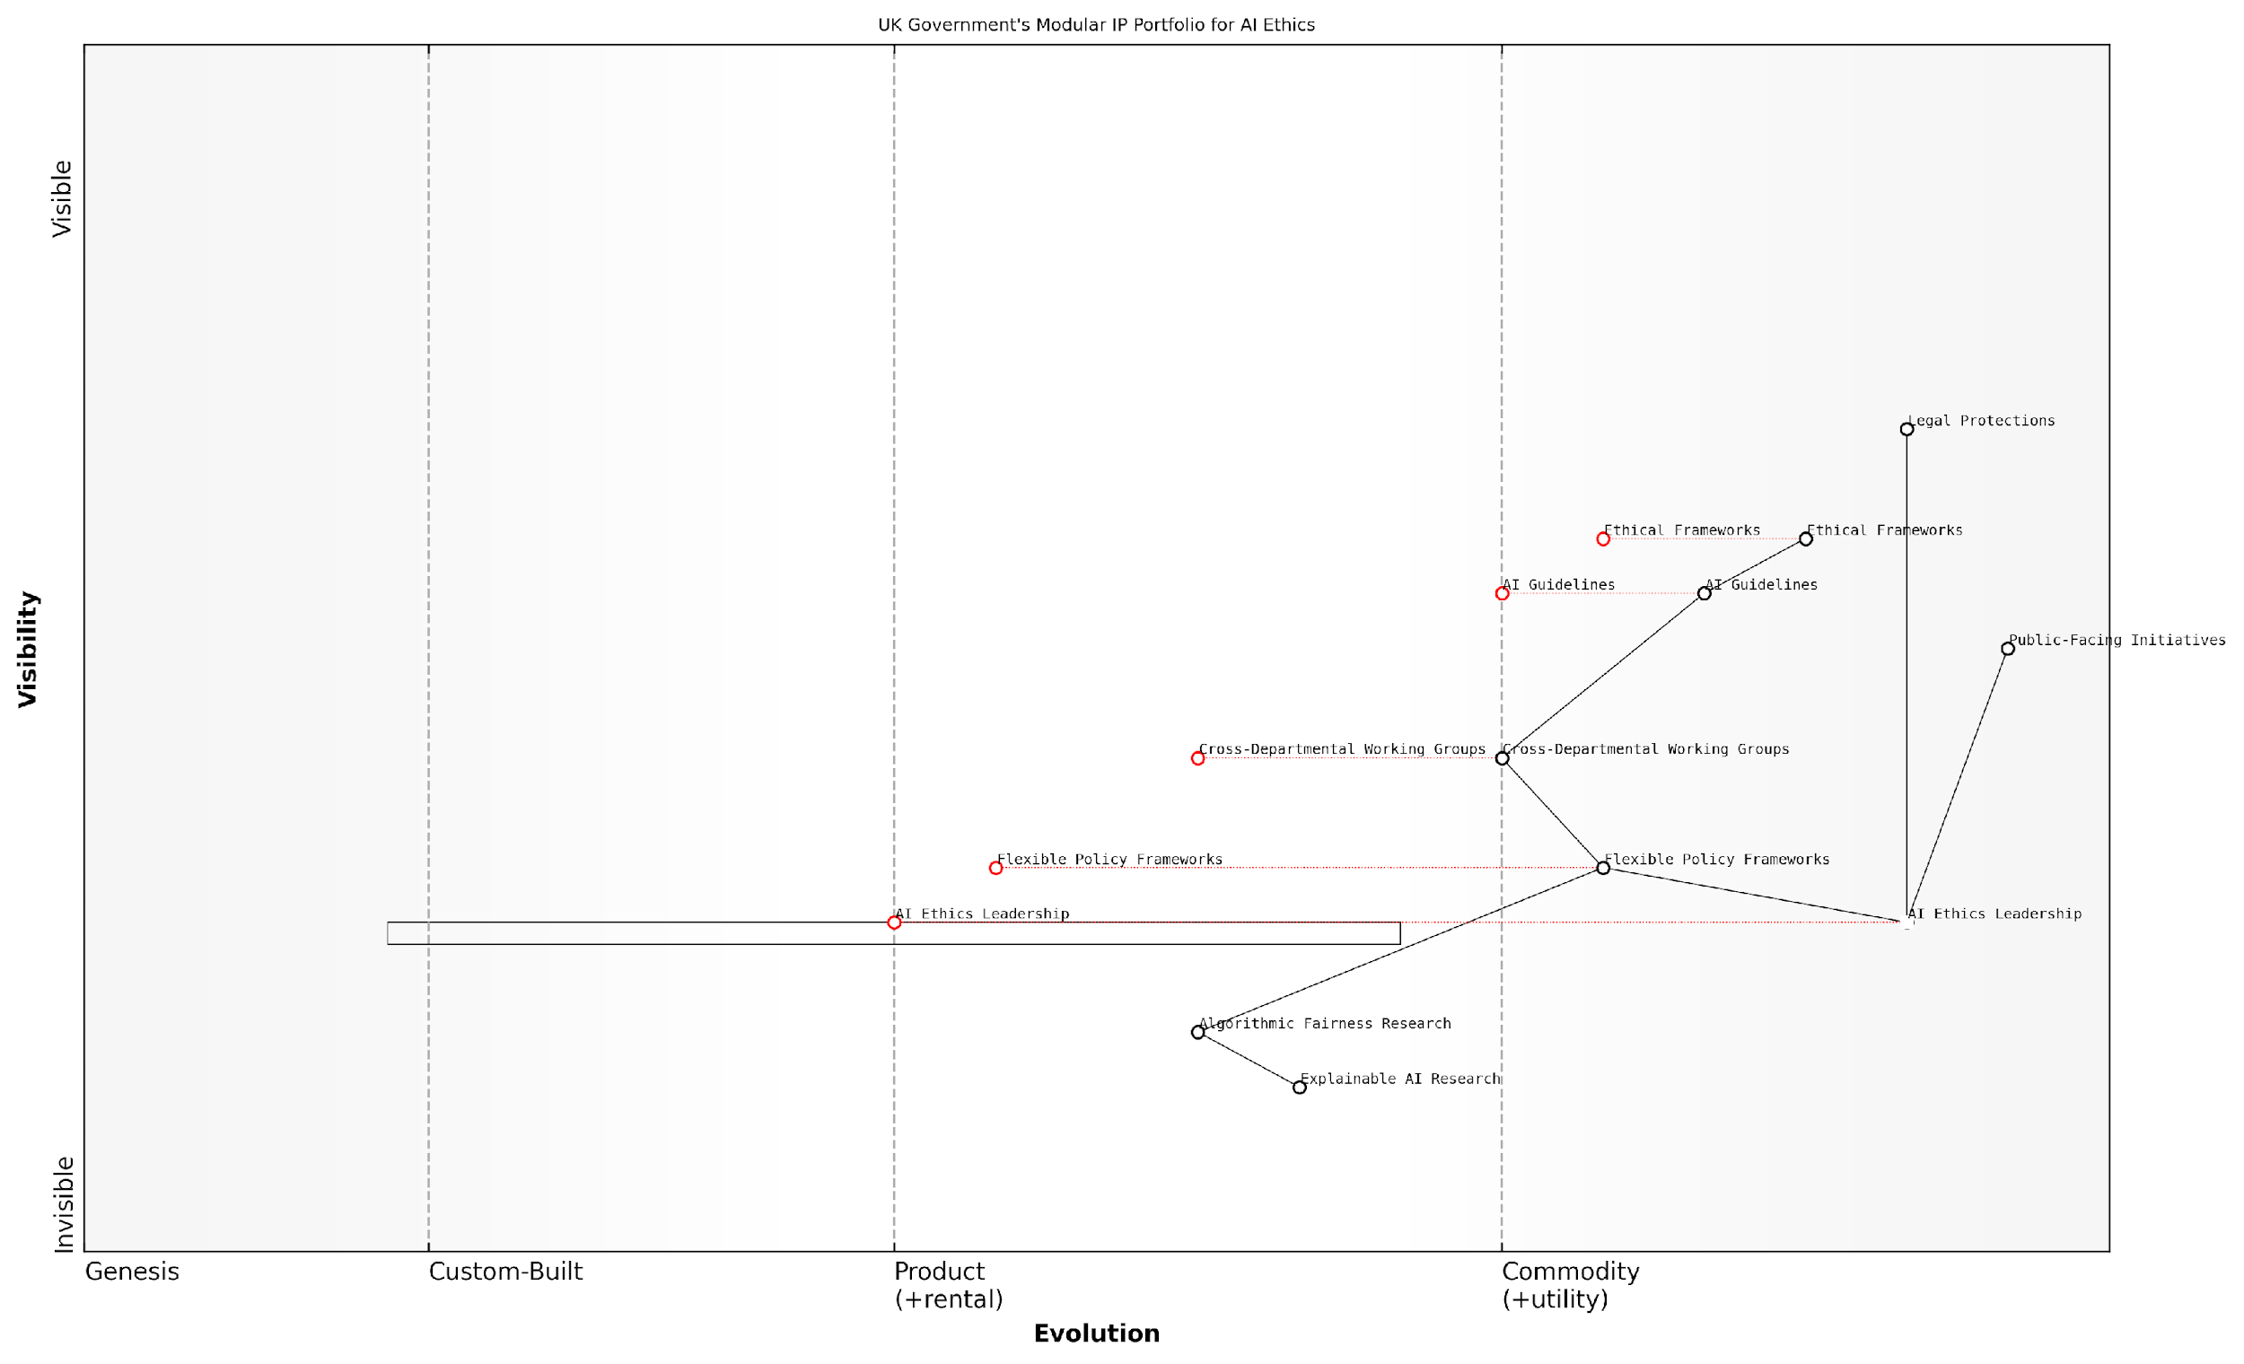

*Draft Wardley Map: [Insert Wardley Map: Building Modular IP Portfolios]*

[Edit this draft Wardley Map](https://create.wardleymaps.ai/#clone:bb38d3a741062dbed2)

Wardley Map Assessment

The UK Government’s strategy for a modular IP portfolio in AI ethics demonstrates a comprehensive and well-structured approach. It balances cutting-edge research with practical policy implementation and public engagement. The strategy’s strength lies in its integrated approach and strong focus on public trust. However, to maintain leadership in this rapidly evolving field, there’s a need to accelerate the evolution of flexible policy frameworks and strengthen the pipeline from research to implementation. The government is well-positioned to lead in AI ethics, but must remain agile and continue to invest in emerging areas like explainable AI and algorithmic fairness to stay ahead of global competition and technological advancements.

[View full Wardley Map report](http://markdown_wardley_map_reports/wardley_map_report_25_Building_Modular_IP_Portfolios.md)

By adopting a modular approach to IP portfolio building, organisations can create a dynamic and responsive intellectual asset base that aligns with their strategic goals across multiple time horizons. This LEGO-inspired technique, when combined with Wardley Mapping, provides a powerful tool for visualising, planning, and executing IP strategies that can adapt to the complex and ever-changing landscape of innovation.

In the digital age, the most valuable IP portfolios are those that can be rapidly reconfigured to meet new challenges and opportunities. The LEGO Wardley Mapping approach to modular IP portfolios provides a framework for building just such an adaptive and resilient intellectual asset base.

As we move forward in this chapter, we will explore how these modular IP portfolios can be leveraged to bridge different innovation horizons and create flexible IP architectures that are primed for future adaptation.

### Using Connector Pieces to Bridge Horizons

In the realm of intellectual property strategy, the ability to connect and transition between different innovation horizons is crucial for long-term success. This section explores how LEGO-inspired connector pieces can be utilised in Wardley Mapping to effectively bridge these horizons, creating a cohesive and adaptable IP strategy that spans from incremental improvements to transformative innovations.

Connector pieces in LEGO serve as vital links between different components, allowing for complex structures to be built from simpler elements. In the context of IP strategy and Wardley Mapping, these connectors represent the strategic linkages between different innovation horizons, enabling organisations to visualise and plan for the evolution of their IP assets over time.

The true power of an IP strategy lies not in its individual components, but in how they are connected and leveraged across different time horizons.

Let us explore the key aspects of using connector pieces to bridge innovation horizons in IP strategy:

* Identifying Strategic IP Connections
* Visualising IP Evolution Pathways
* Facilitating Technology Transfer
* Enabling Cross-Horizon IP Leverage
* Mitigating Innovation Gaps

Identifying Strategic IP Connections: The first step in using connector pieces is to identify the potential linkages between IP assets across different horizons. This involves analysing how current IP (Horizon 1) can be extended or adapted to support emerging opportunities (Horizon 2) or even contribute to transformative innovations (Horizon 3). For instance, a core patent in data encryption (Horizon 1) might have applications in emerging blockchain technologies (Horizon 2) and ultimately contribute to a revolutionary decentralised identity system (Horizon 3).

Visualising IP Evolution Pathways: Once strategic connections are identified, they can be represented on the Wardley Map using LEGO-inspired connector pieces. These connectors visually demonstrate how IP assets might evolve or be repurposed over time. For example, a flexible connector piece could represent a versatile algorithm that has applications across multiple horizons, while a rigid connector might symbolise a specific patent that provides a stable foundation for future innovations.

Facilitating Technology Transfer: Connector pieces can be particularly useful in illustrating how technology and IP can be transferred between different horizons. This is crucial for government and public sector organisations looking to leverage their research and development efforts across various timeframes and applications. For instance, a connector piece might show how a government-funded research project in advanced materials (Horizon 3) could lead to improvements in existing infrastructure (Horizon 1) while also enabling new clean energy technologies (Horizon 2).

Enabling Cross-Horizon IP Leverage: By visualising connections between horizons, organisations can identify opportunities to leverage IP assets across different stages of innovation. This could involve using established patents to protect emerging technologies or applying know-how from mature industries to disruptive new fields. For example, a public health agency might use connector pieces to show how its extensive database of health records (Horizon 1) could inform the development of AI-driven diagnostic tools (Horizon 2) and ultimately contribute to personalised medicine initiatives (Horizon 3).

The ability to leverage IP across horizons is not just about protection; it’s about creating a multiplier effect for innovation and value creation.

Mitigating Innovation Gaps: Connector pieces can also help identify and address potential gaps in an organisation’s IP portfolio. By mapping out the connections between horizons, it becomes easier to spot areas where additional IP protection or development may be needed to ensure a smooth transition between different stages of innovation. This is particularly important for government bodies and public sector organisations that need to maintain long-term strategic advantages while also fostering innovation in emerging fields.

Practical Application in Government and Public Sector: When applying this approach in government and public sector contexts, it’s essential to consider the unique challenges and opportunities these organisations face. For instance, a national defence agency might use connector pieces to illustrate how investments in quantum computing research (Horizon 3) could enhance current cryptographic capabilities (Horizon 1) while also enabling new secure communication technologies (Horizon 2). This visualisation can help justify long-term research funding by demonstrating the potential impact across multiple timeframes and applications.

Moreover, the use of connector pieces in IP strategy can facilitate cross-department collaboration and resource allocation. By clearly showing the linkages between different innovation horizons, government bodies can identify opportunities for shared IP development and utilisation, potentially leading to more efficient use of public resources and accelerated innovation in key areas of national interest.

It’s important to note that the effective use of connector pieces in IP strategy requires a deep understanding of both the technical aspects of the innovations involved and the legal frameworks governing intellectual property. As such, interdisciplinary teams comprising IP lawyers, technical experts, and strategic planners are often necessary to fully leverage this approach.

In the complex landscape of government innovation, the ability to visualise and strategically connect IP assets across horizons can be the difference between fragmented efforts and a cohesive, forward-looking national innovation strategy.

In conclusion, the use of LEGO-inspired connector pieces in Wardley Mapping provides a powerful tool for bridging innovation horizons in IP strategy. By enabling organisations to visualise and plan for the evolution of their IP assets over time, this approach supports more robust, flexible, and forward-looking IP management. For government and public sector organisations, this can translate into more effective use of resources, better-aligned research and development efforts, and ultimately, enhanced ability to drive and support innovation for the public good.

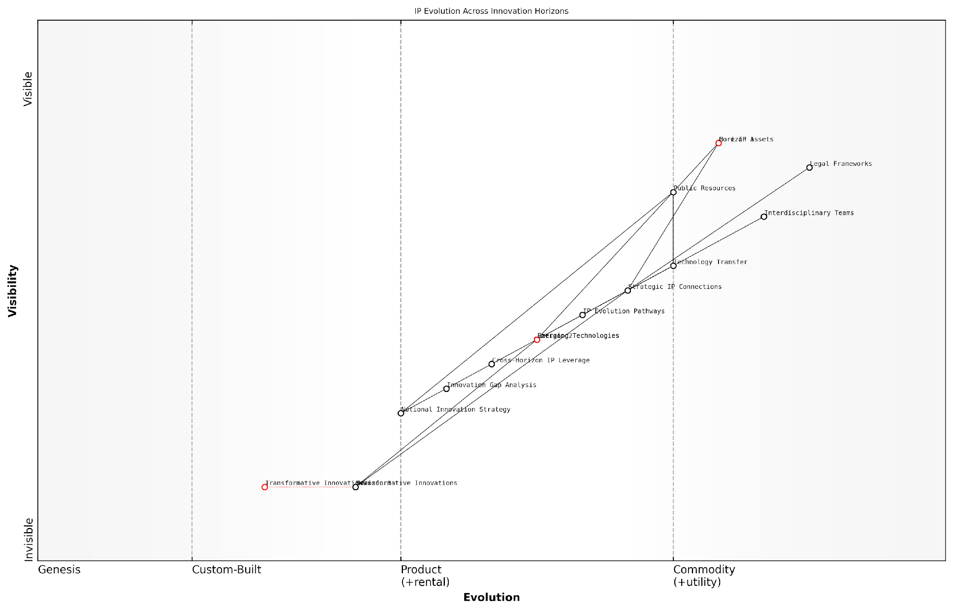

*Draft Wardley Map: [Insert Wardley Map: Using Connector Pieces to Bridge Horizons]*

[Edit this draft Wardley Map](https://create.wardleymaps.ai/#clone:71c960c9d997a99f10)

Wardley Map Assessment

This Wardley Map presents a sophisticated view of IP evolution across innovation horizons, highlighting the critical role of strategic connections and cross-horizon leverage. The key to success lies in effectively managing the transition of value from transformative innovations through emerging technologies to core assets, while continuously evolving legal and organisational frameworks. Organisations that can master this complex interplay of components will be well-positioned to maintain competitive advantage in a rapidly changing innovation landscape.

[View full Wardley Map report](http://markdown_wardley_map_reports/wardley_map_report_26_Using_Connector_Pieces_to_Bridge_Horizons.md)

### Creating Flexible IP Architectures for Future Adaptation

In the rapidly evolving landscape of intellectual property (IP) management, creating flexible IP architectures that can adapt to future changes is paramount. This subsection explores how LEGO-inspired techniques can be applied to Wardley Mapping to build adaptable IP strategies across innovation horizons. By leveraging the modularity and versatility inherent in both LEGO systems and Wardley Mapping, organisations can construct IP architectures that are resilient, scalable, and primed for future opportunities.

The concept of flexible IP architectures aligns closely with the principles of dynamic capability theory in strategic management. Just as organisations need to reconfigure their resources to address changing environments, IP strategies must be designed with built-in flexibility to navigate uncertain futures. The LEGO Wardley Mapping approach provides a visual and tactile method for achieving this adaptability.

Flexible IP architectures are not just about protecting current assets; they’re about creating a framework that allows for rapid pivoting and scaling as new opportunities and challenges emerge in the innovation landscape.

Let’s explore the key components of creating flexible IP architectures using LEGO Wardley Mapping techniques:

* Modular IP Building Blocks
* Interconnected IP Systems
* Scenario Planning with LEGO Wardley Maps
* Adaptive IP Portfolio Management

Modular IP Building Blocks:

The foundation of a flexible IP architecture lies in creating modular IP building blocks. These blocks represent discrete units of intellectual property that can be combined, reconfigured, and repurposed as needed. In the LEGO Wardley Mapping context, each block might represent a patent, a trademark, a piece of proprietary software, or a trade secret.

To implement this concept:

* Categorise IP assets into distinct, self-contained modules
* Use different LEGO brick colours to represent various types of IP (e.g., blue for patents, red for trademarks)
* Assign ‘connection points’ to each IP block, indicating how it can interface with other IP assets
* Create a library of IP building blocks that can be easily visualised and manipulated on your Wardley Map

Interconnected IP Systems:

Flexible IP architectures thrive on interconnectivity. By designing your IP strategy as a system of interconnected components, you create a structure that can adapt to changes in the market, technology, or regulatory environment. In the LEGO Wardley Map, this is represented by how different IP blocks connect and interact with each other.

Key considerations for building interconnected IP systems include:

* Identify dependencies between different IP assets
* Use LEGO connector pieces to show relationships between IP blocks on your Wardley Map
* Create ‘IP stacks’ that represent fully integrated IP solutions for specific products or services
* Design your IP architecture with ‘plug-and-play’ capabilities, allowing for easy addition or removal of IP components

Scenario Planning with LEGO Wardley Maps:

One of the most powerful aspects of using LEGO Wardley Mapping for IP strategy is the ability to quickly model different scenarios and future states. This allows organisations to prepare for various potential outcomes and ensure their IP architecture can adapt accordingly.

To leverage this capability:

* Create multiple versions of your IP Wardley Map to represent different future scenarios
* Use LEGO baseplates to represent different time horizons or market conditions
* Experiment with rearranging IP blocks to visualise how your strategy might evolve
* Identify which IP components remain constant across scenarios and which need to be more flexible

The ability to physically manipulate and reconfigure IP strategies using LEGO bricks provides a tangible way to explore complex future scenarios, making abstract concepts concrete and actionable.

Adaptive IP Portfolio Management:

Flexible IP architectures require ongoing management and adaptation. The LEGO Wardley Mapping approach facilitates this by providing a clear, visual representation of your IP portfolio that can be easily updated and refined over time.

Key strategies for adaptive IP portfolio management include:

* Regularly review and update your LEGO Wardley Map to reflect changes in your IP landscape
* Use the evolution axis of the Wardley Map to track the maturity of different IP assets
* Implement a ‘LEGO suggestion box’ where team members can propose new IP configurations or strategies
* Develop a set of ‘IP architecture patterns’ that can be quickly deployed in response to market changes

By implementing these LEGO-inspired techniques for creating flexible IP architectures, organisations can build IP strategies that are not only robust but also adaptable to future challenges and opportunities. This approach aligns well with the dynamic nature of innovation across different horizons, ensuring that IP management remains a strategic asset rather than a static collection of protections.

In conclusion, the creation of flexible IP architectures using LEGO Wardley Mapping techniques offers a powerful tool for organisations navigating the complex and ever-changing landscape of intellectual property. By embracing modularity, interconnectivity, scenario planning, and adaptive management, companies can build IP strategies that are resilient, scalable, and primed for future success across all innovation horizons.

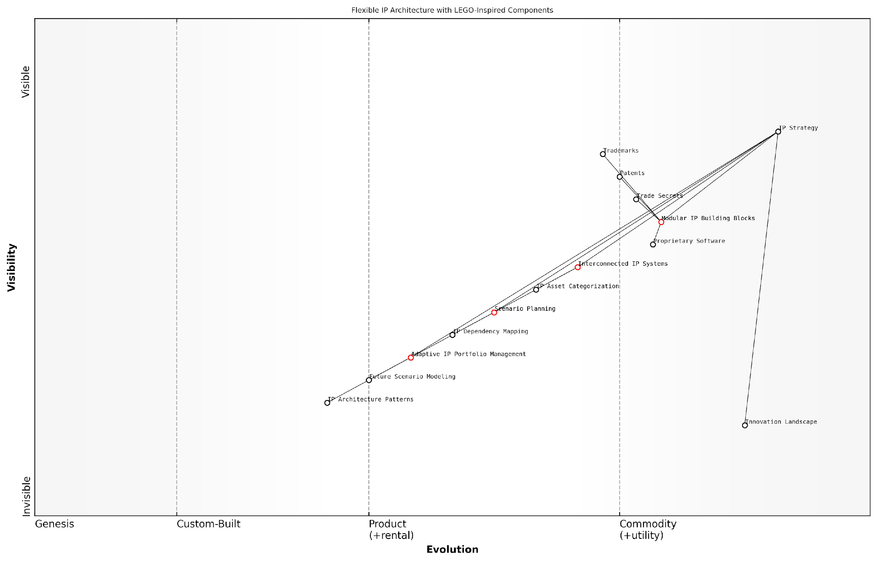

*Draft Wardley Map: [Insert Wardley Map: Creating Flexible IP Architectures for Future Adaptation]*

[Edit this draft Wardley Map](https://create.wardleymaps.ai/#clone:b59cf88190f3c1781b)

Wardley Map Assessment

This Wardley Map presents a forward-thinking approach to IP architecture, emphasising flexibility and adaptability in response to market changes. The strategy of using modular, LEGO-like IP building blocks combined with interconnected systems and scenario planning positions the organisation well for future challenges. However, to fully capitalise on this approach, there needs to be a continued focus on evolving the less certain components, particularly in areas of adaptive management and predictive modelling. The organisation should prioritise developing more dynamic capabilities in scenario planning and adaptive portfolio management, while also exploring emerging technologies like AI and blockchain to enhance its IP strategy. By doing so, it can create a truly flexible IP architecture that not only responds to market changes but anticipates and shapes them, providing a significant competitive advantage in an increasingly complex IP landscape.

[View full Wardley Map report](http://markdown_wardley_map_reports/wardley_map_report_27_Creating_Flexible_IP_Architectures_for_Future_Adap.md)

# Chapter 3: Leveraging IP Opportunities

## Strategic IP Positioning

### Offensive vs. Defensive IP Strategies

In the realm of intellectual property (IP) strategy, particularly within the context of The LEGO Wardley Mapping manual for horizons of intellectual property, understanding the nuances between offensive and defensive approaches is crucial. This dichotomy forms the foundation of strategic IP positioning, allowing organisations to effectively leverage their intellectual assets in an increasingly competitive landscape.

Offensive IP strategies are proactive approaches aimed at creating value and gaining competitive advantage. These strategies often involve aggressively pursuing patent applications, actively enforcing IP rights, and strategically using IP to block competitors or gain market share. Defensive strategies, on the other hand, focus on protecting existing IP assets, mitigating risks, and maintaining freedom to operate within a given market space.

The choice between offensive and defensive IP strategies is not binary. The most effective IP strategies often blend elements of both, creating a dynamic and adaptable approach that evolves with the organisation’s goals and market conditions.

When applying the LEGO Wardley Mapping approach to IP strategy, we can visualise these offensive and defensive elements as interconnected building blocks within our strategic landscape. This visualisation allows us to better understand how different IP assets and strategies interact and evolve over time.

* Offensive Strategies in LEGO Wardley Mapping:
  + Represented by forward-moving blocks on the map
  + Often positioned towards the right side, indicating novel or emerging technologies
  + Connected to potential new revenue streams or market opportunities
* Defensive Strategies in LEGO Wardley Mapping:
  + Represented by stable or protective blocks
  + Often positioned towards the left side, indicating more established technologies or markets
  + Connected to core business operations and existing revenue streams

One of the key advantages of using the LEGO Wardley Mapping approach for IP strategy is the ability to easily reconfigure and adapt our strategic positioning as market conditions change. This flexibility is particularly valuable when balancing offensive and defensive strategies.

For instance, a government agency developing new technologies for public services might initially adopt a defensive IP strategy, focusing on protecting its innovations and ensuring freedom to operate. However, as the technology matures and opportunities for commercialisation or international collaboration emerge, the agency might shift towards a more offensive strategy, actively seeking partnerships or licensing opportunities.

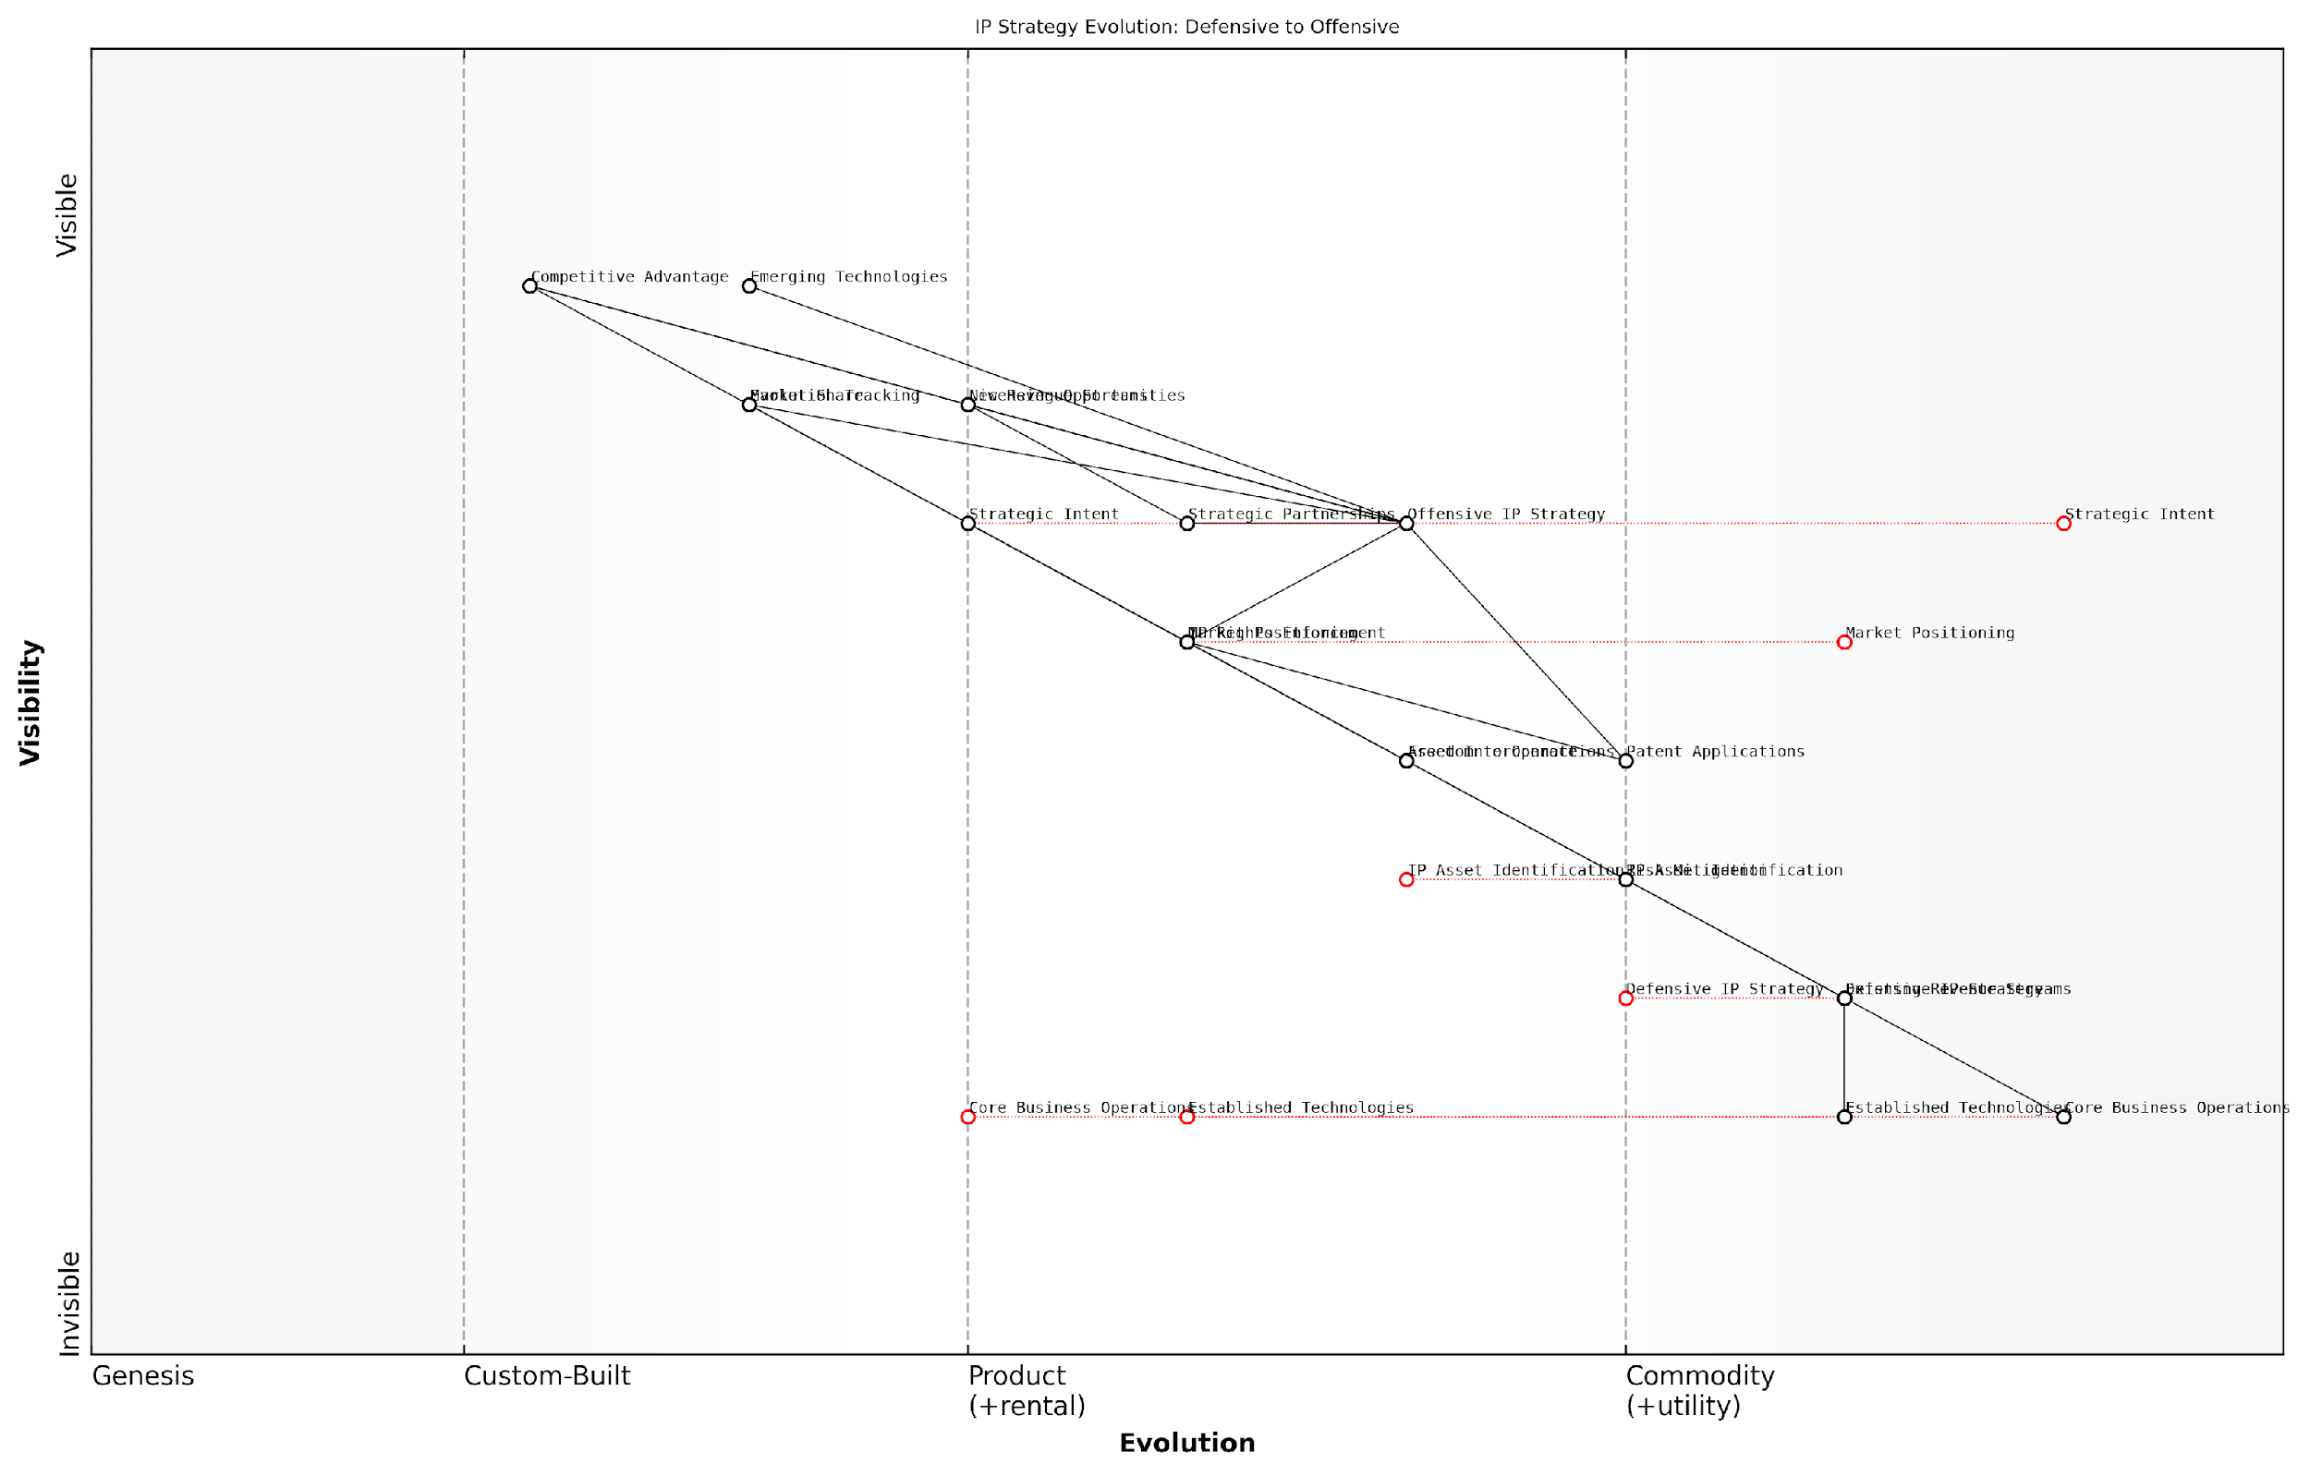

*Draft Wardley Map: [Insert Wardley Map: Offensive vs. Defensive IP Strategies]*

[Edit this draft Wardley Map](https://create.wardleymaps.ai/#clone:95f03d3065ff3d9e7a)

Wardley Map Assessment

This Wardley Map reveals a strategic inflection point in IP management, showcasing the transition from a primarily defensive posture to a more offensive, value-creating approach. The integration of emerging technologies and strategic intent into IP strategy presents significant opportunities for competitive advantage and new revenue streams. However, this evolution also introduces new risks and capability requirements. Success will depend on balancing traditional defensive measures with aggressive offensive tactics, all while maintaining agility to adapt to rapid technological changes. Companies that can effectively navigate this transition, leveraging both established and emerging components of their IP ecosystem, will be well-positioned to dominate their markets and drive innovation in their industries.

[View full Wardley Map report](http://markdown_wardley_map_reports/wardley_map_report_28_Offensive_vs._Defensive_IP_Strategies.md)

In practice, the implementation of offensive and defensive IP strategies using the LEGO Wardley Mapping approach involves several key considerations:

* 1. Asset Identification: Clearly map out all IP assets, including patents, trademarks, copyrights, and trade secrets.
  2. Market Positioning: Place each asset on the Wardley Map based on its current market position and level of commoditisation.
  3. Strategic Intent: Use different coloured LEGO blocks to represent offensive (e.g., red) and defensive (e.g., blue) strategic intents for each asset.
  4. Interconnections: Utilise LEGO connectors to show relationships between assets and how they support overall business objectives.
  5. Evolution Tracking: Regularly update the map to reflect changes in asset positioning and strategic intent over time.

A real-world example of this approach in action comes from my experience advising a UK government research institution. The institution had developed a promising new renewable energy technology but was unsure how to position its IP strategy.

Using the LEGO Wardley Mapping approach, we created a visual representation of their IP landscape. Initially, most of their IP assets were positioned defensively, focused on protecting their core research. However, as we mapped out potential future scenarios, we identified opportunities for a more offensive strategy, including strategic patenting to block potential competitors and proactive licensing to industry partners.

By visualising our IP strategy using LEGO Wardley Mapping, we were able to shift our thinking from purely protective to value-creating. This new perspective opened up opportunities we hadn’t previously considered and allowed us to develop a more balanced and dynamic IP strategy.

This case exemplifies how the LEGO Wardley Mapping approach can help organisations, particularly in the public sector, to move beyond traditional, often defensive, IP strategies towards more nuanced and value-driven approaches.

In conclusion, the effective balancing of offensive and defensive IP strategies is crucial for organisations seeking to maximise the value of their intellectual assets. The LEGO Wardley Mapping approach provides a powerful tool for visualising, planning, and adapting these strategies in response to changing market conditions and organisational goals. By embracing this methodology, organisations can develop more dynamic, responsive, and value-driven IP strategies that support their broader objectives and drive innovation.

### Creating IP Moats and Barriers to Entry

In the realm of intellectual property strategy, creating effective moats and barriers to entry is a crucial aspect of maintaining competitive advantage. This concept, when viewed through the lens of LEGO Wardley Mapping, takes on new dimensions of clarity and strategic depth. By visualising IP assets and their relationships within the competitive landscape, organisations can construct robust defences around their innovations and market positions.

The LEGO Wardley Mapping approach to creating IP moats involves several key strategies:

* Layered IP Protection
* Strategic Patent Clustering
* Trade Secret Fortification
* Dynamic IP Portfolio Management
* Cross-licensing and Patent Pooling

Let’s explore each of these strategies in detail, demonstrating how they can be effectively visualised and implemented using LEGO Wardley Mapping techniques.

1. Layered IP Protection

Layered IP protection involves creating multiple layers of intellectual property rights around a core innovation or product. In LEGO Wardley Mapping, this can be visualised as stacked blocks of different colours, each representing a different type of IP protection.

For instance, a pharmaceutical company might protect a new drug formulation with:

* Patents on the active compound (represented by red blocks)
* Patents on the manufacturing process (blue blocks)
* Trademarks for the drug name and branding (yellow blocks)
* Trade secrets for specific formulation details (green blocks)

By stacking these ‘blocks’ in the Wardley Map, we can visually represent the comprehensive protection strategy, making it easier to identify gaps or opportunities for additional layers.

1. Strategic Patent Clustering

Patent clustering involves filing multiple related patents around a core technology or product. In LEGO Wardley Mapping, this can be visualised as a central block surrounded by interconnected smaller blocks.

This strategy is particularly effective in fast-moving technology sectors. For example, a telecommunications company might create a patent cluster around a new 5G technology:

* Core patent on the fundamental 5G technology (central block)
* Patents on various implementations and applications (surrounding blocks)
* Patents on complementary technologies and improvements (connected blocks)

By visualising this cluster in a Wardley Map, strategists can identify areas for further patent development and potential licensing opportunities.

1. Trade Secret Fortification

While patents provide time-limited monopolies, trade secrets can offer indefinite protection if properly maintained. In LEGO Wardley Mapping, trade secrets can be represented as special ‘locked’ blocks that require specific conditions to access or move.

For instance, a soft drink company might protect its formula through:

* Strict access controls (represented by a ‘key’ mechanism on the block)
* Employee confidentiality agreements (visualised as a ‘shield’ around the block)
* Segmentation of the formula (multiple ‘locked’ blocks that must be combined)

By mapping these elements, organisations can ensure comprehensive protection of their most valuable secrets and identify potential vulnerabilities.

1. Dynamic IP Portfolio Management

In rapidly evolving markets, static IP strategies quickly become obsolete. Dynamic IP portfolio management involves continuously reassessing and reconfiguring IP assets. LEGO Wardley Mapping excels in visualising this process, allowing for easy reconfiguration of ‘blocks’ as market conditions change.

A technology company might use this approach to:

* Identify and divest non-core patents (removing blocks from the map)
* Acquire strategic IP assets (adding new blocks)
* Reposition existing IP for new markets (moving blocks to different areas of the map)

This visual, dynamic approach allows for agile IP strategy adjustments in response to market shifts or competitive moves.

1. Cross-licensing and Patent Pooling

In complex technology ecosystems, cross-licensing and patent pooling can create formidable barriers to entry. LEGO Wardley Mapping can visualise these arrangements as interconnected blocks across different company ‘territories’ on the map.

For example, in the semiconductor industry, companies might engage in:

* Bilateral cross-licensing agreements (represented by bridges between company territories)
* Industry-wide patent pools (visualised as shared ‘parks’ of IP blocks)
* Standards-essential patent commitments (special blocks that span multiple territories)

By mapping these complex relationships, organisations can identify strategic opportunities for collaboration and assess the strength of industry-wide IP moats.

The true power of IP moats lies not just in individual patents or trade secrets, but in the strategic configuration of diverse IP assets. LEGO Wardley Mapping provides an unparalleled tool for visualising and optimising these configurations.

In conclusion, creating effective IP moats and barriers to entry requires a multifaceted approach that goes beyond simple patent filing. By leveraging LEGO Wardley Mapping techniques, organisations can visualise, plan, and implement comprehensive IP strategies that create lasting competitive advantages. This approach not only enhances protection but also facilitates clearer communication of IP strategy across the organisation and with external stakeholders.

As we move forward in this chapter, we will explore how these IP moat strategies can be integrated with broader innovation and business strategies, ensuring that IP protection aligns with and supports overall organisational goals.

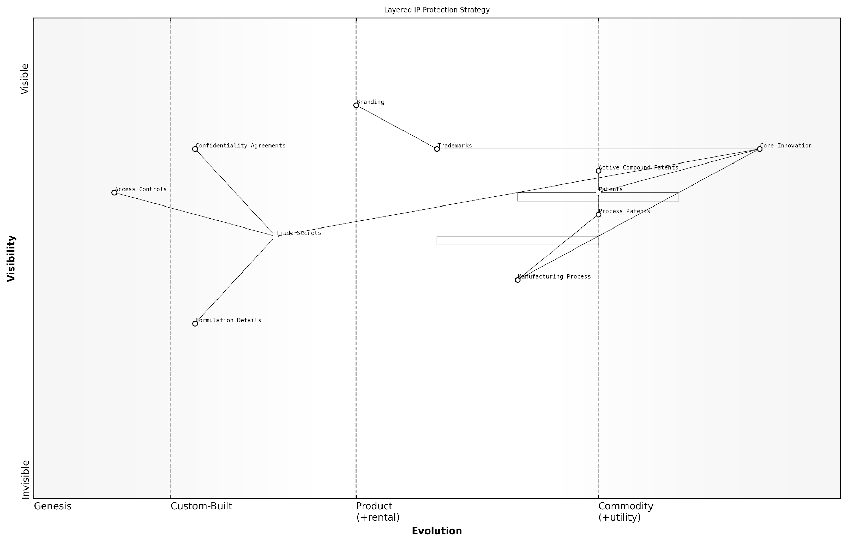

*Draft Wardley Map: [Insert Wardley Map: Creating IP Moats and Barriers to Entry]*

[Edit this draft Wardley Map](https://create.wardleymaps.ai/#clone:6615a706fec5fa62e7)

Wardley Map Assessment

The Layered IP Protection Strategy presented in this Wardley Map demonstrates a mature and comprehensive approach to safeguarding intellectual property. The strategy effectively balances visible protections like patents and trademarks with less visible but crucial elements such as trade secrets and access controls. The positioning of the Core Innovation as the anchor underscores its critical importance to the overall business model. The multi-layered approach provides robust protection but may benefit from further evolution in areas like trade secret management and AI-driven IP analytics. To maintain competitive advantage, the organisation should focus on enhancing its custom-built components, particularly in the realm of trade secrets and access controls, while also preparing for the increasing commoditization of basic IP protections. The strategy shows potential for adaptation to emerging technologies and changing market dynamics, positioning the organisation well for future challenges in the IP landscape.

[View full Wardley Map report](http://markdown_wardley_map_reports/wardley_map_report_29_Creating_IP_Moats_and_Barriers_to_Entry.md)

### Collaborative IP Development and Open Innovation

In the rapidly evolving landscape of intellectual property (IP) strategy, collaborative IP development and open innovation have emerged as powerful approaches for organisations seeking to maximise their innovative potential. This subsection explores how these concepts can be effectively integrated into IP strategy using the LEGO Wardley Mapping framework, providing a unique perspective on leveraging collective intelligence whilst safeguarding valuable intellectual assets.

The traditional view of IP as a closely guarded secret is giving way to more collaborative models, recognising that innovation often thrives at the intersection of diverse ideas and expertise. By mapping collaborative IP development and open innovation strategies using LEGO Wardley techniques, organisations can visualise complex ecosystems of partners, technologies, and market forces, enabling more informed decision-making and strategic positioning.

Open innovation is not about giving away your crown jewels, but about strategically sharing and collaborating to create greater value than you could alone.

Let’s explore the key components of collaborative IP development and open innovation through the lens of LEGO Wardley Mapping:

* Identifying Collaborative Opportunities
* Mapping the Collaborative Ecosystem
* Balancing Openness and Protection
* Leveraging External Innovation
* Creating Value Through Collaboration

Identifying Collaborative Opportunities: Using LEGO Wardley Mapping, organisations can visualise their IP landscape and identify areas where collaboration could yield the greatest benefits. By colour-coding different types of IP assets and their evolutionary stages, it becomes easier to spot potential synergies with external partners or opportunities for open innovation initiatives.

Mapping the Collaborative Ecosystem: The LEGO approach allows for the creation of modular, interconnected maps that represent the various stakeholders, technologies, and market forces at play in a collaborative IP ecosystem. By using different LEGO pieces to represent different entities and connecting them with appropriate links, organisations can create a dynamic visual representation of their collaborative network.

In the world of collaborative innovation, your map is only as good as your ability to see the connections between seemingly disparate elements.

Balancing Openness and Protection: One of the key challenges in collaborative IP development is striking the right balance between openness and protection. LEGO Wardley Mapping can help by allowing organisations to create different scenarios using stackable blocks, representing varying levels of IP protection and collaboration. This visual approach makes it easier to assess the risks and benefits of different strategies.

Leveraging External Innovation: Open innovation often involves tapping into external sources of ideas and technologies. By using LEGO Wardley Mapping to visualise the innovation landscape, organisations can identify external capabilities that complement their own IP portfolio. This approach can help in making informed decisions about partnerships, acquisitions, or licensing agreements.

Creating Value Through Collaboration: The ultimate goal of collaborative IP development is to create value that exceeds what could be achieved independently. LEGO Wardley Maps can be used to model different value creation scenarios, showing how collaborative efforts can lead to new products, services, or markets. By visualising these potential outcomes, organisations can better align their collaborative efforts with their overall strategic objectives.

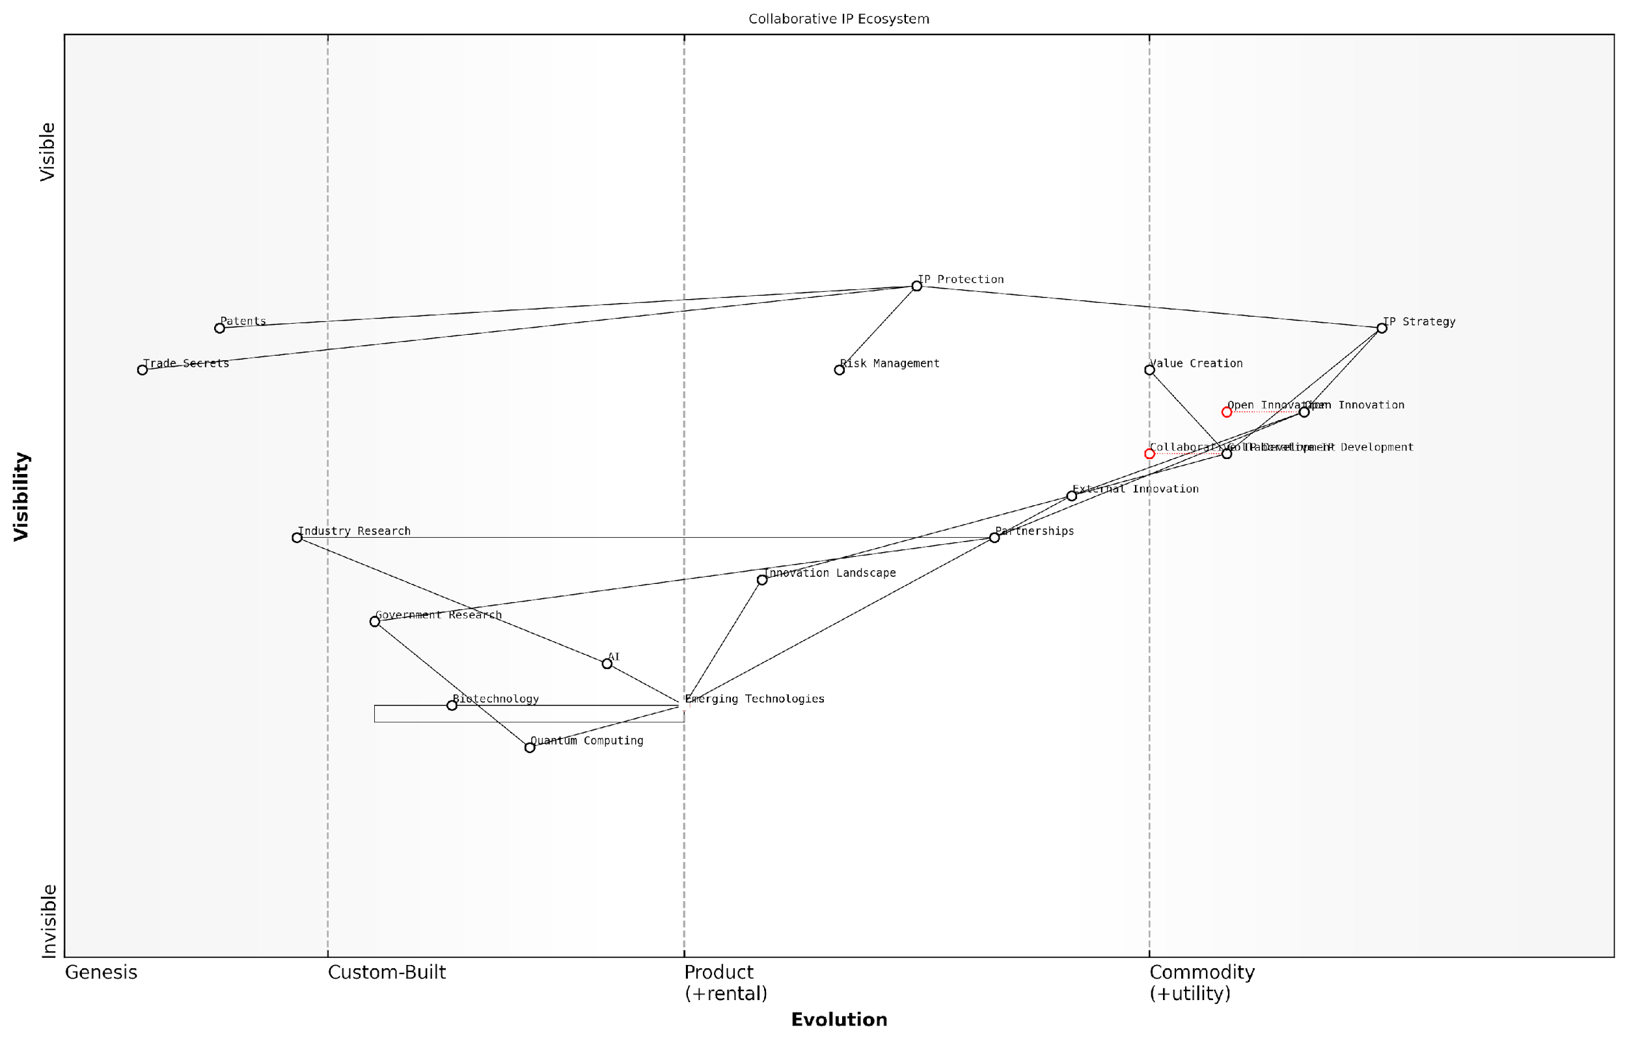

*Draft Wardley Map: [Insert Wardley Map: Collaborative IP Development and Open Innovation]*

[Edit this draft Wardley Map](https://create.wardleymaps.ai/#clone:97f4b2158bf13c4d76)

Wardley Map Assessment

This Collaborative IP Ecosystem map represents a forward-thinking approach to IP development, balancing traditional IP protection with open innovation and emerging technologies. The strategic positioning is strong, with clear pathways from foundational research to market-facing innovations. Key opportunities lie in further integration of AI, quantum computing, and biotechnology into the IP development process. The main challenges involve managing the risks of open collaboration while protecting valuable IP, and ensuring the organisation can keep pace with rapidly evolving technologies. By focusing on strengthening internal capabilities in emerging tech, enhancing collaborative platforms, and maintaining a robust IP strategy, the organisation can maintain its competitive edge and drive future innovation in the IP landscape.

[View full Wardley Map report](http://markdown_wardley_map_reports/wardley_map_report_30_Collaborative_IP_Development_and_Open_Innovation.md)

Case Study: Government-Industry Collaboration in Emerging Technologies

To illustrate the power of collaborative IP development using LEGO Wardley Mapping, consider a case study from the public sector. A government agency responsible for fostering innovation in emerging technologies used this approach to develop a collaborative research programme with industry partners.

The agency created a LEGO Wardley Map that visualised the current state of various emerging technologies, including artificial intelligence, quantum computing, and biotechnology. By colour-coding different types of IP (patents, trade secrets, know-how) and using stackable blocks to represent different levels of technological readiness, they were able to identify areas where government-industry collaboration could accelerate innovation.

The map revealed that while the government had significant foundational research in quantum computing, industry partners had more advanced applied research and patents in specific applications. By visualising these complementary strengths, the agency was able to design a collaborative programme that leveraged the best of both worlds, accelerating the development of practical quantum computing applications while ensuring appropriate IP protection for all parties involved.

The visual nature of LEGO Wardley Mapping allowed us to communicate complex IP ecosystems to stakeholders from diverse backgrounds, facilitating more productive discussions and faster decision-making.

This collaborative approach, guided by the LEGO Wardley Map, led to the creation of a successful public-private partnership that not only advanced the field of quantum computing but also resulted in several jointly-owned patents and a thriving open-source community around certain non-critical components of the technology.

In conclusion, collaborative IP development and open innovation, when strategically implemented using LEGO Wardley Mapping techniques, can significantly enhance an organisation’s innovative capabilities. By providing a visual, dynamic representation of the collaborative IP ecosystem, this approach enables more informed decision-making, better risk management, and ultimately, the creation of greater value through strategic partnerships and open innovation initiatives.

## IP Monetization Strategies

### Licensing and Cross-licensing Opportunities

In the realm of IP monetisation strategies, licensing and cross-licensing opportunities represent a cornerstone of value creation, particularly when viewed through the lens of LEGO Wardley Mapping. These strategies allow organisations to extract maximum value from their intellectual property assets whilst simultaneously fostering innovation and collaboration across industry boundaries.

To fully appreciate the potential of licensing and cross-licensing within the context of LEGO Wardley Mapping, it’s crucial to understand how these strategies can be visualised and optimised using this innovative approach.

* Mapping Licensing Opportunities
* Cross-licensing Strategies
* Value Chain Integration
* Evolution and Movement in Licensing Landscapes

Mapping Licensing Opportunities: When applying LEGO Wardley Mapping to licensing opportunities, we begin by identifying the key components of our IP portfolio. Each patent, trademark, or piece of proprietary technology can be represented as a LEGO brick on our map. The position of these bricks along the evolution axis indicates their maturity and ubiquity in the market.

For instance, a newly filed patent might be positioned on the left side of the map, indicating its genesis phase. As we move rightward, we might place more established technologies or widely recognised trademarks. This visual representation allows decision-makers to quickly identify which IP assets are prime candidates for licensing based on their position in the market.

The beauty of LEGO Wardley Mapping lies in its ability to transform complex IP landscapes into intuitive, visual strategies. It’s like having a bird’s-eye view of your entire IP ecosystem.

Cross-licensing Strategies: Cross-licensing becomes particularly interesting when viewed through the LEGO Wardley Mapping lens. By representing different organisations’ IP portfolios as distinct sets of LEGO bricks, we can visually identify complementary technologies or brands that could benefit from cross-licensing agreements.

For example, if Company A’s map shows strength in early-stage AI technologies (represented by blue bricks on the left side of the map), while Company B’s map reveals expertise in mature data processing techniques (represented by red bricks on the right), a cross-licensing opportunity becomes apparent. This visual approach can uncover synergies that might be overlooked in traditional IP analysis.

Value Chain Integration: One of the most powerful aspects of LEGO Wardley Mapping for licensing strategies is its ability to illustrate how licensed IP integrates into broader value chains. By connecting licensed IP ‘bricks’ to other components in the map, organisations can visualise how acquired technologies or brands can enhance their overall market position.

For instance, a government agency developing smart city solutions might license IoT patents from a tech company. On the LEGO Wardley Map, we could represent this licensed IP as a yellow brick, connecting it to the agency’s existing infrastructure (blue bricks) and citizen services (green bricks). This visual integration helps stakeholders understand the strategic value of the licensing agreement in the context of the entire smart city initiative.

In my experience advising government bodies, the ability to visually demonstrate how licensed IP fits into the bigger picture has been invaluable in securing buy-in from diverse stakeholders.

Evolution and Movement in Licensing Landscapes: The dynamic nature of LEGO Wardley Mapping is particularly valuable when considering the evolution of licensing opportunities over time. As markets mature and technologies advance, the position of IP assets on the map will shift. This movement can signal new licensing opportunities or the need to renegotiate existing agreements.

For example, a patented technology that starts on the left side of the map (genesis phase) may move rightward as it becomes more widely adopted. This movement could indicate that it’s time to shift from an exclusive licensing strategy to a more broad-based approach, maximising revenue as the technology becomes commoditised.

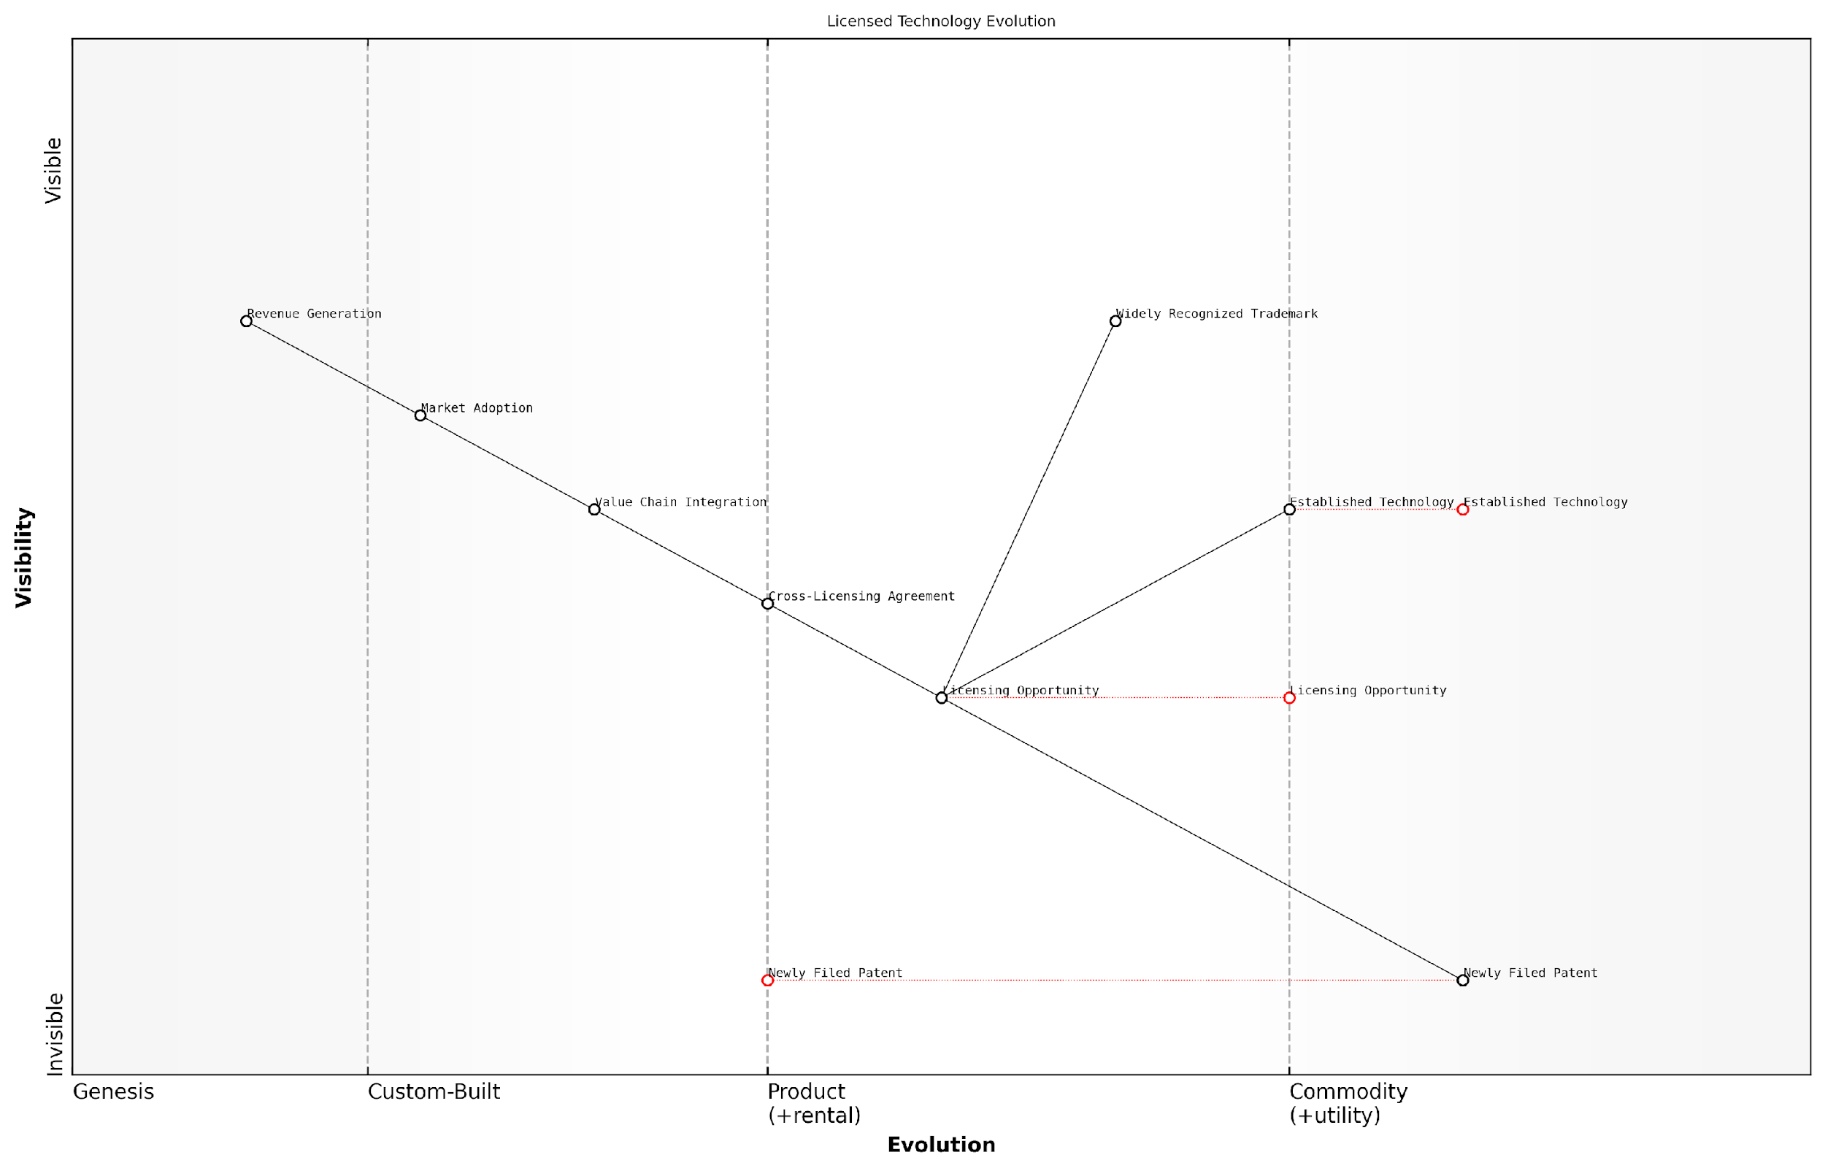

*Draft Wardley Map: [Insert Wardley Map: Licensing and Cross-licensing Opportunities]*

[Edit this draft Wardley Map](https://create.wardleymaps.ai/#clone:93824a41777ba92879)

Wardley Map Assessment

This Wardley Map presents a robust framework for IP monetization, highlighting the critical role of licensing and cross-licensing in bridging IP creation and revenue generation. The strategic focus should be on optimising the transition from Newly Filed Patents to Licensing Opportunities, while simultaneously developing advanced capabilities in Value Chain Integration. The inclusion of Cross-Licensing Agreements as a distinct component underscores its importance in modern IP strategies. To maintain a competitive edge, organisations must balance short-term optimization of licensing processes with long-term investments in ecosystem development and emerging technologies for IP management and valuation.

[View full Wardley Map report](http://markdown_wardley_map_reports/wardley_map_report_31_Licensing_and_Cross-licensing_Opportunities.md)

Practical Considerations for Implementation: When implementing LEGO Wardley Mapping for licensing and cross-licensing strategies, organisations should consider the following best practices:

* Regularly update your IP map to reflect new filings, grants, and market changes
* Use colour-coding to distinguish between different types of IP (patents, trademarks, trade secrets) for easy visual parsing
* Conduct collaborative mapping sessions with potential licensing partners to identify mutual opportunities
* Integrate market size and revenue potential data into your map to prioritise licensing efforts
* Use the map to track licensing agreement durations and renewal dates, ensuring proactive management of your IP portfolio

Case Study: In a recent project with a UK government research institution, we employed LEGO Wardley Mapping to identify licensing opportunities for a portfolio of advanced materials patents. By visually mapping the institution’s IP against the evolving needs of the private sector, we uncovered several high-value licensing opportunities that had previously been overlooked.

The visual nature of the map allowed researchers and business development professionals to collaborate effectively, bridging the gap between technical innovation and market application. As a result, the institution secured licensing agreements that not only generated revenue but also accelerated the real-world impact of their research.

The LEGO Wardley Mapping approach transformed our licensing strategy from a reactive, ad-hoc process to a proactive, strategic driver of innovation and revenue.

In conclusion, the application of LEGO Wardley Mapping to licensing and cross-licensing strategies offers a powerful tool for visualising, analysing, and optimising IP monetisation efforts. By transforming complex IP landscapes into intuitive, dynamic visual representations, organisations can uncover new opportunities, make more informed decisions, and ultimately extract greater value from their intellectual property assets.

### IP-driven Business Models

In the realm of intellectual property strategy, IP-driven business models represent a powerful approach to leveraging an organisation’s intangible assets for competitive advantage and revenue generation. This subsection explores how organisations can strategically position their IP assets at the core of their business operations, creating value and driving innovation through the lens of LEGO Wardley Mapping.

IP-driven business models are particularly relevant in the context of The LEGO Wardley Mapping manual for horizons of intellectual property, as they exemplify the strategic positioning of IP assets along the value chain. By visualising these models using Wardley Maps, organisations can gain insights into the evolution of their IP assets and identify opportunities for monetisation and growth.

* Patent-centric models: Leveraging a strong patent portfolio to create market exclusivity or generate licensing revenue
* Brand-driven models: Utilising trademark and brand assets to build customer loyalty and expand into new markets
* Content-based models: Monetising copyrighted materials through various distribution channels and formats
* Trade secret-focused models: Maintaining competitive advantage through closely guarded proprietary information and processes

When applying LEGO Wardley Mapping techniques to IP-driven business models, we can create visual representations that highlight the interconnectedness of various IP assets and their position within the value chain. This approach allows for a more nuanced understanding of how different IP types contribute to the overall business strategy.

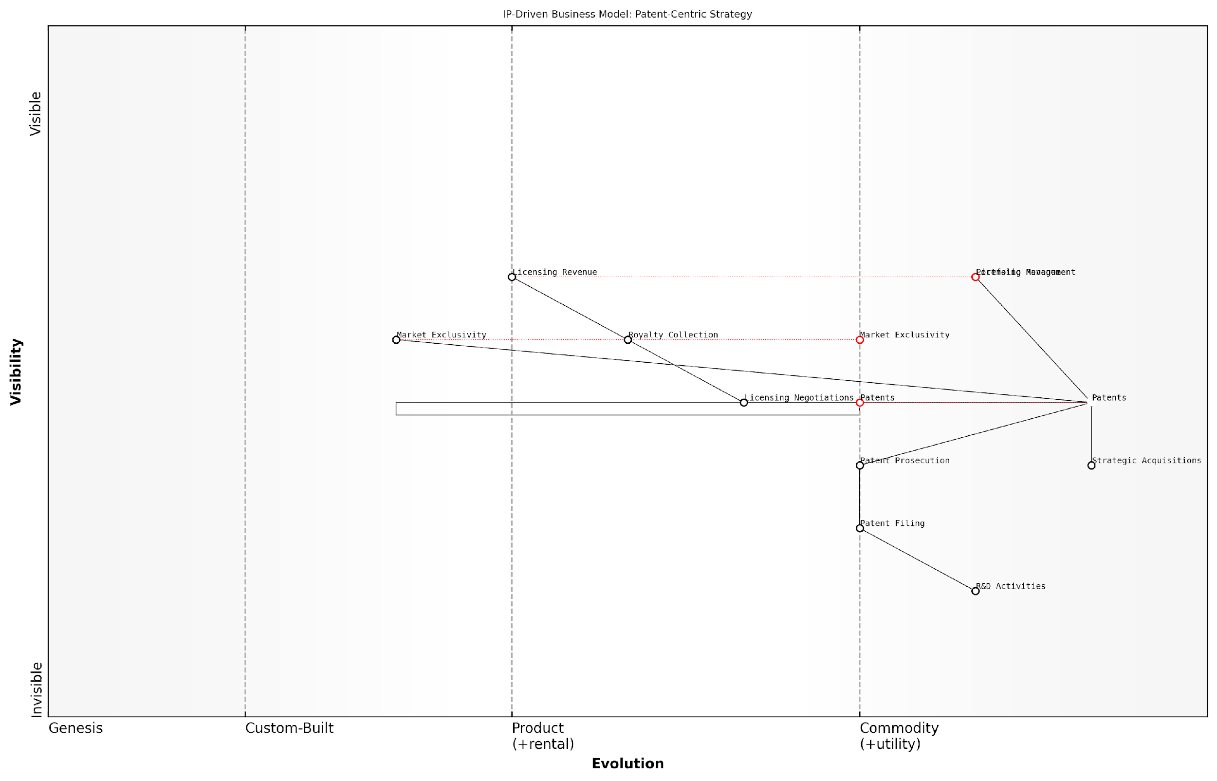

*Draft Wardley Map: [Insert Wardley Map: IP-driven Business Models]*

[Edit this draft Wardley Map](https://create.wardleymaps.ai/#clone:38db1c24daf446723d)

Wardley Map Assessment

This map represents a well-structured, patent-centric IP strategy that effectively links R&D to revenue generation. However, it may be at risk of disruption from more open and collaborative innovation models. The key strategic challenge is to maintain the strengths of this approach while adapting to a more interconnected and rapidly evolving technological landscape. This may involve developing new capabilities in data-driven decision making, ecosystem management, and balancing proprietary IP with more open innovation approaches.

[View full Wardley Map report](http://markdown_wardley_map_reports/wardley_map_report_32_IP-driven_Business_Models.md)

One of the key advantages of using LEGO Wardley Mapping for IP-driven business models is the ability to visualise the modularity and flexibility of IP assets. Much like LEGO bricks, IP assets can be combined and reconfigured in various ways to create new value propositions and adapt to changing market conditions.

IP-driven business models are not static constructs, but dynamic systems that evolve with market needs and technological advancements. The LEGO Wardley Mapping approach allows us to visualise this evolution and make strategic decisions accordingly.

Let’s explore some specific IP-driven business models and how they can be visualised and optimised using LEGO Wardley Mapping techniques:

1. Patent Licensing Model:

In this model, an organisation focuses on developing and acquiring patents, then generating revenue through licensing agreements. Using LEGO Wardley Mapping, we can visualise the patent portfolio as a set of interconnected blocks, with each block representing a specific patent or patent family. The map would show the evolution of these patents from genesis (newly filed or acquired) to commodity (widely licensed or nearing expiration).

Key components to map include:

* R&D activities
* Patent filing and prosecution processes
* Licensing negotiation and agreement management
* Royalty collection and monitoring systems
* Patent portfolio management and strategic acquisitions

By mapping these components, organisations can identify opportunities to streamline their licensing processes, target high-value patent acquisitions, and anticipate shifts in the technology landscape that may impact their patent portfolio’s value.

1. Brand Extension Model:

This model leverages strong brand assets to expand into new product categories or markets. Using LEGO Wardley Mapping, we can visualise the core brand as a foundational block, with various brand extensions branching out as connected pieces. The map would illustrate the evolution of brand assets from novel (new market entry) to utility (established brand presence).

Key elements to map include:

* Core brand identity and values
* Target market segments
* Product or service categories
* Distribution channels
* Marketing and promotional activities
* Brand protection and enforcement strategies

This mapping approach helps organisations identify synergies between different brand extensions, spot gaps in their brand portfolio, and make informed decisions about which new markets or product categories to enter.

1. Content Monetisation Model:

For creative industries, this model focuses on generating revenue from copyrighted content across various formats and channels. LEGO Wardley Mapping can visualise content assets as modular blocks that can be recombined and distributed through different channels. The map would show the evolution of content from custom (original creation) to product (packaged for distribution) to commodity (widely accessible).

Key aspects to map include:

* Content creation processes
* Rights management systems
* Distribution platforms (e.g., streaming services, physical media)
* Audience engagement metrics
* Derivative works and adaptations
* Anti-piracy measures

This mapping approach helps content creators and distributors identify new monetisation opportunities, optimise their distribution strategies, and adapt to changing consumption patterns.

The power of LEGO Wardley Mapping in IP-driven business models lies in its ability to reveal hidden connections and dependencies between different IP assets and business processes. This visibility enables more agile and responsive IP strategies.

When implementing IP-driven business models using LEGO Wardley Mapping, it’s crucial to consider the following best practices:

* Regularly update your maps to reflect changes in the IP landscape and market conditions
* Use colour-coding to distinguish between different types of IP assets and their maturity levels
* Incorporate external factors such as regulatory changes and competitive actions into your maps
* Engage cross-functional teams in the mapping process to gain diverse perspectives on IP value and utilisation
* Use the maps to facilitate strategic discussions and decision-making around IP investments and monetisation strategies

By adopting these practices, organisations can create dynamic, adaptable IP-driven business models that maximise the value of their intellectual property assets while remaining responsive to market changes and technological advancements.

In conclusion, IP-driven business models, when visualised and analysed through the lens of LEGO Wardley Mapping, offer a powerful framework for organisations to strategically leverage their intellectual property assets. This approach not only enhances the ability to identify monetisation opportunities but also fosters a more holistic and flexible approach to IP strategy, aligning it closely with overall business objectives and market dynamics.

### Valuing and Trading IP Assets

In the dynamic landscape of intellectual property strategy, valuing and trading IP assets has become a critical component for organisations seeking to maximise the potential of their innovation portfolios. This subsection explores the intricate process of determining the worth of IP assets and the strategies for effectively trading them, all within the context of the LEGO Wardley Mapping framework for IP horizons.

Valuing IP assets is a complex endeavour that requires a multifaceted approach, combining financial metrics, market analysis, and strategic considerations. When applying the LEGO Wardley Mapping methodology to this process, we can visualise the value chain of IP assets and their evolution across different innovation horizons, providing a more comprehensive understanding of their worth.

* Quantitative Valuation Methods: Discounted Cash Flow (DCF), Relief from Royalty, and Comparable Transactions
* Qualitative Factors: Strategic importance, competitive advantage, and potential for future innovations
* Market-Based Approaches: Analysing industry trends, technological advancements, and market demand
* Risk Assessment: Evaluating legal, technological, and market risks associated with the IP asset

By incorporating these valuation methods into our LEGO Wardley Map, we can represent each factor as a building block, with different colours and sizes indicating their relative importance and impact on the overall value of the IP asset. This visual representation allows decision-makers to quickly grasp the multifaceted nature of IP valuation and make informed decisions about trading strategies.

The true value of an IP asset lies not just in its current worth, but in its potential to shape future innovation landscapes. Our LEGO Wardley Mapping approach allows us to visualise this potential across multiple horizons, enabling more strategic decision-making in IP trading.

Once we have established a comprehensive valuation framework, we can explore various strategies for trading IP assets. The LEGO Wardley Mapping manual for IP horizons provides a unique perspective on this process, allowing us to visualise different trading options and their potential impacts on our overall IP portfolio and innovation strategy.

* Direct Sale: Transferring full ownership of the IP asset to another party
* Licensing: Granting permission to use the IP asset while retaining ownership
* Cross-Licensing: Exchanging IP rights with other organisations to access complementary technologies
* IP-Backed Financing: Using IP assets as collateral for securing funding
* Joint Ventures: Collaborating with partners to leverage shared IP assets
* IP Auctions: Participating in specialised marketplaces for buying and selling IP assets

Each of these trading strategies can be represented as a distinct ‘LEGO set’ within our Wardley Map, with different configurations illustrating the potential outcomes and strategic implications of each approach. This visual representation helps organisations to align their IP trading decisions with their broader innovation goals and market positioning.

One of the key advantages of using the LEGO Wardley Mapping approach for IP trading is the ability to model different scenarios and their potential impacts on the organisation’s IP portfolio. By creating modular ‘IP trading sets’, we can quickly reconfigure our strategy in response to market changes, emerging opportunities, or shifts in our innovation horizons.

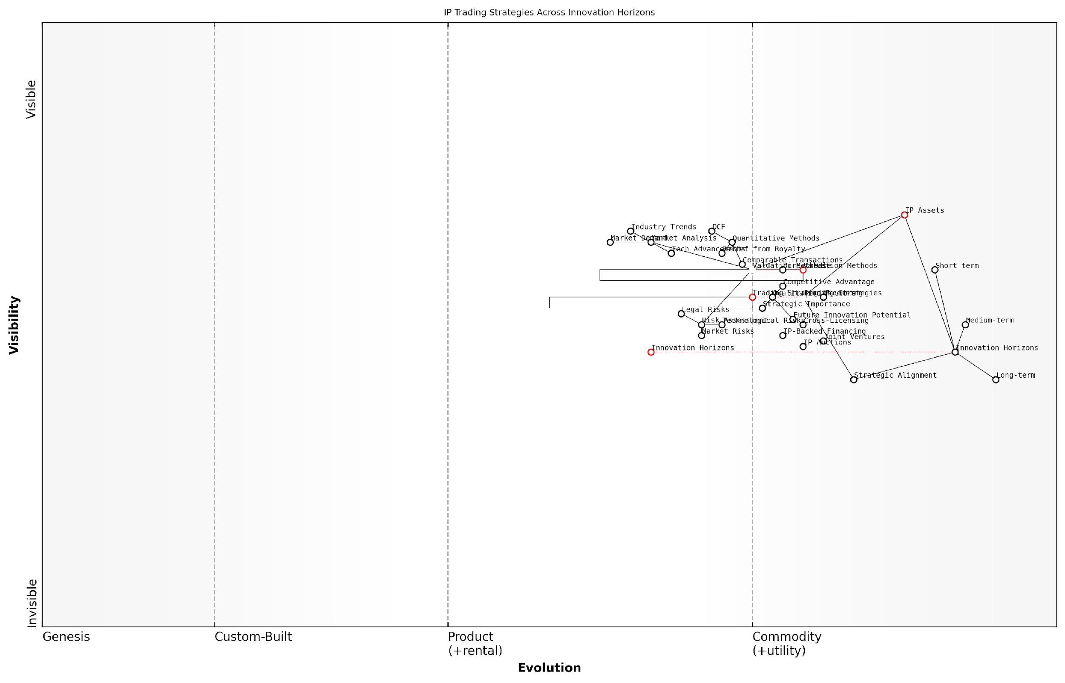

*Draft Wardley Map: [Insert Wardley Map: Valuing and Trading IP Assets]*

[Edit this draft Wardley Map](https://create.wardleymaps.ai/#clone:4bda02c019536b8b3f)

Wardley Map Assessment

This Wardley Map reveals a sophisticated understanding of IP trading strategies across innovation horizons. It highlights the critical role of IP assets and the evolving nature of valuation and trading methods. The key strategic opportunity lies in better aligning short-term trading strategies with long-term innovation goals, while leveraging emerging technologies to enhance valuation and risk assessment capabilities. Organisations that can effectively integrate these elements and develop a holistic, forward-looking approach to IP monetization will be well-positioned to create and capture value in the evolving IP landscape.

[View full Wardley Map report](http://markdown_wardley_map_reports/wardley_map_report_33_Valuing_and_Trading_IP_Assets.md)

In practice, the process of valuing and trading IP assets using the LEGO Wardley Mapping approach involves several key steps:

* Mapping the current IP portfolio across innovation horizons
* Identifying potential trading opportunities and their strategic fit
* Conducting thorough valuations using the multifaceted approach outlined earlier
* Visualising different trading scenarios using LEGO-inspired building blocks
* Assessing the impact of each scenario on the overall IP landscape and innovation strategy
* Executing the chosen trading strategy and monitoring its effects on the IP Wardley Map

A case study from the public sector illustrates the power of this approach. A government research institution used the LEGO Wardley Mapping methodology to evaluate its extensive patent portfolio in renewable energy technologies. By visualising the patents across different innovation horizons and potential trading strategies, the institution identified several underutilised assets that could be licensed to private sector companies. This not only generated additional revenue but also accelerated the adoption of green technologies in the market.

The LEGO Wardley Mapping approach transformed our view of IP assets from static entities to dynamic building blocks of innovation. It enabled us to make more strategic decisions about which technologies to develop internally, which to licence out, and where to seek collaborative partnerships.

In conclusion, valuing and trading IP assets is a critical component of modern IP strategy, particularly within the context of government and public sector organisations. The LEGO Wardley Mapping manual for IP horizons provides a powerful framework for visualising, analysing, and optimising these processes. By representing IP assets and trading strategies as modular, reconfigurable components within a broader innovation landscape, organisations can make more informed decisions, adapt quickly to changing circumstances, and maximise the value of their intellectual property portfolios.

## LEGO-inspired IP Portfolio Management

### Building and Reconfiguring IP ‘Sets’

In the dynamic landscape of intellectual property strategy, the ability to build and reconfigure IP ‘sets’ is paramount. This LEGO-inspired approach to IP portfolio management offers unprecedented flexibility and strategic advantage, particularly within government and public sector contexts. By conceptualising IP assets as modular, interconnectable components, organisations can adapt swiftly to changing technological landscapes, policy shifts, and evolving national priorities.

The concept of IP ‘sets’ draws directly from the LEGO philosophy of modular construction, where complex structures are built from simple, standardised components. In the realm of IP strategy, these components represent various forms of intellectual property—patents, trademarks, copyrights, and trade secrets—that can be combined and reconfigured to create robust IP portfolios tailored to specific strategic objectives.

The beauty of the LEGO-inspired IP set approach lies in its adaptability. Just as a child can dismantle and rebuild a LEGO creation, organisations can swiftly reconfigure their IP portfolios to address new challenges or seize emerging opportunities.

Let us explore the key aspects of building and reconfiguring IP ‘sets’ within the framework of LEGO Wardley Mapping:

* Modular IP Asset Development
* Strategic Grouping and Categorisation
* Interconnectivity and Synergies
* Scalability and Expansion
* Rapid Reconfiguration for Changing Landscapes

Modular IP Asset Development: The foundation of the IP ‘set’ approach lies in developing IP assets with modularity in mind. This involves creating patents, for instance, that are not only valuable in isolation but also designed to interconnect with other IP assets. In the public sector, this might involve developing modular patents for government IT systems that can be easily integrated or separated as needed.

Strategic Grouping and Categorisation: IP assets are grouped into ‘sets’ based on strategic objectives, technological domains, or potential applications. For example, a government research institution might create an ‘AI in Healthcare’ set, combining patents, algorithms protected as trade secrets, and copyrighted software related to artificial intelligence applications in the health sector.

Interconnectivity and Synergies: The power of the IP ‘set’ approach lies in the synergies created when different IP assets are combined. By mapping these interconnections using Wardley Maps, organisations can visualise how different IP components support and enhance each other. For instance, a patent on a novel encryption method might be strategically linked with copyrighted software implementing that method, creating a more robust protective barrier.

The true value of an IP portfolio often lies not in individual assets, but in the strategic combinations and interconnections between them. Like LEGO bricks, the whole can be far greater than the sum of its parts.

Scalability and Expansion: The modular nature of IP ‘sets’ allows for easy scalability and expansion. As new technologies emerge or strategic priorities shift, new IP components can be developed and seamlessly integrated into existing sets. This is particularly crucial in the fast-paced world of government technology initiatives, where the ability to rapidly scale IP protection is often critical.

Rapid Reconfiguration for Changing Landscapes: Perhaps the most powerful aspect of the IP ‘set’ approach is the ability to swiftly reconfigure IP portfolios in response to changing landscapes. Using Wardley Maps, organisations can visualise how different configurations of their IP ‘sets’ might perform under various scenarios, allowing for proactive strategy adjustments.

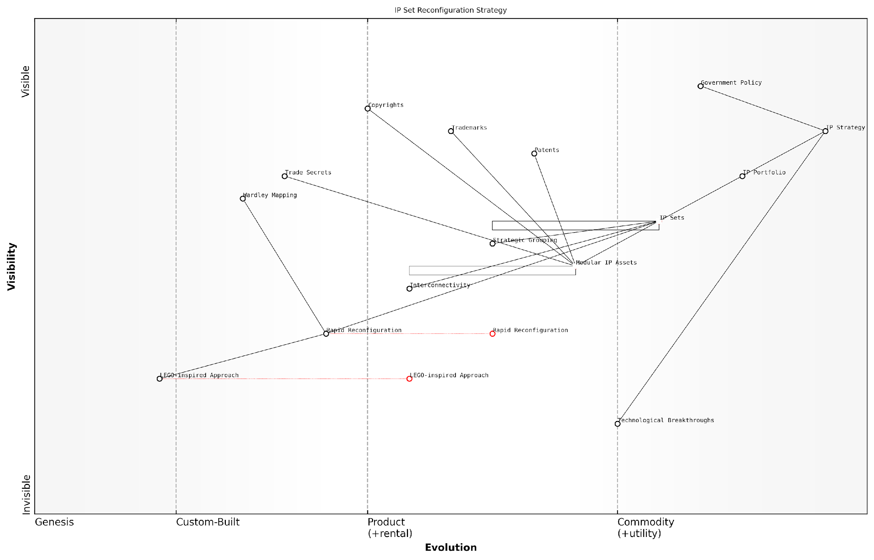

*Draft Wardley Map: [Insert Wardley Map: Building and Reconfiguring IP ‘Sets’]*

[Edit this draft Wardley Map](https://create.wardleymaps.ai/#clone:b96e64044deface19f)

Wardley Map Assessment

This Wardley Map represents a forward-thinking approach to IP management, leveraging modular design principles inspired by LEGO to create a flexible and adaptive IP strategy. The focus on IP Sets and Rapid Reconfiguration positions the organisation to respond quickly to market changes and technological breakthroughs. However, to fully realise the potential of this approach, there needs to be continued investment in evolving capabilities, particularly in the areas of Strategic Grouping and Interconnectivity. The LEGO-inspired Approach, while still in its early stages, has the potential to be a significant differentiator in the IP management landscape. To maintain this advantage, the organisation should focus on accelerating the evolution of key components while also keeping an eye on emerging technologies and methodologies that could further enhance their IP strategy.

[View full Wardley Map report](http://markdown_wardley_map_reports/wardley_map_report_34_Building_and_Reconfiguring_IP_'Sets'.md)

A practical example of this approach in action can be seen in the UK Government’s response to the COVID-19 pandemic. By rapidly reconfiguring existing IP ‘sets’ related to vaccine technology, data management, and public health systems, the government was able to accelerate vaccine development and rollout while ensuring appropriate IP protections were in place.

The LEGO Wardley Mapping approach to building and reconfiguring IP ‘sets’ offers several key benefits for government and public sector organisations:

* Increased Agility: Ability to quickly adapt IP strategies to new challenges or opportunities.
* Enhanced Collaboration: Modular IP ‘sets’ facilitate easier collaboration between departments or even between nations on joint initiatives.
* Improved Resource Allocation: By visualising IP ‘sets’ on Wardley Maps, organisations can more effectively allocate resources to high-impact areas.
* Strategic Foresight: The ability to model different IP configurations allows for better preparedness for future scenarios.
* Maximised Value: By strategically combining and reconfiguring IP assets, organisations can extract maximum value from their IP portfolios.

However, implementing this approach is not without challenges. Organisations must invest in developing the necessary skills and tools to effectively map and manage their IP ‘sets’. This includes training staff in both LEGO-inspired strategic thinking and Wardley Mapping techniques, as well as developing or acquiring appropriate software tools to support the visualisation and management of complex IP portfolios.

The transition to a LEGO-inspired IP portfolio management approach requires a shift in mindset. It’s not just about collecting IP assets, but about strategically designing, combining, and reconfiguring them to build a dynamic and responsive IP strategy.

In conclusion, the concept of building and reconfiguring IP ‘sets’ represents a powerful new paradigm in IP portfolio management, particularly well-suited to the complex and rapidly evolving needs of government and public sector organisations. By combining the flexibility and modularity of LEGO with the strategic insights provided by Wardley Mapping, organisations can create IP strategies that are not only robust but also highly adaptable to future challenges and opportunities.

### Creating IP ‘Instructions’ for Different Scenarios

In the realm of intellectual property (IP) strategy, the concept of creating ‘instructions’ for different scenarios is a powerful approach inspired by LEGO’s modular design philosophy. This subsection explores how organisations can develop flexible, scenario-based IP strategies that can be easily adapted to changing market conditions, technological advancements, and competitive landscapes.

Just as LEGO provides step-by-step instructions for building complex models from simple bricks, IP strategists can create detailed ‘instructions’ for navigating various IP scenarios. These instructions serve as strategic playbooks, guiding organisations through different IP challenges and opportunities.

* Defensive Scenarios: Instructions for protecting core IP assets
* Offensive Scenarios: Guidelines for leveraging IP to enter new markets
* Collaborative Scenarios: Frameworks for open innovation and cross-licensing
* Crisis Scenarios: Rapid response plans for IP infringement or legal challenges

By developing these scenario-based instructions, organisations can quickly assemble the appropriate IP strategy ‘set’ when faced with new challenges or opportunities. This approach aligns perfectly with the dynamic nature of Wardley Mapping, allowing for real-time adjustments and strategic pivots.

The beauty of creating IP ‘instructions’ is that it transforms abstract strategy into concrete, actionable steps. It’s about making the complex simple and the theoretical practical.

Let’s delve deeper into the process of creating these IP ‘instructions’ and how they can be applied in various contexts:

1. Scenario Identification and Analysis

The first step in creating IP ‘instructions’ is to identify and analyse potential scenarios that an organisation might face. This process involves:

* Conducting thorough market research and competitive analysis
* Engaging in strategic foresight exercises to anticipate future trends
* Analysing historical IP challenges and opportunities within the industry
* Collaborating with cross-functional teams to gather diverse perspectives

By mapping these scenarios onto a Wardley Map, organisations can visualise how different IP assets and strategies might evolve under various conditions.

1. Developing Modular IP Strategies

Once scenarios are identified, the next step is to develop modular IP strategies that can be combined and reconfigured like LEGO bricks. These modular strategies might include:

* Patent filing and maintenance procedures
* Trademark protection and brand management tactics
* Trade secret safeguarding protocols
* Licensing agreement templates and negotiation strategies
* IP valuation methodologies for different asset types

Each of these modular strategies should be well-documented, with clear guidelines on when and how to implement them. This approach allows for rapid assembly of comprehensive IP strategies tailored to specific scenarios.

1. Creating Step-by-Step Instructions

With modular strategies in place, the next phase involves creating detailed, step-by-step instructions for each identified scenario. These instructions should be:

* Clear and concise, avoiding legal jargon where possible
* Visual, incorporating flowcharts and decision trees
* Flexible, allowing for adaptation to slight variations in scenarios
* Aligned with the organisation’s overall IP strategy and business objectives

Effective IP ‘instructions’ are like a well-designed LEGO set – they provide a clear path to the desired outcome while allowing for creativity and adaptation along the way.

1. Testing and Refinement

Before finalising the IP ‘instructions’, it’s crucial to test them through simulations and tabletop exercises. This process helps identify any gaps or weaknesses in the strategies and allows for refinement. Involve key stakeholders from legal, R&D, and business units in these exercises to ensure the instructions are practical and aligned with organisational needs.

1. Implementation and Continuous Improvement

Once tested and refined, the IP ‘instructions’ should be integrated into the organisation’s broader IP management system. This integration might involve:

* Training sessions for relevant staff members
* Integration with existing IP management software
* Regular reviews and updates to reflect changes in the IP landscape
* Feedback mechanisms to capture insights from real-world application

By treating these instructions as living documents, organisations can ensure their IP strategies remain relevant and effective in the face of evolving challenges and opportunities.

Case Study: Tech Sector Application

To illustrate the practical application of IP ‘instructions’, consider a case study from the tech sector. A leading software company developed a set of IP ‘instructions’ for navigating patent thickets in emerging markets. These instructions included:

* Steps for conducting freedom-to-operate analyses
* Guidelines for identifying potential cross-licensing partners
* Strategies for building defensive patent portfolios
* Protocols for responding to infringement allegations

When the company decided to enter a new market with complex patent landscapes, they were able to quickly assemble and execute a tailored IP strategy using these pre-prepared ‘instructions’. This approach allowed them to navigate potential IP pitfalls efficiently, saving time and resources while minimising risk.

The true power of IP ‘instructions’ lies in their ability to transform reactive IP management into proactive IP strategy. They empower organisations to anticipate challenges and seize opportunities with confidence and agility.

In conclusion, creating IP ‘instructions’ for different scenarios is a powerful approach that combines the flexibility of LEGO-inspired modular thinking with the strategic foresight of Wardley Mapping. By developing these instructions, organisations can build adaptive, resilient IP strategies capable of navigating the complex and ever-changing landscape of intellectual property management.

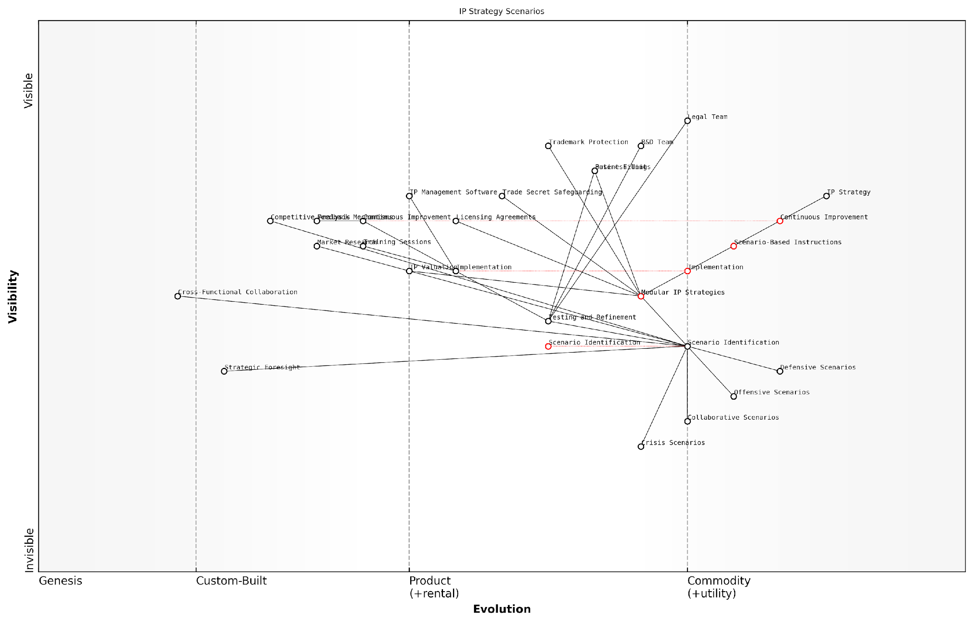

*Draft Wardley Map: [Insert Wardley Map: Creating IP ‘Instructions’ for Different Scenarios]*

[Edit this draft Wardley Map](https://create.wardleymaps.ai/#clone:5a41def28286fd09b5)

Wardley Map Assessment

This Wardley Map represents a sophisticated and forward-thinking approach to IP strategy management. The emphasis on scenario-based planning and modular strategies positions the organisation well for adapting to rapidly changing IP landscapes. Key opportunities lie in further evolving Strategic Foresight capabilities and enhancing cross-functional collaboration. The integration of defensive, offensive, collaborative, and crisis scenarios provides a comprehensive framework for IP management. To maintain and enhance competitive advantage, focus should be placed on accelerating the evolution of key components like Scenario Identification and Modular IP Strategies, while also investing in emerging technologies that can revolutionise IP management practices. The organisation is well-positioned to lead in IP strategy innovation, provided it addresses the identified capability gaps and continues to prioritise adaptability and continuous improvement in its approach.

[View full Wardley Map report](http://markdown_wardley_map_reports/wardley_map_report_35_Creating_IP_'Instructions'_for_Different_Scenarios.md)

### Adapting IP Strategies as Markets Evolve

Content for Adapting IP Strategies as Markets Evolve not found.

# Chapter 4: Case Studies in IP Mapping Success

## Technology Sector: Navigating Patent Thickets

### Mapping Complex Patent Landscapes

Content for Mapping Complex Patent Landscapes not found.

### Identifying Strategic Patent Acquisition Targets

Content for Identifying Strategic Patent Acquisition Targets not found.

### Developing Freedom-to-Operate Strategies

Content for Developing Freedom-to-Operate Strategies not found.

## Creative Industries: Managing Copyright Portfolios

### Visualizing Content Libraries and Franchises

Content for Visualizing Content Libraries and Franchises not found.

### Mapping Distribution Channels and Licensing Opportunities

Content for Mapping Distribution Channels and Licensing Opportunities not found.

### Protecting IP in the Digital Age

Content for Protecting IP in the Digital Age not found.

## Manufacturing: Balancing Trade Secrets and Patents

### Mapping Process Innovations and Know-how

Content for Mapping Process Innovations and Know-how not found.

### Strategies for Global IP Protection

Content for Strategies for Global IP Protection not found.

### Leveraging IP for Competitive Advantage

Content for Leveraging IP for Competitive Advantage not found.

# Chapter 5: Ethical and Legal Considerations in IP Mapping

## Navigating the Digital IP Landscape

### Challenges of IP Protection in the Digital Era

Content for Challenges of IP Protection in the Digital Era not found.

### Mapping Jurisdictional Differences in IP Law

Content for Mapping Jurisdictional Differences in IP Law not found.

### Ethical Considerations in IP Strategy

Content for Ethical Considerations in IP Strategy not found.

## Risk Management and Compliance

### Identifying and Mitigating IP Risks

Content for Identifying and Mitigating IP Risks not found.

### Ensuring Compliance with IP Regulations

Content for Ensuring Compliance with IP Regulations not found.

### Ethical Use of Competitors’ IP Information

Content for Ethical Use of Competitors’ IP Information not found.

## Future-Proofing Your IP Strategy

### Anticipating Changes in IP Law and Technology

Content for Anticipating Changes in IP Law and Technology not found.

### Building Adaptable IP Portfolios

Content for Building Adaptable IP Portfolios not found.

### Fostering an Ethical IP Culture in Your Organisation

Content for Fostering an Ethical IP Culture in Your Organisation not found.

# Conclusion: Assembling Your IP Future

## Key Takeaways and Best Practices

### Summarising the LEGO Wardley Mapping Approach to IP

Content for Summarising the LEGO Wardley Mapping Approach to IP not found.

### Implementing IP Mapping in Your Organisation

Content for Implementing IP Mapping in Your Organisation not found.

### Continuous Improvement and Adaptation in IP Strategy

Content for Continuous Improvement and Adaptation in IP Strategy not found.

## The Future of IP Strategy

### Emerging Trends in IP Management

Content for Emerging Trends in IP Management not found.

### The Role of AI and Machine Learning in IP Mapping

Content for The Role of AI and Machine Learning in IP Mapping not found.

### Building a Culture of Innovation and IP Awareness

Content for Building a Culture of Innovation and IP Awareness not found.

# Appendix: Book Generation Details

* Initial Topic: The LEGO Wardley Mapping manual for horizons of intellectual property
* Refined Topic: The LEGO Wardley Mapping manual for horizons of intellectual property
* Total Output Tokens: 177944
* Total LLM Cost: $2.67

# Appendix: Further Reading on Wardley Mapping

The following books, primarily authored by Mark Craddock, offer comprehensive insights into various aspects of Wardley Mapping:

## Core Wardley Mapping Series

1. **Wardley Mapping, The Knowledge: Part One, Topographical Intelligence in Business**
   * Author: Simon Wardley
   * Editor: Mark Craddock
   * Part of the Wardley Mapping series (5 books)
   * Available in Kindle Edition
   * [Amazon Link](https://www.amazon.com/dp/B0BVSXB5W5)

* This foundational text introduces readers to the Wardley Mapping approach:
  + Covers key principles, core concepts, and techniques for creating situational maps
  + Teaches how to anchor mapping in user needs and trace value chains
  + Explores anticipating disruptions and determining strategic gameplay
  + Introduces the foundational doctrine of strategic thinking
  + Provides a framework for assessing strategic plays
  + Includes concrete examples and scenarios for practical application
* The book aims to equip readers with:
  + A strategic compass for navigating rapidly shifting competitive landscapes
  + Tools for systematic situational awareness
  + Confidence in creating strategic plays and products
  + An entrepreneurial mindset for continual learning and improvement

1. **Wardley Mapping Doctrine: Universal Principles and Best Practices that Guide Strategic Decision-Making**
   * Author: Mark Craddock
   * Part of the Wardley Mapping series (5 books)
   * Available in Kindle Edition
   * [Amazon Link](https://www.amazon.com/dp/B0C2SFTR7Z)

* This book explores how doctrine supports organisational learning and adaptation:
  + Standardisation: Enhances efficiency through consistent application of best practices
  + Shared Understanding: Fosters better communication and alignment within teams
  + Guidance for Decision-Making: Offers clear guidelines for navigating complexity
  + Adaptability: Encourages continuous evaluation and refinement of practices
* Key features:
  + In-depth analysis of doctrine’s role in strategic thinking
  + Case studies demonstrating successful application of doctrine
  + Practical frameworks for implementing doctrine in various organisational contexts
  + Exploration of the balance between stability and flexibility in strategic planning
* Ideal for:
  + Business leaders and executives
  + Strategic planners and consultants
  + Organisational development professionals
  + Anyone interested in enhancing their strategic decision-making capabilities

1. **Wardley Mapping Gameplays: Transforming Insights into Strategic Actions**
   * Author: Mark Craddock
   * Part of the Wardley Mapping series (5 books)
   * Available in Kindle Edition
   * [Amazon Link](https://www.amazon.com/dp/B0C7CR9R9Q)

* This book delves into gameplays, a crucial component of Wardley Mapping:
  + Gameplays are context-specific patterns of strategic action derived from Wardley Maps
  + Types of gameplays include:
    - User Perception plays (e.g., education, bundling)
    - Accelerator plays (e.g., open approaches, exploiting network effects)
    - De-accelerator plays (e.g., creating constraints, exploiting IPR)
    - Market plays (e.g., differentiation, pricing policy)
    - Defensive plays (e.g., raising barriers to entry, managing inertia)
    - Attacking plays (e.g., directed investment, undermining barriers to entry)
    - Ecosystem plays (e.g., alliances, sensing engines)
* Gameplays enhance strategic decision-making by:
  1. Providing contextual actions tailored to specific situations
  2. Enabling anticipation of competitors’ moves
  3. Inspiring innovative approaches to challenges and opportunities
  4. Assisting in risk management
  5. Optimising resource allocation based on strategic positioning
* The book includes:
  + Detailed explanations of each gameplay type
  + Real-world examples of successful gameplay implementation
  + Frameworks for selecting and combining gameplays
  + Strategies for adapting gameplays to different industries and contexts

1. **Navigating Inertia: Understanding Resistance to Change in Organisations**
   * Author: Mark Craddock
   * Part of the Wardley Mapping series (5 books)
   * Available in Kindle Edition
   * [Amazon Link](https://www.amazon.com/dp/B0C34FX8XC)

* This comprehensive guide explores organisational inertia and strategies to overcome it:
* Key Features:
  + In-depth exploration of inertia in organisational contexts
  + Historical perspective on inertia’s role in business evolution
  + Practical strategies for overcoming resistance to change
  + Integration of Wardley Mapping as a diagnostic tool
* The book is structured into six parts:
  1. Understanding Inertia: Foundational concepts and historical context
  2. Causes and Effects of Inertia: Internal and external factors contributing to inertia
  3. Diagnosing Inertia: Tools and techniques, including Wardley Mapping
  4. Strategies to Overcome Inertia: Interventions for cultural, behavioural, structural, and process improvements
  5. Case Studies and Practical Applications: Real-world examples and implementation frameworks
  6. The Future of Inertia Management: Emerging trends and building adaptive capabilities
* This book is invaluable for:
  + Organisational leaders and managers
  + Change management professionals
  + Business strategists and consultants
  + Researchers in organisational behaviour and management

1. **Wardley Mapping Climate: Decoding Business Evolution**
   * Author: Mark Craddock
   * Part of the Wardley Mapping series (5 books)
   * Available in Kindle Edition
   * [Amazon Link](https://www.amazon.com/dp/B0BVHF2MBH)

* This comprehensive guide explores climatic patterns in business landscapes:
* Key Features:
  + In-depth exploration of 31 climatic patterns across six domains: Components, Financial, Speed, Inertia, Competitors, and Prediction
  + Real-world examples from industry leaders and disruptions
  + Practical exercises and worksheets for applying concepts
  + Strategies for navigating uncertainty and driving innovation
  + Comprehensive glossary and additional resources
* The book enables readers to:
  + Anticipate market changes with greater accuracy
  + Develop more resilient and adaptive strategies
  + Identify emerging opportunities before competitors
  + Navigate complexities of evolving business ecosystems
* It covers topics from basic Wardley Mapping to advanced concepts like the Red Queen Effect and Jevon’s Paradox, offering a complete toolkit for strategic foresight.
* Perfect for:
  + Business strategists and consultants
  + C-suite executives and business leaders
  + Entrepreneurs and startup founders
  + Product managers and innovation teams
  + Anyone interested in cutting-edge strategic thinking

## Practical Resources

1. **Wardley Mapping Cheat Sheets & Notebook**
   * Author: Mark Craddock
   * 100 pages of Wardley Mapping design templates and cheat sheets
   * Available in paperback format
   * [Amazon Link](https://www.amazon.com/dp/B09TPDM9PP)

* This practical resource includes:
  + Ready-to-use Wardley Mapping templates
  + Quick reference guides for key Wardley Mapping concepts
  + Space for notes and brainstorming
  + Visual aids for understanding mapping principles
* Ideal for:
  + Practitioners looking to quickly apply Wardley Mapping techniques
  + Workshop facilitators and educators
  + Anyone wanting to practise and refine their mapping skills

## Specialized Applications

1. **UN Global Platform Handbook on Information Technology Strategy: Wardley Mapping The Sustainable Development Goals (SDGs)**
   * Author: Mark Craddock
   * Explores the use of Wardley Mapping in the context of sustainable development
   * Available for free with Kindle Unlimited or for purchase
   * [Amazon Link](https://www.amazon.com/dp/B09PNKFHG4)

* This specialised guide:
  + Applies Wardley Mapping to the UN’s Sustainable Development Goals
  + Provides strategies for technology-driven sustainable development
  + Offers case studies of successful SDG implementations
  + Includes practical frameworks for policy makers and development professionals

1. **AIconomics: The Business Value of Artificial Intelligence**
   * Author: Mark Craddock
   * Applies Wardley Mapping concepts to the field of artificial intelligence in business
   * [Amazon Link](https://www.amazon.com/dp/B0C6V9VZ9B)

* This book explores:
  + The impact of AI on business landscapes
  + Strategies for integrating AI into business models
  + Wardley Mapping techniques for AI implementation
  + Future trends in AI and their potential business implications
* Suitable for:
  + Business leaders considering AI adoption
  + AI strategists and consultants
  + Technology managers and CIOs
  + Researchers in AI and business strategy

These resources offer a range of perspectives and applications of Wardley Mapping, from foundational principles to specific use cases. Readers are encouraged to explore these works to enhance their understanding and application of Wardley Mapping techniques.

Note: Amazon links are subject to change. If a link doesn’t work, try searching for the book title on Amazon directly.